VOL. 29 No. 4, April 2021 ISSN 0971-3409

An e-GOVERNANCE PUBLICATION FROM NATIONAL INFORMATICS CENTRE https://informatics.nic.in

Karnataka State

District Akola

District Patna

Indian Customs EDI Systems

Prayas

**BUILD YOUR OWN BOT**

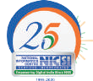

Page 34

Platform

IFMS

Punjab

Building Construction Online Booking System

Mobile App Development

Aabhar

Pension System

**Volume 29 No.4, April 2021**

Patron

**Dr. NEETA VERMA**

**04**

Advisory Panel **Nagesh Shastri Shalini Mathrani IPS Sethi**

**Ajay Singh Chahal**

Editor

**Mohan Das Viswam**

Zonal Editors **Dr. Dibakar Ray Reuban K**

**Kavita Barkakoty Sarbjeet Singh AK Dadhichi**

Web Version **Sunil Sunsunwal Archana Sharma**

Design Support **Mukesh Bharti Rohit Maurya**

Print, Circulation & Dispatch

**Anita Bhardwaj**

Published by

**National Informatics Centre**

MietY,Government of India

A-Block, CGO Complex, Lodhi Road New Delhi-110003, INDIA

Contact Address

**INFORMATICS**

379, A4B4, Floor-3, NIC

A-Block, CGO Complex, Lodhi Road New Delhi-110003, INDIA

Phone: 011 -24305365

Email: [editor](mailto:editor.info@nic.in)[.info@nic.in](mailto:.info@nic.in)

**Contents**

Credits & Editorial **02**

Message:

Director General, NIC **03**

Spotlight:

25 Years of NICSI **04**

NIC celebrates AI Day **06**

Int’l Women’s Day at NIC **48**

From the States:

Karnataka **07**

District Informatics:

Akola **12**

Patna **15**

**12**

e-Gov Products & Services:

ICES 17

Shaladarpan **20**

Prayas 23

Aabhar 27

Online Booking System of BCD **29**

IFMS, Punjab **31**

Technology Update:

|  |  |
| --- | --- |
| Build Your Own Bot | . . . . **34** |
| Mobile App Development | . . . . **36** |
| Appscape | . . . . **39** |
| In the News | . . . . **40** |
| Accolades | . . . . **45** |

**Editorial**

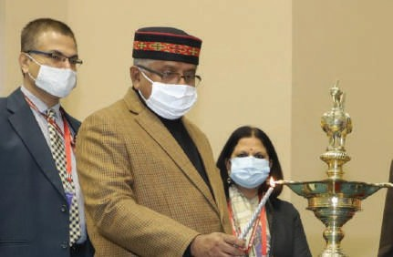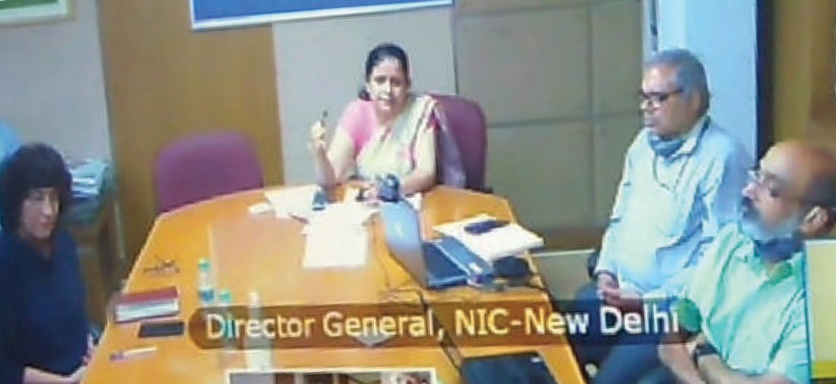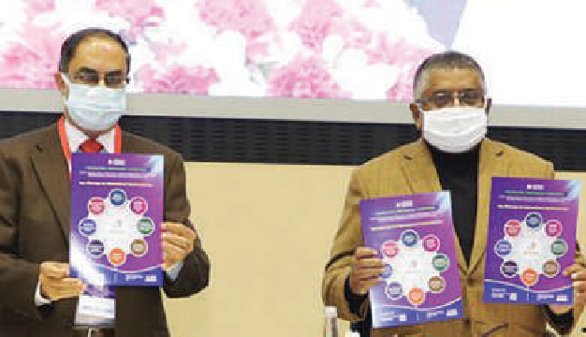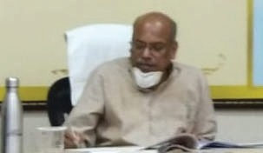

O

ne of the key enabling forces for providing and procuring ICT based solutions to governments, public sector undertakings and various related entities is the **NICSI**. Since its formation in 1995,

**NICSI** has been providing state-of-the-art and cost effective solutions for all the growing ICT needs of various stakeholders and citizens. The success of Digital India programme owes a lot to **NICSI** for the multi-dimensional role it has been playing in supporting the government.

These solutions have been delivered by in- house development, purchase of products and

**02 informatics.nic.in April 2021**

services from quality empanelled vendors. With this, **NICSI** continues to fulfil its vision of contributing to the acceleration of socio- economic growth. It is notable that with the successful execution of over 1700 projects annually, **NICSI** has grown to serve Government of India and other developing countries in its glorious 25 year history.

In this issue, we are glad to cover the Silver Jubilee Year celebration event of **NICSI** held at Vigyan Bhavan, New Delhi. We wish the organisation all the very best in the years to come.

The other two spotlight features in this issue are the celebration of NIC’s Artificial Intelligence Day and International Women’s

Day at NIC. The State covered in this issue is Karnataka and the Districts featured are Akola and Patna. The eGov Products and Services section has ICES, Online Booking System, IFMS Punjab, Prayas and Shaladarpan. In the Technology Update section, BYOB (Build Your Own Bot) and Mobile App Development are featured. The usual sections such as Appscape, In the News and Accolades have interesting updates.

We welcome your valuable feedback and suggestions which would help us improve the magazine to make it more useful.

Take good care of yourself and stay safe.

**- Editor**

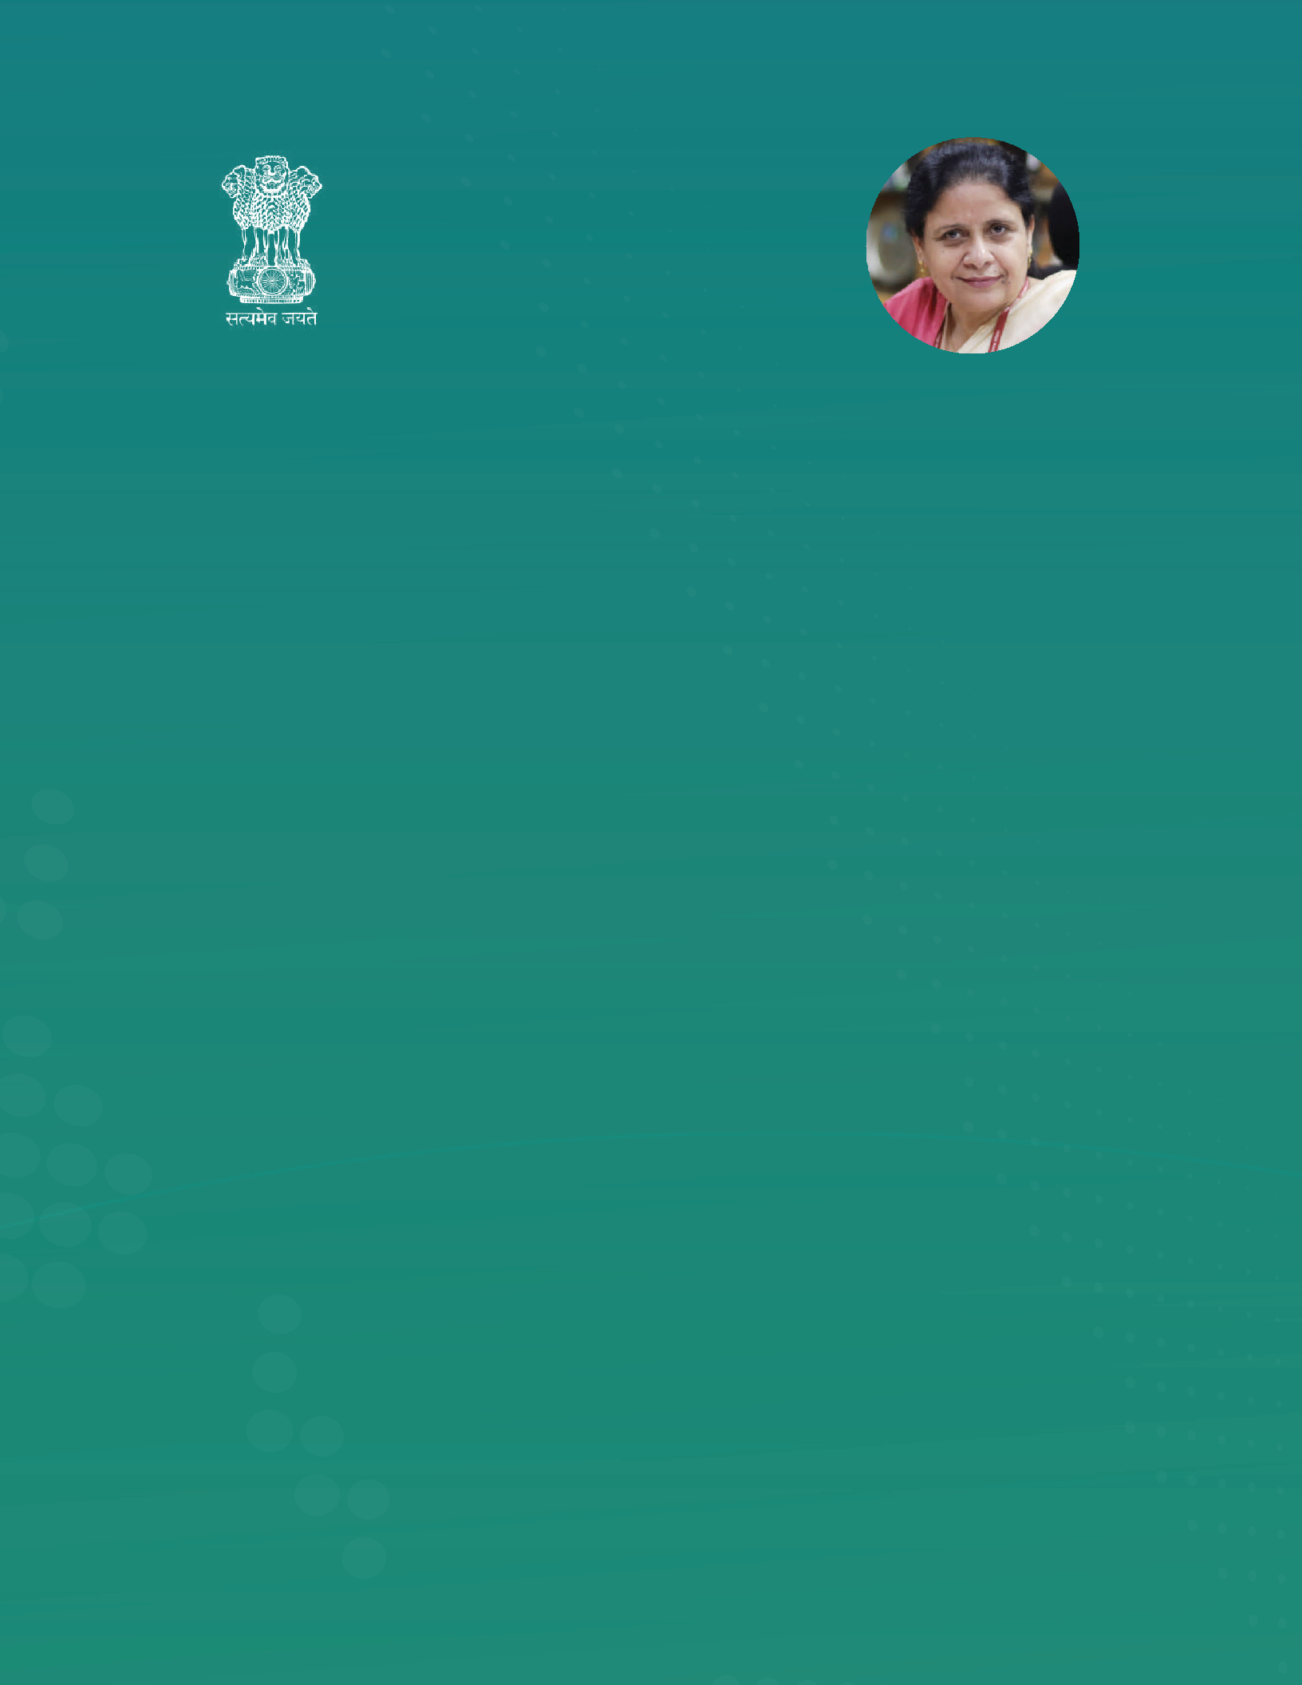**Dr. Neeta Verma**

Director General

National Informatics Centre MeitY, Government of India

ith each passing day, we have witnessed technology permeating deep into our lives. Organizations around the world are harnessing the true potential of tech- nology for creating innovative solutions that can benefit society-at-large. At

W

NIC, our journey has been a testimony to this era of technology-driven innovation through which we have developed and implemented a wide range of solutions for the socio-eco- nomic development of the country. Our solutions cover various sectors ranging from health, education, agriculture, transport, rural development, finance to legislature and judiciary, etc.

Throughout this journey, we have worked at almost every level of administration to develop digital solutions. The Digital India Program brought-in a wave of digital transformation throughout the country and we also experienced a significant increase in the demand for these digital solutions, and also their commissioning in a short period. As we catered to diverse requirements of solutions on-demand, this brought to the fore the need for software products for governance. Thus, we moved from the philosophy of custom-built projects to software products. This shift has also influenced the departments in adopting software products than getting custom built solutions made. Right from our beginning with eOffice to GePNIC, eCourts, eHospital, eCabinet, and many more – we have demonstrated a strong acumen for productization.

Our Product teams at NIC have been very responsive to user feedback & requirements which has helped us continuously evolve our products from one level to the other. With this transformation from projects to products, we have brought in a lot of efficiency in time & resource utilization. It has also helped us in improving the quality of the products in terms of reliability, resilience & scalability. Availability of software products for governance has also helped government departments in getting digital solutions commissioned in a short time. It has helped significantly cut down the long-drawn process of Project Planning, RFP preparation, procurement, and many other related activities, thus creating a win-win situation for all.

I am confident that this trend of building products will continue, and we’ll have many more products for digital governance. The use of these products will also help government departments fast-track their digital transformation journey.

**- Neeta Verma**

**Spotlight**

**NICSI Celebrates its Silver**

**ational Informatics Centre Services Inc (NICSI)** celebrated its Silver Jubilee on 28 Jan 2021 at a formal event at Vigyan Bhawan, Delhi. Shri **Ravi Shankar Prasad**,

N

Hon’ble Union Minister for Law & Justice, Communications and Electronics & IT was the chief guest and the esteemed dignitaries at the dais were Shri **Ajay Sawhney, Secretary**, MeitY, Shri **C. P. Gurnani**, CEO, Tech Mahindra India, Ms. **Debjani Ghosh**, President, NASSCOM, Dr. **Neeta Verma**, Director General, NIC, Dr.

R**ajendra Kumar**, Additional Secretary, MeitY and Chairman, NICSI, Shri **Prashant Kumar Mittal**, MD, NICSI. Delegates from government, industry and academia participated in the event. The silver jubilee celebration was made live for the public and other stakeholders

in government.

NICSI was established in 1995 under NIC, MeitY, GoI for providing and procuring IT solutions for various e-governance projects undertaken by NIC, MeitY, other central ministries and government organizations such as the public sector undertakings.

Hon’ble Union Minister in his inaugural address highlighted Digital India as a movement to empower the ordinary Indians with the power

of technology. He urged NICSI and NIC to develop India as a leader in the Data Economy. Shri Ajay Sawhney, in his address emphasized the need for harmonizing the stand-alone government products and services and looked forward to making these into single products that will be available for the public with ease. Dr. Rajendra Kumar, in his speech highlighted the two key elements “Ease of Living for citizens” and “Ease of Doing Business for the businesses” which can bring a complete transformation in

the way government departments perceive digital, use digital, and in the way citizens and businesses can use that interface for availing services. DG NIC, Dr. Neeta Verma, in her speech, remembered Dr. Sheshagiri who was the founder of NICSI, and also highlighted how NICSI has transformed its business model from Desktop and Servers to Cloud-based Products and Services.

She also mentioned “Tejas”, a product that will give “Data Analytics as a Service” over the cloud. Shri Prashant Kumar Mittal, addressing the gathering mentioned the role of private and government industries behind the great success achieved by NICSI. C. P. Gurnani presented

his views on the role of IT in India’s new Innovation System. Ms. Debjani Ghosh, in her address over video conferencing highlighted the role of IT in enabling **Atmanirbhar Bharat**.

A short film on NICSI’s achievements and journey in the past 25 years was viewed. The software products launched on the occasion were **Tejas** (Visualization Intelligence Tool), **e-Auction** (generic open, public, and

commodity auction platform) and **Work from Anywhere** platform, which facilitiates government officials to access the applications enabling the official work activities seamlessly from anywhere. A brochure on NIC product portfolio including **e-office**, **ServicePlus**, **e-Hospital**, **BhuNaksha**, **e-Prison**, **e-Courts** and **Darpan** was released by the Hon’ble Union Minister. These software products are for International offering.

04 informatics.nic.in

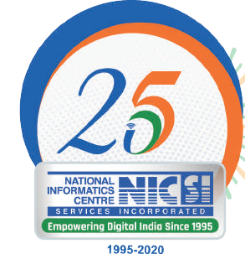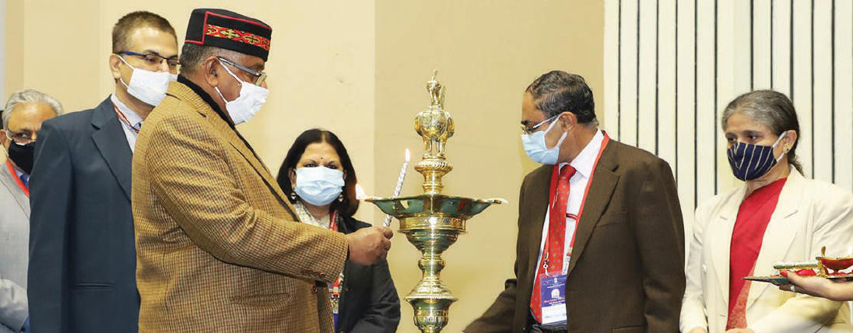

**April 2021**

**Jubilee Year**

**Spotlight**

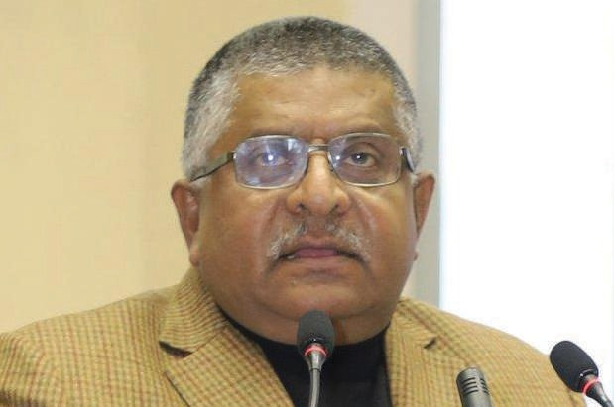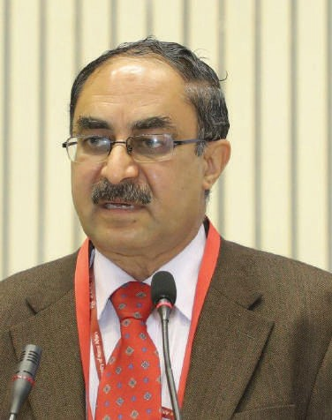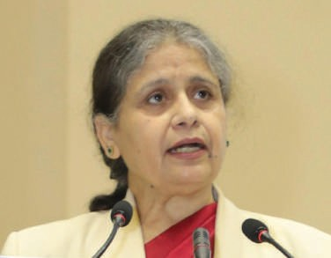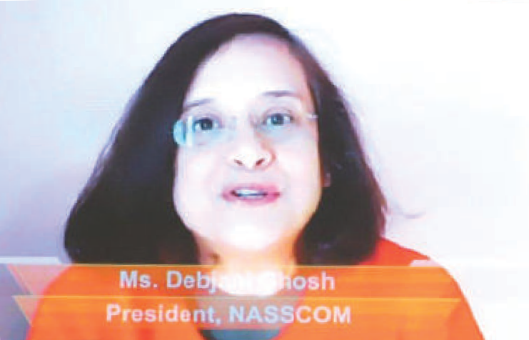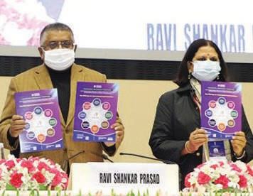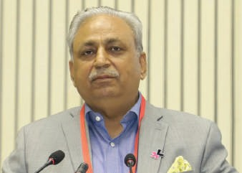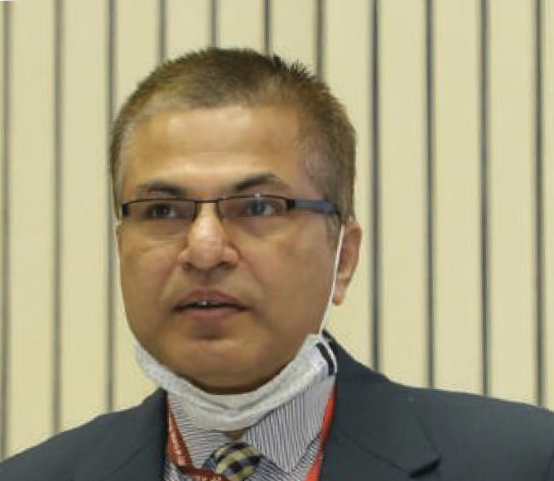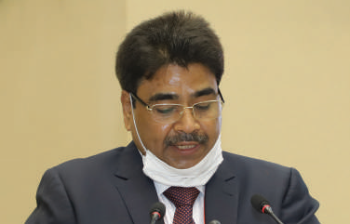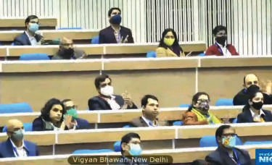

**April 2021**

**informatics.nic.in 05**

**Spotlight**

**NIC celebrates AI Day, 2021**

rtificial Intelligence (AI) Day was celebrated by NIC on the 25th January 2021. Hosted at NIC HQ, the event witnessed the participation of NIC officials from across the nation through video conferencing.

A

Shri Vishal Dhupar, Managing Director, Asia South at NVIDIA, and Dr. (Prof) NN Mathur, Director & Additional DGHS & Director Professor (ENT) Lady Hardinge Medical College were the invited guests who addressed the participants of the event through video conferencing.

DG NIC, Dr. Neeta Verma launched the NIC service **AIAAS** (AI as a Service) on NIC Cloud and also released the white paper on **COE-AI services** consisting of NIC achievements in the last two years related to various e-Governance applications. Top winners of the AI Hackathon which was held last year were felicitated. It was on the same day last year, NIC’s Centre of Excellence in AI (COE-AI) at NIC HQ was inaugurated by the Hon’ble Union Minister, Shri Ravishankar Prasad.

06 informatics.nic.in

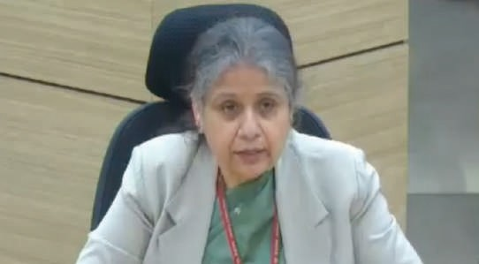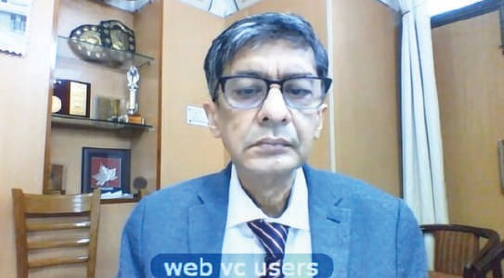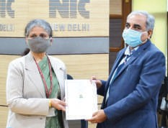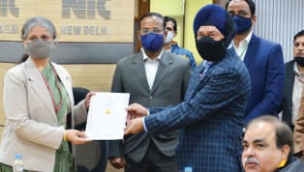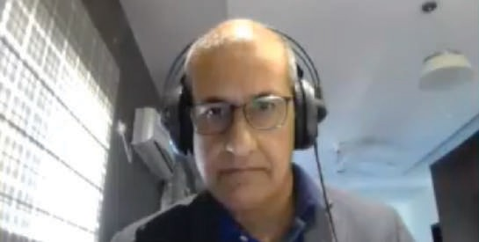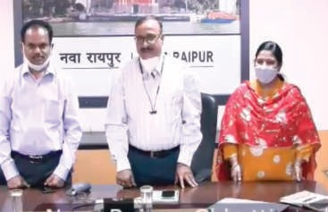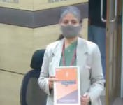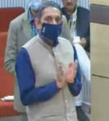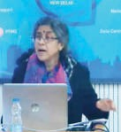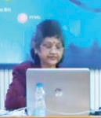

**April 2021**

**Karnataka** State

### Architecting digital solutions and delivering key ICT services to the Government

Edited by **REUBAN K**

##### NIC Karnataka State Centre has been instrumental in designing, developing and implementing e-Governance solutions, which

**resulted in digital transformation in the State at all levels and has helped in achieving transparency and efficiency in the delivery of the citizen centric services.**

**NIC has set up the Centre of Excellence in Blockchain Technology in Bengaluru with a vision to build niche**

**applications using Blockchain in close coordination with the Government.**

###### P.V. Bhat

Dy. Director General & SIO

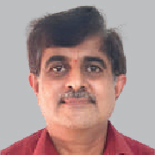[**bhat.pv@nic.in**](mailto:bhat.pv@nic.in)

**B.P. Srinivasan**

Sr. Technical Director

[**b.p.s**](mailto:b.p.srinivasan@nic.in)[**rinivasan@nic.in**](mailto:rinivasan@nic.in)

arnataka, popularly known as ‘One State, Many worlds’ is situated in the Southwestern region of the Country. It is the eighth largest state of

India and formed on 1st November 1956, the state was earlier known as the State of Mysore, and was renamed Karnataka in 1973. It was ruled by many kings belonging to Maurya, Shatavahana, Kadamba, Chalukya and the world famous Vijayanagara dynasties. Being a home to sculptured temples, hill ranges, beaches and other beautiful attractions, Karnataka is known for its heritage destinations, miraculous hill stations and magnificent waterfalls. It is also known for sandalwood and Mysore Silk. The State is also known for famous writers who have won Eight Jnanpith awards for their exemplary work in literature. The State capital Bengaluru is the most sought after destination for the IT Sector and Karnataka Government has reached out to the world to invite investment in the State. Karnataka Government is very keen on providing paperless, faceless, contactless and cashless services to the citizens. NIC is a partner in achieving its goals of spearheading ICT initiatives in the State. This has enabled the State to achieve transparent, effective and efficient citizen centric service delivery and brought governance to the doorstep of the citizens.

K

NIC Karnataka has been playing a key role in the e-Governance initiatives of the Government and is consulted on all major citizen centric projects in the State including the 30 District Offices. NIC Karnataka is instrumental in providing state-of-the- art Data Centre support for the Government and has also designed, developed and implemented e-Governance applications since its inception in Bangalore in 1987.

**ICT Initiatives in the State**

###### Centre of Excellence in Blockchain Technology

A state-of-the-art laboratory has been established to facilitate the Government Departments to perform PoCs, test the applications and move on to production. The centre has explored some blockchain platforms and has established blockchain networks using Hyperledger Fabric and Hyperledger Sawtooth. Blockchain network with nodes in different data centres of NIC has been established to provide a platform for NIC to develop and deploy blockchain enabled applications.

Centre is developing and deploying the applications such as Certificate Chain, Drug Logistics, Remote Voting, etc.

###### Certificate Chain

The marks-sheet of SSLC and PUC students of Karnataka have been stored in Blockchain. The

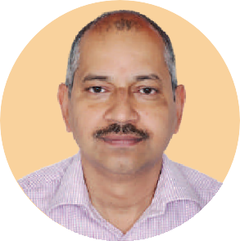

**NIC Karnataka State has been the technology partner with the Government of Karnataka in all the citizen centric applications. The State achieved laurels in many e-initiatives, thanks to NIC for technical support. e-Hospital, FRUITS, DBT, e-Office, e-Waybill, GST Prime, Panchatantra, e-Swathu, e-Aasthi, Blockchain applications are some of the important web and software applications with which the citizens, business community and Government at large are benefitted.**

**The team at NIC Karnataka has vast domain knowledge in all key areas of Government and the technical compe- tency to offer solutions.**

**I am very happy to note that Informat- ics April 2021 is showcasing the e-initia- tives of NIC in Karnataka State.**

**I wish the team NIC Karnataka the very best in all their future endeavours and look forward to their continued support for the State in e-Governance initiatives.**

**P. RAVIKUMAR,** IAS

Chief Secretary Government of Karnataka

KSEEB portal provides facilities for the process of verification. The same system can be implemented for any university marks-sheet. This provides a tamper proof secure system and enables electronic verification by other accepting agencies such as Scholarship, Professional College admission system systems.

Marks-sheet of students who passed the examinations in the academic year 2019-20 is stored in the blockchain.

###### Drug Logistics Chain - Aushada

The main objective of Aushada software is to

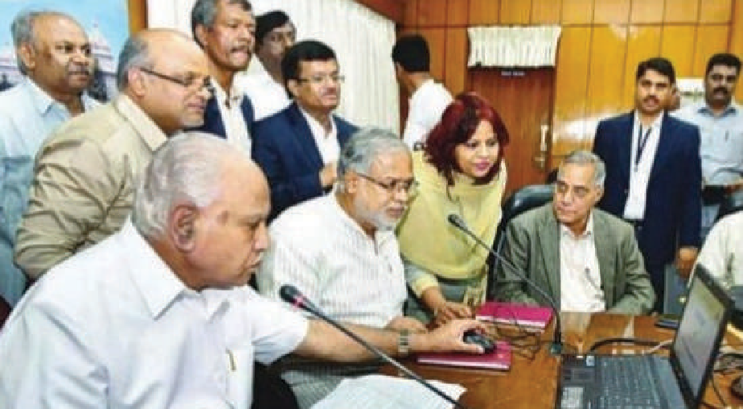

**Hon’ble Chief Minister of Karnataka, Shri B. S. Yediyurappa inaugurating the eGazette Portal**

with DBT platform. This will enable them to do Direct Benefit Transfer to the beneficiary’s bank account through the Aadhaar Enabled Payment System. The DBT platform provides services to the various departments to perform validation of Aadhar number with UIDAI, check for availability of Bank Accounts seeded with Aadhar and through NPCI service and resolve issues with respect to payment. For payment, DBT is integrated with Khajane-II and the State Bank of India.

89 Schemes from 14 departments are on-boarded on the DBT platform. A total amount of Rs 10,160 Cr. has been transferred to 3.65 Cr. Beneficiaries through the DBT portal till date. About Rs. 684 Cr. have been paid to 24.9 lakh beneficiaries under various Covid-19 relief schemes.

###### Panchatantra

Panchatantra is a comprehensive system for automation of activities of all the 6009 Gram Panchayats of Karnataka. Double entry accounting system the core of the project, helps Panchayats to

automate the supply chain management of drugs

procured from Karnataka State Medical Supplies Corporation Limited and supplied free of cost to the patients across Karnataka. At critical stages in the workflow, the data is stored in Blockchain. This includes the POs, the batch ID details, quantity, expiry details, inward and outward details at warehouse and hospitals. The quality test report received from test labs would be updated in blockchain

This will facilitate easy recall of non standard drugs. The patient will be able to check the expiry, quality, manufacture details etc. from the blockchain. For the year 2019-2020 about 800 drug details along with Purchase Orders and the movement details of these from supplier to 26 District Drug Warehouses and 2,783 Health institutions all across

Karnataka State is stored in the blockchain.

in the states of Karnataka, Chhattisgarh, Jharkhand,

Himachal Pradesh, Maharashtra, Chandigarh, West Bengal, Kerala and Haryana. And the implementation is under progress in the states of Assam, Delhi, Bihar and Madhya Pradesh.

###### DBT

**Direct Benefit Transfer**

Government of Karnataka provides benefits citizens through several schemes and programmes of Govt. of India & Govt. of Karnataka - Subsidies to farmers, scholarships to students, social security pensions, and micro-credit to poor women etc to name a few. The new initiative is to provide a common platform for all Government departments to integrate their beneficiary management system

capture all the financial transactions like receipts, payments, demands, etc. and thereby allowing Panchayats to generate various financial statements like Income & Expenditure statements, Balance Sheets, etc It also has citizen interface for online services of the gram panchayats.

Operational in all the Gram Panchayat since 2015-16 this system is benefitting over 400 Lakh of rural population and 6009 GPs in improving in their delivery of services and tax collection.

###### Worksoft

The Rural Development and Panchayat Raj department executes multiple development works under various schemes to improve the basic infrastructure in the rural areas. In this process, they

###### GST e-Invoice

GST e-invoice system, the game changer in the GST system, was launched on 1st October, 2020 on PAN-India basis, for the businesses who have an aggregate turnover of more than Rs. 500 Crores in the financial year. ‘e-invoicing’ essentially involves reporting details of specified GST documents to a Government-notified portal and obtaining a Invoice Reference Number (IRN). GST e-invoice System is a path-breaking initiative that is going to revolutionize the way businesses interact with each other. It also helps the recipient to get an Input Tax Credit for the purchases. From day one, this system is running smoothly and in the first two months of introduction itself, more than 1,089 Lakh e-invoices are generated on the NIC portal by 33,000 tax payers.

###### GST Prime

**NIC-GST Analytics System**

GST Prime system is an analytical system from NIC for the GST officers in the country. It pulls the data from the GST Common Portal, E-Way Bill system and other external systems and analyses the data and provides the information to the officers for further action. This system has helped the GST departments in improving tax compliance and collection and fraud detections. GST Prime has been implemented

**Farmer Registration & Unified Beneficiary Information System**

DBT



KSNDMC

Aadhaar

FRUITS

NPCI

SMS Gateway

Nadakacheri

Crop Survey

KSRSAC

Bhoomi

Ration Card

get multiple development works executed in the rural area so that the basic infrastructure is built for rural people.

The comprehensive Worksoft system facilitates the RDPR department in following the procedure laid down for execution of works and effective monitoring of implementation of the same under different schemes.

###### FRUITS

**Farmer Registration & Unified Beneficiary Information System**

FRUITS is an e-Governance application for

managing farmers database and benefits provided to farmers/ institutions/ producing organisations, covering the schemes executed by Department of Agriculture and allied departments. All these departments deal with farmers when it comes to providing benefits from the government in the form of subsidy/ financial assistance. A well organised and scrutinised farmer database will avoid farmers from running from pillar to post for availing benefits and submission of same set of documents repeatedly. For departments, it helps in bringing transparency in selection of beneficiaries, avoiding chances of same beneficiary(ies) availing multiple benefits.

Farmers can request online for registration, modification of existing details etc. Electronic integration has been achieved with Aadhaar, BHOOMI (land Records System), Nada-Kacheri (Revenue departments certificates issue system), PDS and EPIC system. The system also facilitates updation of details of benefits passed on to farmers by stakeholder departments based on registration ID. Applications of stakeholder departments interact and exchange data using Web API.

6 Departments with 27 schemes are on-boarded with FRUITS (**http://www.fruits.karnataka.gov.in)**. Payments to beneficiaries are being done using the DBT platform. An amount of Rs. 570 Crores has been disbursed to about 1 Crore beneficiaries till date under different schemes.

###### FAPS

**Farmer Agriculture Produce Support System**

FAPS application is a total work flow based system

wherein farmer can register, provide produce to the procurement agencies and receive the payment for their produce directly to his bank account. The registration of farmers is done through the FRUITS system, which will validate his details along with land records and agricultural produces.

With the introduction of the above system, the registrations of farmers and procurement of produce is done with ease and the payment to the farmers is made within 15 days of the procurement, which otherwise used to take 3 to 4 months. This has benefitted a substantial number of farmers. During the last financial year, more than ten commodities were covered under MSP operations by six departments/agencies and more than 5.80 lakh farmers are benefitted from this system.

###### Samrakshane

**https://**[**www.samrakshane.karnataka.gov.in**](http://www.samrakshane.karnataka.gov.in/)

Samrakshane (meaning protection) is an end to end, state-of-the-art e-Governance solution and farmer-friendly system for crop insurance enrolment, registering claims, compensation calculation and payment of compensation to farmers under the Crop Insurance Schemes, Pradhan Mantri Fasal Bima Yojana (PMFBY) and Modified Weather Based Crop Insurance Scheme (MWBCIS).

It has been operationalised in 2016 and successfully completed 14 seasons since inception. It has resulted in increase in Non-loanee farmer enrolments and reduction in Process cycle time for compensation payment by almost 10 months. The payments are made through SBI payment gateway.

###### Seva Sindhu

[**http://sevasindu.karnataka.gov.in**](http://sevasindu.karnataka.gov.in/)

Seva Sindhu is a Service Plus based platform to deliver government services at the doorsteps of citizens. Seva Sindhu is integrated with various service delivery channels of the Government of Karnataka namely citizen service centres (Bangalore One, GramaOne, JanaSevaka, Karnataka One) , Atalji Jana Snehi Kendra and Bapuji Kendras. It aims to bring all departmental services under one platform. It is a step towards providing accessible, cost- effective, accountable and transparent government

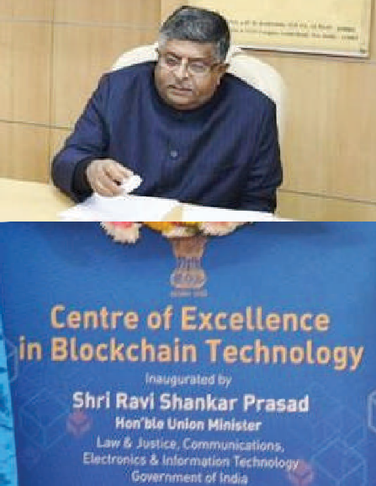

Shri Ravi Shankar Prasad, Hon’ble Union Minister inaugurating the CoE in Blockchain Technology digitally

services to citizens.

As of now, Seva Sindhu provides 760 online services of 64 departments.

###### EASE

**Electronic Answer Script Evaluation System**

EASE is a system to carry out the computerized evaluation of the theory examination, conducted by the various universities, agencies. The system enables onscreen evaluation of theory examinations and is being used by Education Department for entrance tests conducted for recruitment of teachers and lecturers. It is hosted in cloud environment with distributed scanning stations and onscreen evaluation centres, accessed through internet/ intranet.

It is generic system and supports academic

related activities covering parallel evaluations of the same answer scripts by different evaluators using secured encryption of data. It is being implemented for KPSC (Karnataka Public Service Commission),

Dr. C N Ashwathnarayan, Hon’ble Deputy CM and Hon’ble Minister, Higher Education inaugurating the Online e-Affiliation Portal for Universities of Karnataka

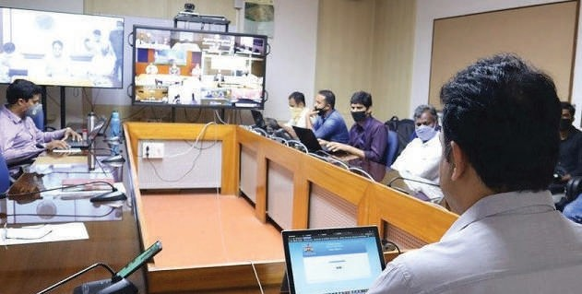

Govt. of Karnataka, for their regular recruitment purposes.

###### e-Gazette system

[**http://erajyapatra.karnataka.gov.in**](http://erajyapatra.karnataka.gov.in/)

The e-Gazette is web application with built in workflow for all the stake holders starting from submitter, uploader, approver and nodal officer. At each stage, the document is digitally signed and finally the Gazette is published on the portal. With launch of e-Gazette, the physical publication of Gazettes has been discontinued and very minimum copies of e-Gazettes are printed and kept for record purpose. Government printing press used to print an average of 39 crore pages of weekly gazette and

1.2 crore pages of extra ordinary gazettes each year.

With e-Gazette, the number of pages per year is reduced to 10,000 pages.

Since it is a web application, all the Gazettes

|  |  |  |
| --- | --- | --- |
| **Project Name** | **Brief Description** | **Implementation Status** |
| **Ahara** | Online Ration Card Management and Food distribution System | More than 120 Lakh families are benefited |
| **E-Hospital** | Online Hospital Management System | Implemented in 146 hospitals out of which 140 are in cloud and 6 in major hospitals in Bengaluru. |
| **E-Way Bill** | Online generation of e-way bill for movement of goods by the business entities as per GST requirements | More than 550 e-way bills are generated every month by 12.5 Lakh tax payers |
| **Aayushman Bharat- Arogya Karnataka** | Karnataka launched Universal Health Scheme integrated with Pradhan Mantri Jan ArogyaYojana (PMJAY) started in March 2018. AB-ArK cards are generated based on the Aadhaar Card and Ration card which have a unique ID. | Total number of AB-Ark cards issued till today 1.4 crores Number of APL Beneficiaries: 25.27 Lakhs Number of BPL Beneficiaries: 1.16 Cr |
| **Property Tax System for BBMP** | Online property tax payment system for citizens of Bangalore | Total property Tax collection for 2020-2021 : 2363 crores (As on  date) |
| **Nadakacheri** | Online workflow based system for process and deliver 45 different types of certificates by  the revenue department | More than 1Cr certificates are generated on an average per year. Around 5 Cr certificates reprinted on an average per year |
| **DSSP** | Workflow based processing and distribution of social security schemes of the  government for needy people | Total active beneficiaries 68 lakh and Total payments made per month – 600 Cr approx. Total new beneficiaries added every day  – 800 on an average |
| **E-courts** | Workflow based system for court cases management | Implemented in all courts |
| **State Scholarship Portal** | Online Workflow based common platform to disburse scholarship through DBT to eligible  students of Karnataka. | 2019-2020 – Total students 33.6 lakhs with a total amount of Rs.  379.9 Cr |
| **E-Office** | Workflow based system for processing and management of files and letters in  government departments | Implemented in 421 departments with user base of 22333 officers |
| **e-Man** | Workflow based system for asset management | Implemented at NIC, Rashtrapathi Bhawan., Health and Family Welfare Department |
| **FIST** | Financial & Stock Accounting (FIST) software for Supply Chain Management of Public Distribution System, | FIST is implemented in 300+ Whole Sale Points of KFCSC |
| **KEA** | Online Verification of Documents for Engg, Medical/Dental & Allied courses Admission for KEA ( Karnataka Examination Authority.) | Implemented since 2012 |
| **e-Suraksha** | Online and workflow based system for services of electrical inspectorate departments | Implemented 26 services |
| **WCMS** | Web Content Management System for Department of Collegiate Education (DCE) and Department of Technical Education (DTE) | Enabled websites for 430 Government First Grade Colleges and  85 Government Polytechnics |
| **EMIS** | Education Management Information System For Government First Grade, Grant-in-aid  Colleges and Govt. Polytechnics. | Implemented in 430 colleges |
| **RCCMS** | Revenue Court Case Monitoring System is web enabled application integrated with Karnataka Land Records System providing complete process flow of revenue courts right from filing of case to disposal of case. | This application is being implemented by all the Revenue/  Magisterial Courts of Karnataka State. |
| **PM-KISAN** | Prime Minister “Kisan Samman Nidhi” Scheme to boost farmer’s income by transferring  Rs 6000/- per year through DBT. | Till date 54 Lakh farmers Benefitted. |
| **e-Aasthi** | Workflow based system for management of non-agricultural land records/properties of  urban areas | Implemented in 203 urban bodies |
| **e-Swathu** | Workflow based system for management of non-agricultural land records/properties of  rural areas | Implemented in 6009 Grama Panchayats since 2014 |
| **Sakala** | Karnataka Guarantee of Services to Citizens | Implemented for 1019 services of 95 departments |
| **Aushada** | Online and workflow based drug supply chain management system | 26 warehouses and 3000 hospitals are using Aushada software. |
| **E-Procurement** | End-to-end eProcurement & ePublishing implementation through Central Public  Procurement Portal (GePNIC ) of NIC. | Implemented in more than 25 Central Government Organizations and 8 PSUs and other central institutes. |
| **e-Janma** | Single window system for Registration of Births/ Deaths for Rural, Urban and Government hospitals, enabled with Digitally Signed Certificate | Implemented since 2016 |
| **Jeevan Pramaan** | Generation of Digital Life Certificates for Pensioners | Implemented for DPDO, Army K & K Sub Area, GPO. On-boarding of KPTCL is under progress. |

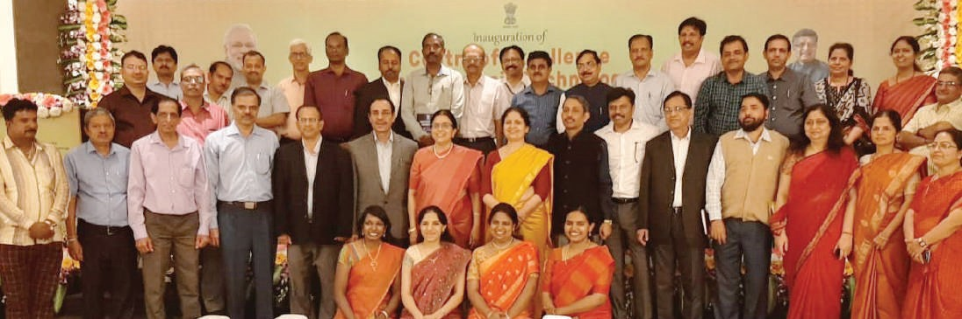

Teams of NIC Karnataka and NIC Hqrs with DG-NIC during the inauguration of Centre for Excellence in Blockchain Technology

notified by government is available to general public. Also, unlike the weekly publication of the gazette in the printed version, the e-Gazette has the option to publish the gazette as and when required by the department, it is pertinent to mention here that, the e-Gazette has been very well received by all the Departments, and Government has made it mandatory for all the departments to publish the gazettes only on e-Gazette portal.

**RTI online Portal**

Right to information Online Portal is the digital enablement for the citizen to file online RTI application to get required information. It is a workflow based web portal which has the facility for a citizen to file an RTI application under the relevant sections of the RTI Act and also enables for filing the appeal against the Public Information officer.

As on now, 9 departments with about 600 Public Authorities, 8600 Public Information officers and 8600 First Appellate Authorities are on boarded on the portal. About 4500 RTI request and about 900 First appeals have been filed online. The process of onboarding the remaining departments are on.

The Right to information portal is also integrated with online payment gateway. It has alert systems built in to message the PIO about the pending applications in the login and RTI applicant about the

current stage of his/ her application. The application has been well received by the public and the other stake holders.

###### EMS - Election Management System

Election Management System (EMS) is comprehensive system for State Election Commission (SEC), comprising of all the activities related with Election. The notification of the election by SEC, notification by the District administration, Appointment of Returning officers, Capturing Candidate profile, constituency mapping with reservation, scrutiny of the applications, rejection and withdrawal of candidature, poll day polling percentage and tabulation of results are the modules built-in to the system.

With the help of this software, SEC is able to monitor the election process more effectively at the micro level. During the current election, about 5730 Gram panchayats have been notified for election, 3 lakh plus candidates are in the fray and election are being held in 44,730 polling stations.

###### Online University Affiliation System

The system facilitates colleges to file online applications after availing user credentials from the respective universities, enables formation of local inspection committees, with provision to accept the

inspection details vis-a-vis data entered by colleges. The system facilitates auto generation of marks for various parameters as designed by the Government and generation of reports to be sent to the syndicate for approval and enables various MIS reports.

The University affiliation system portal has been implemented for Department of Higher education, Govt of Karnataka covering 14 conventional universities in the State and 5000 affiliated colleges.

###### Accolades

* Nada Kacheri (e-KSHANA-Instant service delivery system, Revenue Department): Jury Award of Excellence in providing Citizen Centric Delivery, at the 23rd National Conference on e-Governance, held in Mumbai

•

FRUITS: Third place in Data Quality Challenge 2018 Samrakshane: National e-Governance award 2018, SKOCH Order of Merit 2017, Gems of Digital India Award 2018

•

•

e-AASTHI: SKOCH Order of Merit 2017

•

e-SWATHU: SKOCH Order of Merit 2017 and CSI- Nihilent Award 2014-2015

###### Way Forward

* The Centre of Excellence in Blockchain Technology is in the process of designing more applications of relevance to the citizens such as Certificate (Caste, Income, Birth, Death etc.) repository, Property

•

Receiving the Jury Award for e-KSHANA – Instant service delivery system at the 23rd National Conference on e-Governance, held in Mumbai

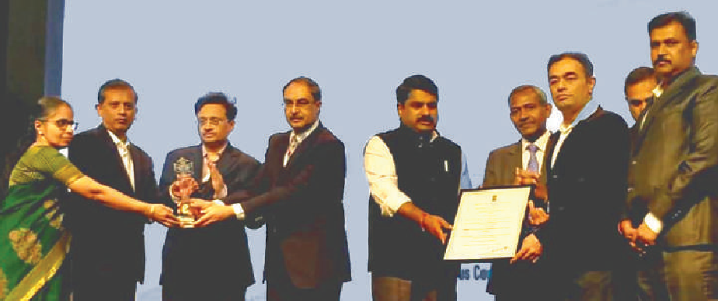

details, Licenses etc. in near future Integrating the ongoing applications with IoT

Enhancing the scope of Tax payers, eligible for eInvoice

•

•

Rollout of GST Prime in remaining states Incorporating AI Tools to enrich the ongoing applications

•

For further information, please contact:

**State Informatics Officer** NIC Karnataka State Centre VI & VII Floor, Mini Tower

Dr. Ambedkar Veedhi, Bengaluru - 560001 KARNATAKA

Email: [sio-kar@nic.in,](mailto:sio-kar@nic.in) Phone: 080-22863790

**Akola** District

### Pioneer with excellence in digital governance at the Cotton City of India

Edited by **AK DADHICHI**

##### NIC, Akola is a pioneer with excellence in digital governance, with communication facilitation, technical support, system analysis, and innovative implementation of ICT. NIC, Akola is recognized with more than twenty various types of awards and recognitions for innovative initiatives of delivery of cloud-like services with Virtual Machine as a service, major

**contribution in the implementation of NLRMP for Akola and Maharashtra, and Framework**

**for e-Governance of fundamental resources water, electricity.**

###### Moiz Hussain Hussain Ali

Dy. Director General

& SIO

[**hussain@nic.in**](mailto:hussain@nic.in)

**Nitin Vishnu Choudhari**

Scientist-D & DIO

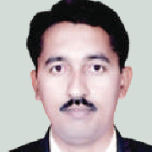[**nv.**](mailto:nv.choudhari@nic.in)[**choudhari@nic.in**](mailto:choudhari@nic.in)

**Anil S. Chinchole**

Scientist-D & ADIO

[**as.**](mailto:as.chinchole@nic.in)[**chinchole@nic.in**](mailto:chinchole@nic.in)

kola district is situated in the middle east of Maharashtra State. This district is situated between North 20.17 to 21.16 latitude and East

76.7 to 77.4 longitudes. There are ranges of Gavilgad hills on the north of the district. The total area of Akola district is 5428 sq. Km. There are 7 tehsils in Akola District Akola, Balapur, Patur, Barshitakali, Murtizapur, Akot, and Telhara. There is 1 Municipal corporation, 5 Municipal councils, 1 Nagar panchayat in the district. Akola is famous for its various shimmering rivers, gorgeous winters, sprawling forts, and intricately carved temples and mosques. Identity of Akola district is Dr. Panjabrao Deshmukh Krishi Vidyapeeth (PDKV), Shri Vijay P. Bhatkar, an architect of India’s national initiative in supercomputing, and Shri Sanjay Shamrao Dhotre, Union Minister of State for Human Resource Development, Communications and Electronics and Information Technology.

A

###### ICT Initiatives in the District

Akola continued all its communication facilitation, technical support, system analysis services uninterrupted full time all the days for the ICT initiative in the district. The major ICT activities are as follows.

###### General Loksabha PC Election 2019 & Vidhansabha AC Election 2019

NIC Akola has provided Technical support, Communication Facilitation, System Analysis, capacity building, and allied services for General Loksabha Parliamentary Constituency Election 2019 and Vidhansabha Assembly Constituency Election 2019 for 06 Akola Parliamentary Constituency including the Legislative Assembly Constituencies(LAC) 28 Akot LAC, 29 Balapur LAC, 30 Akola West LAC, 31 Akola East LAC, 32 Murtizapur and 33 Resod LAC. NIC Akola provided complete technical support in the following processes.

* + Polling and counting activities including Nominations
  + Polling Party Formation
  + EVM Management System
  + C-Vigil
  + Live Web Casting from Sensitive Polling booths
  + ETPBS (Electronically Transmitted Postal Ballot System) generation
  + Poll Day Monitoring System (PDMS)
  + Counting staff randomization
  + ETPBS counting
  + Counting Day Monitoring System (CDMS)
  + ECI Suvidha application

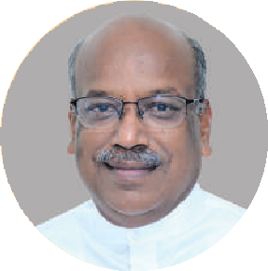

**NIC, Akola has played an important**

**role in Covid-19 pandemic situation as well as in video conferencing, providing support for the management and monitoring of e-Governance projects. NIC Akola actively supported and participated in the programs and functions organized in the Akola district. I have taken special note of the perfect work done by NIC, Akola. I foresee that NIC, Akola will work with the same zeal and enthusiasm and serve with the same spirit and energy.**

**Shri SANJAY DHOTRE**

**Union Minister of State for Education, Communications and Electronics & Information Technology, GoI**

DIO and ADIO of NIC, Akola received an appreciation certificate from Hon District Collector, Akola for the support in Elections 2019.

###### Technical Support as a part of Covid-19 Task Force Emergency Services

During the situation of the global epidemic of COVID-19 virus NIC, Akola continued all its communication facilitation and technical support services uninterrupted full time all the days including holidays as per the need and requirement. NIC, Akola actively provided technical support and conducted nearly 200 Video Conferencing sessions, including the VIP VC sessions of Hon Prime Minister, Hon Shri Sanjay Dhotre, MOS for MeitY, and Hon Chief Minister, etc. NIC, Akola actively providing technical support for Covid-19 related applications including Aarogya Setu Application implementation

**Hon’ble MoS, Shri Sanjay Dhotre conducting VC from Akola with DG, NIC**

###### Significant Achievements and Initiatives

* + - NIC, Akola have three major significant innovative

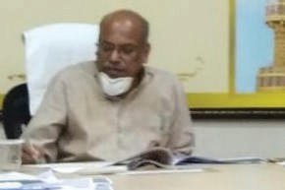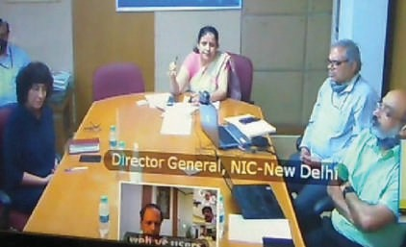

initiatives of delivery of cloud-like services with

Virtual Machine as a service, Major contribution in the implementation of NLRMP for Akola and Maharashtra, and Framework for e-Governance of fundamental resources water, electricity

* + - Akola is the first District in Maharashtra where online mutation started for taluka Telhara in August 2014. Online e-Mutation processing in

all 7 Taluka’s of Akola is started from Feb 2015.

and monitoring, Covid-19 Quarantine Alert System (CQAS), E-pass System, and Covid 19 Collection Centre Application.

###### National Land Records Modernization Programme (NLRMP)

For making the process of the switch over from offline to online processing quick and seamless, NIC District Centre, Akola has adopted resource optimization for utility computing. It made use of several innovations like Process isolation, Virtualization, Server consolidation, Software, Hardware portability, and leveraging of shared

of Maharashtra. All Kotwal book entries are scanned and computerized with Metadata entry and made available online for the public using the Kotwal Book online application. The online distribution of the Kotwal Book records was started in 2015 and till now 30,513 Kotwal book copies have been served online, and a total transaction for the revenue of Rs. 7,62,825/- was achieved.

Citizens at the remote village level can avail of

the copy of the Kotwal book online from anywhere with online payment through the payment gateway. Those Govt. Offices, to whom the copy of the Kotwal Book is submitted by citizens, can verify its

Akola is one of the leading Districts in the online e-Mutation processing activity of Maharashtra

* District Website switched over to Secure, Scalable and Sugamya Website as a Service (S3WaaS)

framework from 5 April 2018. Akola is the third district in the state of Maharashtra to switch over to S3WaaS

* New Initiative of Framework for e-Governance of fundamental resources Electricity, Water “based on emerging cognitive technologies

networks with cloud-like services with complete

Virtual Machine as a service implemented in the State of Maharashtra. The notable achievements of the project are improved service delivery, increased throughput, increased efficiency, and creates cost-effective solutions for concrete and effective e-Governance. National Informatics Centre Akola has developed Virtual Machines of Client for the sustainability of Property Card Information System (PCIS) at District and Taluka Inspector of Land Records (TILR) offices running all over the state of thereby saving hardware cost at each location.

###### Pradhan Mantri Kisan Samman Nidhi (PM Kisan)

Technical support and capacity building for the beneficiary’s records data uploading, correction to the Taluka and district level staff.

###### Akola district- Online Kotwal Book

Kotwal Book is the birth/ death/ caste records maintained in the form of registers by the Village Kotwals since ancient times in the Vidarbha region

**Website of District Akola** [**(http:/**](http://digitalakola.in/))**/**[**digitalakola.in/)**](http://digitalakola.in/))

authenticity online by using the QR Code Reader.

Website: <http://digitalakola.in/>

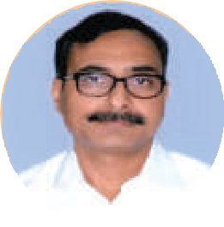

**NIC, Akola wholeheartedly executed a valuable role during Election 2019, Covid-19 pandemic, NLRMP, PM Kisan, Video Conferencing, MAHAPAR, and other e-Governance projects, with great responsibility. The contribution of NIC, Akola to the successful conduct of the entire computerization was indeed very much commendable. The technical expertise and proficiency exhibited by NIC, Akola officials has helped us to carry out the entire computerization works successfully with ease and efficiency. I appreciate and congratulate NIC, Akola for the integrity, teamwork, team spirit, promptness, sincerity, hard work shown.**

**JITENDRA S. PAPALKAR,** IAS

**Collector & District Magistrate Akola District**

###### District Website

Design, Development, and Maintenance of District Website https://akola.gov.in district website is migrated to Secure, Scalable & Sugamya Website as a Service (S3WaaS) Framework n 05th April 2018. Akola is the third district in the state of Maharashtra to migrate the district website to the S3WaaS platform.

**Smart Performance Appraisal Report Recording Online Window** (SPARROW- **महापार**) MAHAPAR

Training and Technical support are provided

for users of Smart Performance Appraisal Report Recording Online Window (MAHAPAR) in Akola District for filing their online Annual Performance Appraisal Reports (APAR). Imparted training for use of DSC and e-Sign. **Website: https://mahapar.maharashtra.gov.in**

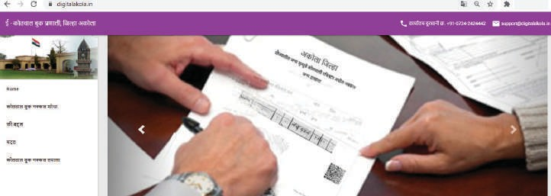

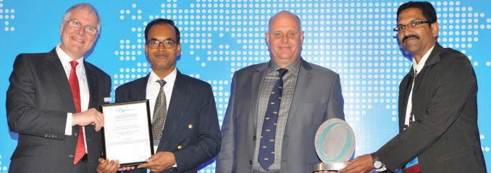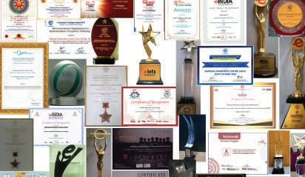

Trophies, citations and certificates recognising NIC, Akola

Shri Nitin V. Choudhari, DIO, NIC, Akola and Shri Prasad Ranade, receiving the Open Group Award for Innovation and Excellence 2018

###### Other Key Initiatives

During the situation of the global epidemic of COVID-19 virus NIC, Akola continued all its communication facilitation and technical support services uninterrupted full time all the days including holidays as per the need and requirement. NIC, Akola actively provided technical support and conducted nearly 200 Video Conferencing sessions, including the VIP VC sessions of Hon Prime Minister, Hon Shri Sanjay Dhotre, MOS for MeitY, and Hon Chief Minister, etc. NIC, Akola actively providing technical support for Covid-19 related applications including Aarogya Setu Application implementation and monitoring, Covid-19 Quarantine Alert System (CQAS), E-pass System, and Covid 19 Collection Centre Application.

###### Framework for e-Governance of fundamental resources Electricity, Water

We are getting items wise bills for grocery and other items purchased in the supermarket. We are getting call wise and usage wise bills for telephone and mobile. But for water and electricity, we are not getting billing as per the device wise utilization. Why? Basically, due to fact that digital unique identification and the digital accessing system do not exist for water and electricity devices and equipment.

Problem Statement

No digital record keeping and accessing system with digital UID (like IP address) with basic Attributes

(Name, Value, Type, Location,) exists for resources and items of water and electricity system (sources, devices, outlets, inlets, Channels, storage etc).

The billing is based only on the basis of the flow of resource (water, electricity) through the meter, and all the leakages, theft, unpaid unrecoverable bills are saddled on the consumers in hidden. Instead, consumers should know and pay for the exact utilization of the resource by the devices and equipment’s like TV, Refrigerator, AC, Washing Machine etc.

Solution: Brief Description

The initiative involves the framework for e-Gov- ernance of fundamental resources (Water, Electricity, etc) using:

1. Digital record-keeping with Digital UID (unique identification) address like IP and Digital UID loca- tion address (based on longitude and latitude) and
2. Digital accessing with IoT sensors, Actuators by using the emerging cognitive Technologies like IoT (Internet of Things), BIoT (Building Internet of Things), IoET (Internet of Every Thing), Software-De- fined Infrastructure(SDI), Wi-Fi 6, 5G, Edge Comput- ing, Fog Computing, GPS, AI, Data Analytics, Block- chain, etc.

This initiative is for the total remote management of water and electricity system with the ultimate aim to provide water and electricity bills with devise wise consumption similar to Telephone and Mobile. Devices, Equipment, and Components of water and electricity are expected to come with IoT inbuilt to control remotely

and measure its utilization. Online Resources at: https://akola.gov.in/national-informatic-center/

###### Awards and Accolades

NIC, Akola is bestowed with 21 Awards and Recognitions including the International Award of Open Group’s Award for “Online e-Mutation Implementation for District Akola“ and two South Asia level Awards of Manthan south Asia Pacific Award in 2014 and 2016-17. DIO and ADIO of NIC, Akola are honoured by Hon Chief Minister, Maharashtra for excellence in e-Governance. In the year 2020, NIC, Akola received three awards for the initiative “Framework for e-Governance of fundamental resources Electricity, Water” as below.

* NIC, Akola is the Winner of SKOCH “ORDER OF MERIT” and SKOCH Silver Award of Technology in SKOCH Awards 2020, in the 68th SKOCH Summit

virtually held on 30th November 2020

* NIC, Akola is the Winner of the Digital Technology Sabha Awards 2020, under the category Internet of Things (IoT). The Award is conferred on 26th

August 2020

* NIC, Akola is the winner of elets INDIA Transformation Award 2020. Award felicitated on

10th July 2020

###### Summary

Along with the smooth and agile communication facilitation, NIC, Akola executed an excellent role in the implementation of effective digital governance in the district Akola. NIC, Akola introduced and

Honouring with bouquet: The then Hon’ble CM (Maharashtra), Shri Devendra Fadanvis at Collector Office, Akola. Recognition to Shri Nitin V. Choudhari, DIO (Akola) along Shri Anil S. Chinchole, ADIO (Akola)

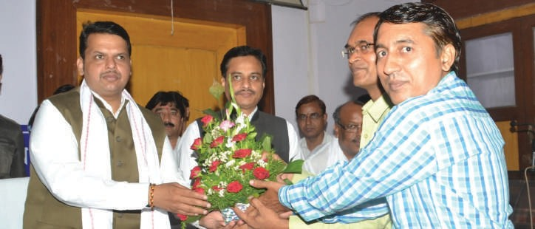

implemented major path-breaking innovative initiatives for the optimization of technical resources for improved service delivery, increased throughput, and increased efficiency and to provide cost- effective solutions for the concrete and effective e-Governance.

The active role of NIC, Akola helped District Administration in successfully conducting Election 2019; cope up with the Covid-19 pandemic situation, and implementing e-Governance in Akola district.

For further information, please contact:

**District Informatics Officer**

NIC Akola District Centre

Small Savings Building, Collector Office, Akola- 444001 MAHARASHTRA

Email: [dio-ako@nic.in,](mailto:dio-ako@nic.in) Phone: 0724-2435409

**Patna** District

### Combating Covid-19 pandemic situations with efficient ICT interventions and Management

Edited by **Dr. DIBAKAR RAY**

##### Patna became the first district to implement the e-Pass system of NIC in Bihar. With the application, a web portal was also created to enable citizens apply for e-Pass with much ease. The system

**has benefitted many who were stranded due to medical or other emergency reasons at various places in the District. In addition, Video Conferencing facility of National Informatics Centre is used by NIC-Patna to facilitated easy communication among various levels of Officials of the State Government during the pandemic period.**

###### Pankaj Kumar

Technical Director & DIO

[**pankaj.kumar@nic.in**](mailto:pankaj.kumar@nic.in)

**Ram Bhagawan Singh**

Scientist-C & ADIO

[**ram.bhagawan@nic.in**](mailto:ram.bhagawan@nic.in)

atna, also known as Patliputra is the capital of the state of Bihar in India. One of the oldest continuously inhabited places in the world, Patna was founded in **490**BC by the king of Magadha. It is located on the south bank of the river Ganga. Patna is the 21st fastest growing city in the world and the fifth fastest-growing city in India and is expected to grow at an average annual rate of **3.72**%. As of 2015, the GDP per capita of Patna is **₹1,06,000/-** and its

GDP growth rate is **7.29** percent.

P

NIC, District Centre, Patna along with the District Administration remain in forefront of the fight against the Covid-19 pandemic. District Administration has created an IT Cell at NIC for compilation of Data generated out of various activities undertaken by Government to tackle Covid-19 pandemic. NIC through Video Conferencing facilities has enabled continuation of communication across various levels of government while maintaining social distancing norms.

###### COVID-19 Cell Management System

This site hosted at Mini Cloud of NIC Bihar State Unit, was configured with VPN for remote updates. The portal facilitated consolidated Daily review by District Magistrate, Patna of Reports submitted by Covid-19 Cell In-charges.

###### COVID-19 Sahyog Portal

Person or families not having Ration Card but who otherwise are eligible for the same were given who are eligible for Ration Card, but they do not have for Ration Cards and also, they were granted one- time help of **₹1000/**- from the Government. Detail data of such person was collected by ‘Jeevika Didis’ and was entered at the portal - **https://aapda.bih.nic. in/fooddbt/.**

ICT Support was provided for collection of input details of **1,58,217** families at this portal and also for generating New Ration Cards using ePDS.

###### DM’s Regular Review Meetings

Under the leadership and guidance of the District Magistrate (DM), NIC Patna, has implemented all ICT activities to tackle Covid-19 Pandemic. District administration has also analyzed Data/ Reports generated through various systems to take appropriate, effective and timely action to control the pandemic and has set example for other Districts of Bihar.

###### e-Kamaan

e-Kamaan is a web-based software which was designed and developed by NIC District Centre, Patna for easy and secure management of selection, deployment and payment process related to Home Guards of Bihar. The software interacts with

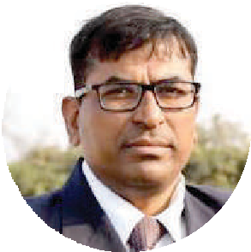

**During the COVID-19 pandemic**

**containment many restrictions existed including physical contacts, maintaining of social distancing, many new IT solutions were initiated in the district. One of the most important was the e-Pass system for the stranded persons across the district. Patna was the first district to launch this in the state of Bihar. A web portal and IT application were also created in which citizens could apply to the e-Pass system with much ease. A large number of citizens have been benefitted from this initiative. Later on, it was extended to all districts of Bihar which helped the people who were stranded and had to travel due to medical or other emergency reasons.**

**Besides, the NIC Patna has helped in communicating with the field offices and also with the State level offices using video conferencing facility of National Informatics Centre for which the NIC officers has worked and rendered support throughout day and night throughout the lockdown period.**

**KUMAR RAVI,** IAS

Former District Magistrate, Patna Government of Bihar

present manual system and converts it completely into automated system. e-Kamaan is being used by the district commandant offices for compiling online roster register based on missed call, for duty allotment of home guards by randomized kamaan generation, for providing up to-date payments information reporting and for online grievance

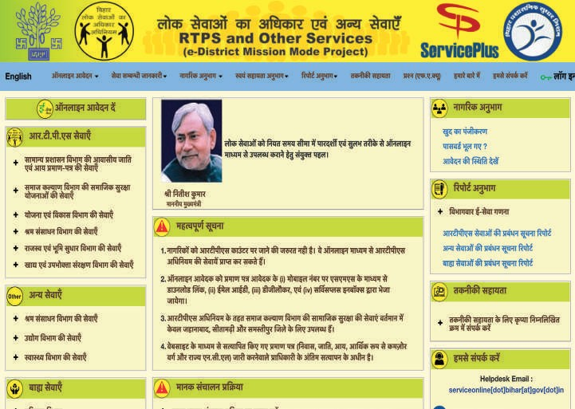

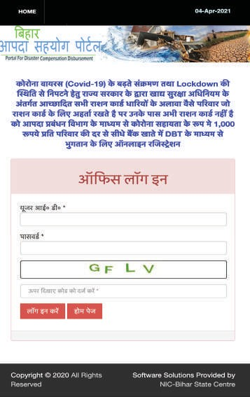ServicePlus portal for RTPS and Other Servies (e-District Mission Mode Project) of Bihar

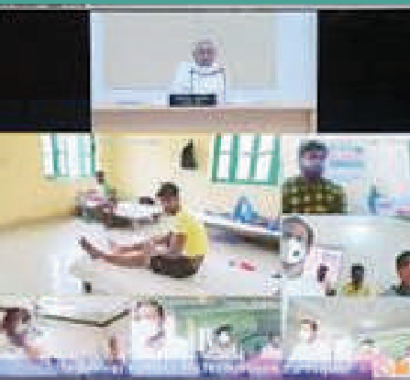

Hon’ble Chief Minister of Bihar interacts with inmates of Quarantine Centres through VC, facilitated by NIC

DM’s review meeting in progress (file photo)

redressal etc. This system will also provide a Head Quarter module for generating different types of district-wise MIS reports related to home guards.

**Aapda Sampoorti (Corona Sahayata)**

[**http://aapda.bih.nic.in/coronasahayata**](http://aapda.bih.nic.in/coronasahayata)

A one-time help of **₹1000/-** were provided to the family of Bihari Mazdoor who were stranded in different States. A mobile App was developed which allows the beneficiary to submit his selfie photo with location coordinates, Aadhaar Number, and Bank Account Number at Bihar against his name. In Patna District, **64584** applications were received and **56032** applications approved for payments. It was the first initiative of its kind and helped the residents of Bihar who were stranded in other states. Later, similar initiatives have been replicated in other states too.

**e-Pass (Service Online for Covid-19)**

**https://serviceonline.bihar.gov.in**

NIC, Patna was actively involved in the process of Issuance of e-Pass during COVID-19 pandemic on

ServicePlus web portal (**https://serviceonline.bihar. gov. in**). The passes were meant for the movement of vehicles and persons during the lockdown within and outside the State.

e-Pass Application Software has undergone various changes to reflect change in criteria and rules of issuance of e-Pass based on the changed in prevailing guideline issued by State and District Authorities time to time.

As on December 2020, **38,073** applications for e-Pass were received, out of which **4161** have been approved, **23589** rejected and **10323** were pending.

###### Summary

An unprecedented situation like COVID-19 Pandemic has been tackled successfully by the district administration with ICT support provided by NIC District Centre Patna. With change in pandemic situation, under leadership of the current District Magistrate Dr. Chandrashekhar Singh, IAS, NIC Patna has started working on new domains in addition to other regular eGovernance initiatives of the District. Recently NIC Patna District Centre has developed a Mobile application for responsive administration with social media platform under Digital Governance Mobile Challenge. Initiatives have also been taken for user friendly applications to maintain Law and Order roster duty for the capital.

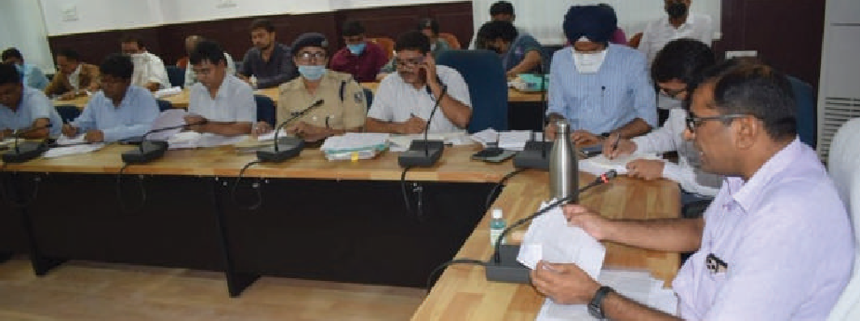For further information, please contact:

**District Informatics Officer**

NIC Patna District Centre, Collectorate Hindi Bhawan, Chajju Bagh, Patna - 800001 BIHAR

Email: [dio-ptn@nic.in,](mailto:dio-ptn@nic.in) Phone: 0612-2227545

# Indian Customs EDI Systems

### Taking Ease of Doing Business to greater heights

Edited by **MOHAN DAS VISWAM**

##### A significant step was taken in the year 2009, to transform the then existing ICES Application to a uniform and centralized software

**which culminated successfully with the launch of ICES 1.5. Thus the**

**de-centralized application gave way to a robust central server based application. The many features**

**of this application include single sign-on and central management of sites/ users by the National System Manager, Consolidation of Data for National Level MIS,**

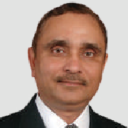**Centralized Directory Management, License and Bond Management and standardized procedures across the country.**

###### Naresh Kumar Sharma

Sr. Technical Director & HoD

[**nksharma@nic.in**](mailto:nksharma@nic.in)

**Jaswinder Singh Sachdeva**

Sr. Technical Director

[**jaswin@nic.in**](mailto:jaswin@nic.in)

**K.V. Sai Prasad**

Scientist-D

[**sai@nic.in**](mailto:sai@nic.in)

he Indian Customs EDI Systems (ICES), a flagship application of NIC, was launched in the year 1995. This was a major initiative in

the field of International Trade. It heralded a new era of Transparent and Paperless trade. The core functionality of the Indian Customs procedures has been fully automated through ICES. From a single location in 1995, the umbrella of ICES now covers more than 250 locations across the country. ICES aims to

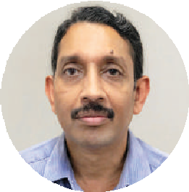

**Customs Duty comprised around 27**

**percent of total revenue receipt of our country. ICES facilitates the duty collection with daily collection of around INR 1500 crores. It has been integrated with PFMS in a major boost to expeditious disbursal of Drawback to exporters thus enhancing Ease of Doing Business. It has also incorporated a Faceless/ Paperless and Contactless Appraisal system which has introduced high standards of transparency and at the same time reduced time and cost. ICES goes a long way in achieving the Govt.’s goals of “Ease of Doing Business” and “Digital India”.**

**NAGESH SHASTRI**

Deputy Director General National Informatics Centre

T

##### Become the support pillars of our economy

There are two vital pillars of International Trade of any country. These are Export and Import of commodities.

ICES comprises of two main sub systems namely, Indian Customs EDI system/ Imports (ICES/I) and Indian Customs EDI System/ Export (ICES/E).

##### Promote Ease of Doing Business

Prompt response to the needs of the trade is an important part of the overall process of Computerization of Customs related functionalities and procedures. At the same time, taking into account the requirement of transparency in working, Customs officers at various levels were made accountable for their actions through a tracking mechanism.

##### Minimize personal interaction

Minimum personal contact of Trade with Customs officers and various Government agencies like DGFT, EPCs, Ports, Airport Authority of India and Banks has been achieved with a robust message exchange mechanism among various stakeholders. It is a significant step towards a graft free business and faster clearances.

##### Provide a holistic view

To provide the mechanism for retrieval of consolidated information from various Custom locations and to make useful policy related

Indian Customs EDI system Website

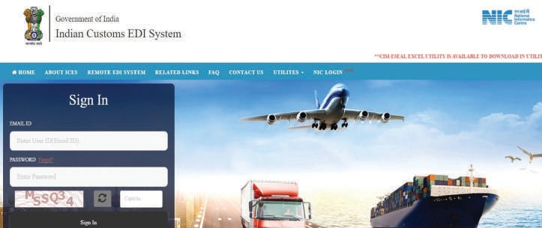

Read/Write Access

Read/Write Access

Service Centre

ICEGATE

ICES Primary

Directory Read Access

Directory Read Access

Directory Read Access

Read/Write Access

DRA

Centralised Directory Management

Centralised Directory Server

Risk Management Server

Architecture



economic decisions, nationally and to share critical information with various agencies associated with Export and Import Statistics and Investigations.

##### Facilitate filing of documents from the comfort of one’s premises

The Exporters, Importers and Custom House Agents (CHAs) can also submit Bills of Entry, Shipping Bills and other related documents through the Remote EDI Software (RES),which is a standalone

customs clearance

* Electronic exchange of information with the trading partners like Ports, DGFT, Airlines, Shipping Lines/ Shipping Agents, Custom House Agents/



Importers/ Exporters, Banks, CFS Operators, DGCIS, RBI etc.



* System calculation of import duties, export incentive –drawback, duty foregone due to export incentives etc. and digital payments



A major exercise was initiated in 2009 to migrate

Role Management

License

software package developed by NIC.

##### Features of the Product

###### The Pioneering version of ICES

•

Developed by re-engineering the core processes in Indian Customs

* + Introduced paper-less work flow and automated

the then existing de-centralized version of the ICES Application to a Uniform Centralized software which culminated successfully with the launch of ICES 1.5 or Central Server based application.

###### The Advantages of upgrade to ICES 1.5

•

Single sign-on and central management of sites/ users by National System Manager

ICES/Import

Directories



Service Centre

ICES/Export

Hon’ble Union Minister of State for Finance, Shri Anurag Thakur, felicitating the Shri S. B. Singh, DDG for the achievements of ICES

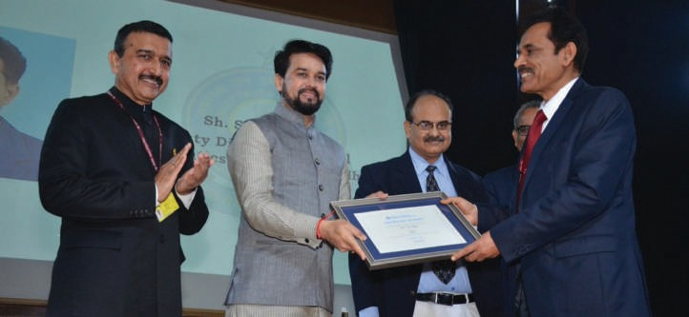

* Consolidation of Data for National Level MIS
* Centralized Directory Management
* Centralized License and Bond Management
* Standardized procedures across the country

##### Technical Specifications

The ICES application has been developed with Oracle as the backend database. The initial version of Oracle 3.0 graduated with new releases with the current application running on Oracle 12c. The initial Front end was a mix of Forms/ Reports as part of the Developer Suite, but keeping pace with the emerging technology, Open Source tools such as Java with Spring/ Struts Framework, are being used now for all the requirements.

##### Advent of Mobile Technology in ICES

The iOS mobile app for QR Code reader and verification has been developed and deployed in the App store. The ICETAB android app for Tab based devices was developed by NIC, with features of Uploading of Examination Report along with photos to ICES. The ICETRACK application facilitating tracking of documents , duty calculator, scanning of QR code mentioned on the final documents and GSTIN Enquiry has also been developed by NIC.

##### Benefits

In terms of Daily statistics, around INR 1500 crores of Customs Duty is collected, around INR 100 crores of Drawback payment is made and more than 50,000 documents are filed. This all is facilitated by the ICES Application of NIC. It is a matter of great pride that 27 percent of total revenue receipt of India is earned by the Customs Duty only.

###### Major Benefits of Trade friendly measures to Exporters/ Importers

•

Automatic refund of GST for EDI sites based on RMS instructions has been implemented. As a major boost to expeditious disbursal of Drawback, the integration of ICES with PFMS was also initiated. A Touch screen based module has been provided for enquiry of the Document’s current status for trade. Physical printout to QR Code based digitally signed verifiable Clearance Orders of LEO and OOC made ICES a Trade’s favourite. The new GST regime in ICES rolled out smoothly on 01-Jul-2017, as per schedule.



Document submission by Importers

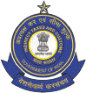

**INDIAN CUSTOMS**

FSSAI

Food Safety Standards Authority of India



CDSCO

Drug Controller



AQCS

Animal Quarantine

Trader or Agent submits all information required for shipment once to the Single Window Service provider

**SINGLE WINDOW**

Select, sort, ﬁlter information, routes it to targeted recipients (agencies, bank etc.)

in the proper sequence or ﬂow and return responses to Trader

**SWIFT**

Participating Government Agencies (PGAs)

e-clearance of goods

Textile Committee



WCCB

Wild Life Crime Control Bureau

Plant

DPPQ&S

Department of Plant Protection, Quarantine and Storage

Quarantine

Animal

Quarantine

Bank

**Future Roadmap**

* + To develop Conversational chatbots with backend RESTAPI connectivity
  + Predictive analysis of Export and Import trends at various ports
  + Using machine learning algorithms and python packages

Ease of Doing Business



Responses from the various authorities and ﬁnancial institutes are retured to the Trader or Agent. An all positive ﬁnal response denotes cargo clearance

Single Window for Indian Customs

Customs

Chambers of

Commerce

Tabacco Board

Insurance

Company

* + Using Natural Language processing techniques for automatic generation of SQL scripts from statistical tables

1. Becomes highest ranked economy in South Aisa
2. Improvement in 6 to 10 parameters
3. Among top-10 improvers for second consecutive year
4. Also in top 10 for protecting minority investors
5. Leaves Bhutan (81) behind this year
6. India reduced the time and cost to export & import through various initiatives

Implementation of electronic sealing of containers

Allowing electronic document submission with digital Signatures

Upgrading of port infrastructure

Jump- 23 places

Rank-77

EASE OF DOING BUSINESS - INDIA (2019)

* + Use of blockchain technology for exchange License details with DGFT
  + Dynamic reports - User should have option for selecting the output columns and input parameters

For further information, please contact:

**Naresh Kumar Sharma**

STD & HOD (Customs Division)

Room No. 301, 3rd Floor, A1B4, NIC Hq NEW DELHI – 110003

Email: [nksharma@nic.in,](mailto:nksharma@nic.in) Phone: 011-24305292

**Integrated ShalaDarpan**

### Decision Support System for Schools Monitoring & Management

Edited by **SARBJEET SINGH**

##### ShalaDarpan is a unique idea to provide an end-to-end solution to the Education department for effective monitoring and management of all Government Schools. System facilitates decision support, Planning (School Open/ Upgrade/ Merge/ Close), School operations (Admissions, Promotions,

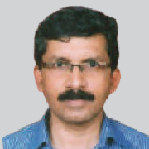**and Results) along with Staff Management (Recruitment, Posting, and Relieving) and proper implementation of Beneficiary Schemes.**

###### Tarun Toshniwal

Dy. Director General & SIO

[**tarun.**](mailto:tarun.toshniwal@nic.in)[**toshniwal@nic.in**](mailto:toshniwal@nic.in)

**Vinod Kumar Jain**

Sr. Technical Director

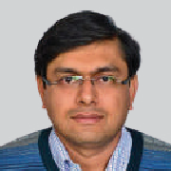[**vinod.**](mailto:vinod.jain@nic.in)[**jain@nic.in**](mailto:jain@nic.in)

**Animesh Pant**

Scientist - C

[**animesh.pant@nic.in**](mailto:animesh.pant@nic.in)

**Rajendra Singh Bidawat**

Scientist - B

[**rs.bidawat@nic.in**](mailto:rs.bidawat@nic.in)

halaDarpan is an excellent system developed for the Education Department, Rajasthan, covering online records of all students, teachers

and staff of government schools. System is used by students, teachers, staff and higher managements for their day to day working. System reaches up to village level for the services like daily attendance, Staff selection, Joining/ Relieving of staff, Class wise academic records, Result preparations, School Infrastructure status and Enrollment status in about 65,000+ government schools of Rajasthan. It is also being used as a real time system for state level Planning, Decision support and schemes/ programs implementation. System covers online information of 80+ Lakhs Students, 4.6+ Lakhs Teachers/ Staff details of all types of Government Schools in the state.

S

ShalaDarpan is widely appreciated by various state governments as well as the Secretary MHRD, Government of India - most critically because of its ability to largely eradicate offline data processes and redundancy in data collection efforts. 20+ states visited Rajasthan to study the System. ShalaDarpan has received many national/ State level awards, viz. CSI SIG e-Governance Award-2019, State e-Governance Award-2018 and SKOCH Order-of-Merit Certificate-2018.

##### About

The focus of designing the system is “What Government Needs”. Agile development and implementation was carried out in a phased database-to-decision approach wherein all critical databases related to students, staff and schools were built and reports were designed and released to take data-driven decisions. Looking at the impact of Integrated ShalaDarpan in terms of availability of data, prevention of data redundancy, sharp and swift two-way communication across the state education machinery, and coverage of almost all the areas of School’s Management, the system has become a vital need for district/ state level offices.

This centralized data supports the department to face significant challenges such as pupil-teacher ratio, absenteeism, vacancies, low enrollment, inadequate infrastructure, budget requirements etc. School, district and state staff have become more accountable because it is extremely simple to figure out the bottleneck in any implementation.

Analytical reports are available at schools using which lists of possible dropout children are seen so that schools can take necessary action to retain the children in mainstream thus minimizing the dropout numbers. In short, ShalaDarpan has now become a unique, centralized tool integral to the Education Department which is steadily driving Rajasthan

towards the Digital Age.

##### Salient Features

* Bilingual, workflow based user friendly system
* Covers all government Schools under various managements such as the School Education department, Sanskrit education, Social justice, Madarsa, TADA schools etc.
* Transactional information of Staff/ Students maintained
* Availability of Dashboard for every school
* Reliable tool for department to quickly fetch the information for Assembly/ Court/ RTI queries
* Staffing pattern generation based on School Category/ Enrolment etc.
* Live vacancies against the Sanctioned Post and their posting through Counselling Process
* Daily attendance of Staff & Leave Management
* Communication (Web/ SMS/ Email) from Hq. to School/ Staff on various events
* Schools linked through Help & Support Module for their day to day issues
* Result Preparation, Sessional Marks Calculation, Green Sheet & Mark sheet Printing
* Work Progress/ Monitoring Reports
* Used for all beneficiary services viz. Scholarship, Free Textbook distribution, Laptops, Cycle distribution, Transport voucher etc.
* Developed using UDISE code which is a standard for School Education sector to help develop full- fledged customizable product for use by any state
* NIC Chat Intelligence (NICCI) Chatbot for users assistance

##### Technologies Used

Languages & Technology: Asp.Net/C#, JQuery, Bootstrap Design Pattern

RDBMS: SQL Server 2019 and Non Relational DB- Mongo for document storing

##### Important Integration

* Aadhaar
* Jan Aadhaar
* eGRAS Payment Gateway
* SMS and email relay services
* About 80,000+ eMitra Kiosks
* Jan Soochna Portal

###### eGov Products & Services

STUDENT

Admission

SCHOOL/ STAFF

Open/ Close/ Merge

STAFF WINDOW

Proﬁle View & Update

BENEFICIARY SCHEMES

Scholarship:

ACADEMIC PERFORMANCE

Class 1-5 - SIQE,

CITIZEN WINDOW

Talk to Teacher

SCHOOL MANAGEMENT

Staff Selection and

(New/ Transfer)

School

Apply & Track

SA Wise

Posting Posting

Proﬁle Infrastructure

Apply & Track for :

Mark-Sheet

Study Material

through Counseling

Detail Proﬁle

& Facilities

ACP, Pay Fixation,

Cycle/

(eBooks, PDF &

KGBV Hostels

Foreign Tour,

Laptop

Class 6, 7, 9 & 11 -

Section Allotment/ Update

Faculty / Subject

SMC & SDMC Details

Funds Receipt/Expenditure

Teacher Award, Selection Interviews, Transfer, Leave etc.

Distribution

Free Text Book/

Term wise Marks Entry, Green-Sheet

Videos Tutorials)

NAS Preparation Material

Vocational Education

Mapping

Work Book

Preparation and

Budget Demand &

Faculty/Subject/Third

Report Grievance &

Distribution

Mark-Sheet

SMILE (Teaching

Transfer Teacher

Roll No. Allotment

Language

Sanction/Working

Track

Search Staff /

Transport Voucher

Teacher Result through WhatsApp)

Trainee’ Internship

School Star Rating

SR Register

Posts

Student /

Distribution

Mapping

Question

based on Result Info

Transfer Certiﬁcate /

Staff Joining, Reliving

Schools

Class 8, 10 & 12 -

Bank

NSO

NSO Student

& Exit

Staff Proﬁle Update/

Approval

Vacancy in Schools

NMMS

(Merit Cum Means)

Gargi / Balika

Termwise Marks Entry, Sessional Marks and Board

School Search

Online MPR

Monthly Block/ District Ranking

Re-Admission

Class/Subject Teacher

TAF-Teacher

Protshahan

Result Mapping

Eligible

Attendance OoSC &

mapping

Staff Attendance & Leave Approval

Appraisal

Manyta

Award

Mukhyamantri

Result Outcome/ Analytical Reports

Schemes

View Results

Board Exam Form Filling

5th & 8Th Board

Inspection Humari Beti

Mainstreaming

Remedial Classes

PTM, School Safety

Dash Board, View

Yojana

FAQ’s and User

Result Rules &

FAQs

Submit Suggestions

Exam-ERP

Help Centre Support

Circular/Orders

Manual

Mid Day

-Data Updation,

Character Certiﬁcate

Various Schedules

Meal

View Reports

Resolution of issues

ICT in Schools

receive from Schools

Study Certiﬁcate

Vidhyarthi Durghatana Bima

Addl. Responsibility Mapping

Anganwari (Pre

Primary) Integration

Dynamic Website Alumni Details

Work Arrangement and Deputation

Civil Inspection

School

Visit/Inspection

online, Unlock Modules, Password Support, etc.

## Integrated ShalaDarpan

**Core Module**

##### Important Initiatives



**GyanSankalp:** Online platform to mobilize CSR funding, donations and voluntary contributions for the development of Government Schools by displaying infrastructure & other gaps based on

the data available in ShalaDarpan. For the ease of decision making, various pre-packaged donation options made available for citizens. Funds are being transferred in SMC/ SDMC account online through payment gateway. Physical & Financial Progress are

being also monitored to display to the Donor, along with final UC. Donor may propose/ create a project to support any number of selected schools. Funds are directly transferred into school’s bank account, received under Donate to a school category.

##### Deployment Architecture



**SD Services**



**Internet/ Web**

**WAF/ Firewall**

**For Reporting**

**LOAD BALANCER**

**App Server 1 App Server 2 App Server 3 App Server 4 App Server 5**

**Write**

**Read**

**Replication**

**PRIMARY DB**

**SECONDARY DB**

**Replication**

**Replication**

**BACKUP SERVER**

**REPORTING SERVER**

**API GATEWAY**



**SD Portal**



**Staff Joining/ Relieving:** New and existing staff may only join or be relieved from school if processed for various options like transfer, promotion, APO, suspension, deputation, retirement etc. Joining feature is broadened by incorporating it.

**School Allotment for Internship:** Module helps Teacher Trainee with filling choices filling and school allotment for Internship, which is required for various courses Diploma in Elementary Education (D. El. Ed), Bachelor of Education (B. Ed) etc.

**Automated Scholarship:** Module for end-to- end solution from application to disbursement of Scholarship and based on eligibility criteria, Incharge select/ apply students for 11 types of Pre-Matric Scholarship using existing Student’s data along with



**SD Mobile App**



various certificates needed for the allotment process. Scholarship amounts are transferred directly to the beneficiary’s bank account, linked with Student’s JanAadhaar. School/ Student may also track their Application status and payment disbursal.

**Star Rating & District Ranking:** Every school is provided Star rating using 8th, 10th & 12th Board results annually. Block/ District wise monthly rank is generated automatically on a certain cutoff date using 42 parameters data of the Portal. One can view any month Ranking report, drilled down to School level details.

**Staff Selection & District Allotment:** Under this workflow based module, selected candidates info is processed for Merit/ Selection list.District/ division

allotment is executed based on state reservation policy and choices filed by the candidate.

**5th/ 8th Board Automation:** End to end solution for exam related activities starting from Form Filling to Result Publication including Exam Centre Setup, Roll No. Allotment, Admit Card, Result data Capturing, Result Preparation, Mark Sheet printing etc. through all 33 DIET (District Institute of Education and Training) centers.

**Shala Samvad:** Unique tool designed to cater to the needs of students & Parents, helping them to provide info captured through ShalaDarpan like profile, Class/ Subject teacher details, exam result, applied scheme status etc. Feature is also provided to access NCERT (National Council of Educational Research and Training) Books, eContent, Video Lectures, Question Bank etc. Students may also ask any academic doubts and area wise subject teachers reply online.

##### Impact

* Collection and automation process of information reduced multiple entry, redundancy and duplication of data

•

Ensure Subject Teachers availability through rationalization of staff. Long Pending promotion process completed

•

By identifying actual beneficiaries for various schemes like “Transport Voucher”, “Free Text Book” “Laptop/ Cycle” etc. through ShalaDarpan, saving lot of government funds

•

Staff window under ShalaDarpan provided relief to staff by providing online 24x7 channel to apply for various services which has created a positive environment among staff

•

Save lot of money and manpower with quick redressal of issues by simplifying various activities through online processes

•

Automation of various processes through ShalaDarpan saves lots in paper printing.

##### Way forward

* Seniority List for Staff of School Education department
* Mobile Apps for School/ Office Users
* Teacher Diary, Time Table
* Staff Vigilance
* Co-curricular Activities Monitoring
* Online Transfer System
* Pay Fixation and Service Verification
* HRMIS with Pension Kulak
* Online Fund Transfer and Civil Works Monitoring
* Online Training Monitoring and Management
* PAB Plan Preparation, Execution and Monitoring

For further information, please contact:

**State Informatics Officer**

NIC Rajasthan State Centre

8318, NW Block, Govt. Secretariat, C-Scheme, Jaipur- 302006 Rajasthan

Email: [sioraj@nic.in,](mailto:sioraj@nic.in) Phone: 0141-2227992

## Prayas

### Pursuing Excellence in Governance

Edited by **MOHAN DAS VISWAM**

##### Prayas provides powerful visualizations, robust analytics and actionable insights to enable Government to align well with key policy makers and program executioners. This platform

**with consolidated view of 100+ schemes and 600+ KPIs paves the path for better Governance. The platform today visualizes the progress status of more than 100 schemes including PM Ayushman Bharat-Jan Arogya Yojana, Atal Pension Yojana, Jal Jeevan Mission, MGNREGA, PM Gram Sadak Yojana, PM Fasal**

**Bima Yojana, PM Awas Yojana, PM Jan Dhan Yojana, Swachch Bharat Mission etc. through 600+ KPIs and 1800+ Visualizations.**

###### P. K. Mittal

Managing Director- NICSI (Scientist-G) [**pk.mittal@nic.in**](mailto:pk.mittal@nic.in)

###### Anjali Dhingra

General Manager- NICSI (Scientist-F) [**anjali.**](mailto:anjali.d@nic.in)[**d@nic.in**](mailto:d@nic.in)

###### Ashutosh P. Maurya

Dy. General Manager (Scientist-E) [**ap**](mailto:ap.maurya@nic.in)[**.maurya@nic.in**](mailto:.maurya@nic.in)

overnment has launched numerous citizen centric initiatives/ schemes across the country for the benefit of the people. Hence,

to ensure adequate Governance on scheme implementation progress and reach, the need was felt by Government to monitor their progress comprehensively. Thus, **Prayas Platform** was built to fulfill these requirements.

G

**Prayas** has so far enabled to visualize the progress status of more than **100** schemes including PM Ayushman Bharat - Jan Arogya Yojana, Atal Pension Yojana, Jal Jeevan Mission, MGNERGA, PM Gram Sadak Yojana, PM Fasal Bima Yojana, PM Awas Yojana, PM Jan Dhan Yojana, Swachch Bharat Mission etc. through **600+** KPIs and **1800+** Visualizations in the form of graphs, maps, charts, time series etc. These schemes are being implemented by **54** Ministries and Departments across **7** Sectors namely Agriculture and Rural, Finance and Economy, Foreign and Security, Human Resources, Infrastructure and Resources, Social and Welfare, Technology and Governance.

Through this initiative, Apex Offices like PMO can connect with concerned Ministries and Departments in a better manner and jointly identify areas for further improvement thereby promoting culture of collaboration and accountability within the Government, and making Government more productive, effective and efficient.

The core features of the platform include real time performance management with identification of leaders and laggards States/ UTs and comparative dashboard to undertake inter- relation studies to ascertain correlations between multiple schemes for example increase in skilled resources in a state should lead to drop in enrollments of unskilled workers under MGNREGA (Mahatma Gandhi National Rural Employment Guarantee Act).

##### Objectives

* + To provide a holistic view of flagship programs and schemes for monitoring implementation and reach through critical KPIs
  + To analyze schemes/ programs and generate insights for faster decision making
  + To compare progress and facilitate study of inter-relations among schemes
  + To build a secure platform with authentic, consistent and regularly updated data
  + To create awareness among concerned authorities about the progress of their schemes with respect to other regions



**7**

**Sectors**

**54**

**Ministries & Departments**

**100+**

**Schemes**

**600+ 1800+ 300+**

**KPIs Visualizations Govt. Oﬃcers**

**Onboarded**

Platform Stats

##### Salient Features

* Transfer of data from source MIS to **Prayas** through APIs to ensure Data authenticity and maintain single source of truth across stakeholders
* Facility to electronically consume data (API based) on daily basis or as per data periodicity for minimal or no data mismatch between source system and Prayas platform
* Data-due Alerts, to ensure that data is timely pushed to the platform
* Data Quality system comprising of in-built intelligence to assess data anomalies such as unusual spikes, dips, null values, etc. and sends auto-alerts to nodal officers for verification
* Provides easy inclusion & deletion of new schemes, features and functionalities, thus ensuring incremental development with ease
* Enables quick analysis by exhibiting critical KPIs of schemes on the home page along with growth status
* Facilitates easy and quick navigation through multiple layers up to available data granularity
* Secured platform through role-based access and login only through existing Government Email IDs with LDAP authentication



Selection of Schemes

Finalization of KPIs and Data Team

Interface with Prayas Data Collection Team

Data Push to Prayas Data Collection Portal

Data Transformation in Prayas

Development of Visualization-Graphs, Maps etc.

Testing, Incorporation of Feedback & Modifications

Availability over Production

**Ministry/ Departments**

**Prayas**

**Data Collection Team**

**Prayas Data Visualization and Testing Team**

**Visualizations**

* + Provides **overview of scheme progress**, presentation of top performers and laggards at State/ District level
  + Provisions **map view** to build in visual aid and comprehend the situation on ground across the country in a better manner
  + Displays **time-series view of data** to allow assessment of the progress of various schemes over a period viz. yearly, quarterly, monthly, etc., provides opportunity to analyze growth as per selected time period
  + Enables **drill-down of schemes** with a multitude of analytical visualizations including graphs, charts, quadrant analysis, exploratory analysis, and other representative tableaus for representing and quickly analyzing data
  + **Single view glance** of schemes and programs being implemented across Ministries and Departments
  + Well aided with consistent visuals to enable administrative officers to identify root cause of problems, take decisions and ensure timely measures for ongoing schemes
  + **Sector-wise schemes view** to identify schemes across sectors such as Social and Welfare, Finance & Economy, Technology and Governance
  + **Department-wise scheme view** to allow users to select the specific Ministry such as Finance and view schemes such as PM Mudra Yojana, PM Suraksha Bima Yojana, Stand Up India, Sukanya Samriddhi Yojana etc.

##### Thematic Dashboards

Ensure that system has the capability to view the performance of schemes at a holistic level and at the same time the focus on specific zones and sectors is not lost. So far, thematic dashboards have been built in the following areas:

* + Insurance – Presents schemes providing insurance benefits namely Ayushman Bharat PM Jan Arogya Yojana, PM Jeevan Jyoti

Process for onboarding new Scheme on Prayas

24 informatics.nic.in

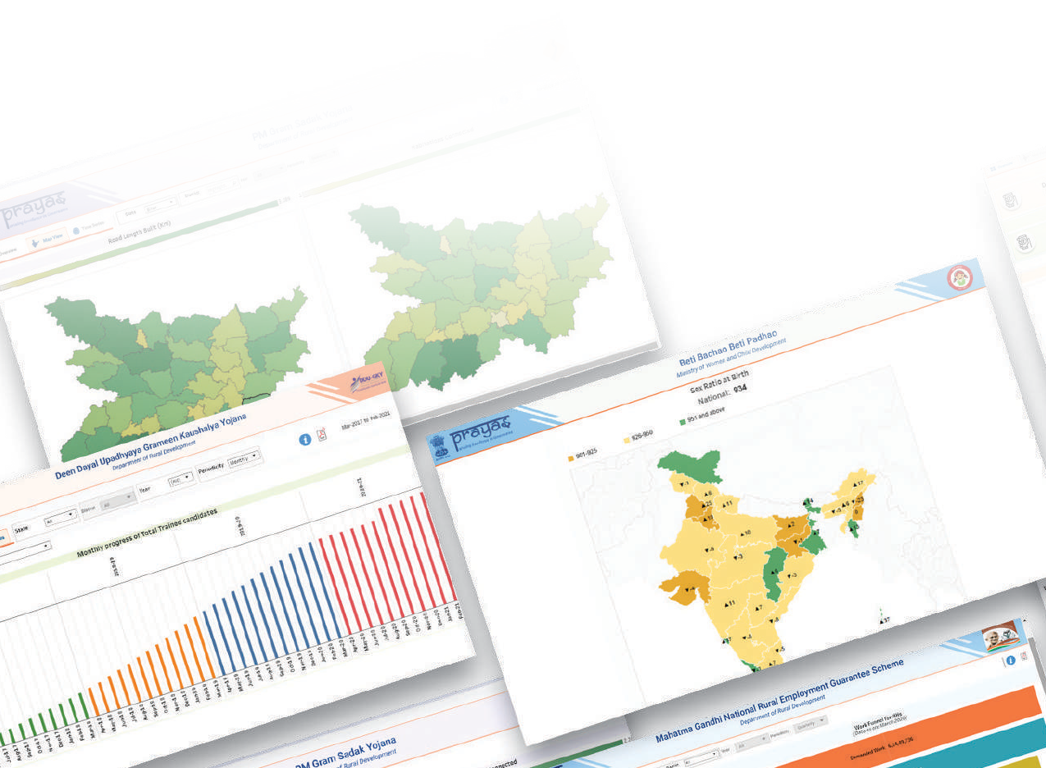

**April 2021**



**Aspirational Districts**

**Union Territories**

**Insurance Schemes**

**North Eastern Regions**

**Comparative Dashboards**

Thematic Dashboards

Bima Yojana and PM Suraksha Bima Yojana irrespective of Ministry and Department thus providing holistic view of people being covered through these schemes

* + North Eastern Region – Provides view of status of scheme implementation in NE States
  + Union Territories - Focuses on the progress of schemes in Union Territories
  + Aspirational Districts - Helps users to assess the schemes/ programs performance with a focus on aspirational districts within the State/ UT

##### Multi-Dimensional Comparative Dashboards

* + Provides option to **select multiple dimensions** such as schemes, KPIs and States/ UTs in unison. This helps to understand the correlation among various schemes and their comparative performance. For eg., this could help ascertain impact of opening of **Health and Wellness Centre** on **PM Jan Aarogya Yojana**, as with primary care growing it is expected that dependency on tertiary care would reduce
  + Enables **comparative assessment** of multiple schemes across Districts in the State. This helps to gain insights such as districts

leading for multiple schemes in the State, consistent growth or sudden spike etc. With this information administrators would be able to identify lead districts and assimilate best practices/ innovative solutions and possibly share these learnings with laggard districts

##### Approach Adopted to Build the Platform

Data Analytics Platform underlying **Prayas** has three components:

In the **first component** the **Data Collection for identified Schemes/ Programs** is performed for outcome/ target oriented Key Performance Indicators (KPIs) electronically using API based technologies along with pre-defined granularity, periodicity, and tenure of data availability from Ministries and Departments through our Prayas Data collection portal. Once data is received the **second component** caters to **Data Processing and Analytics**. Here, data is processed to generate visuals including graphs, time-series data etc. to identify actionable insights.

Finally, the **third component** presents the **Dashboard/ Visualization layer** with comprehensive views across Sectors, Ministries & Departments, Thematic Dashboards etc. created for users.

Prayas is a data driven framework that enables government to visualize progress of its flagship schemes on a single platform and monitor their progress basis Key Performance Indicators (KPIs). Prayas electronically captures aggregated anonymous data from IT systems of Schemes in a predefined format at an agreed frequency and granularity through a secure bridge, thus maintaining a single source of truth.

**Prayas also helps to assess implementation and reach of different schemes against on a variety of dimensions, such as Sector, Department, State, District, Region as well as on a time scale and get actionable insights.**

**Dr. NEETA VERMA**

Director General National Informatics Centre

**April 2021**

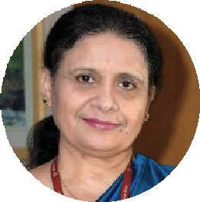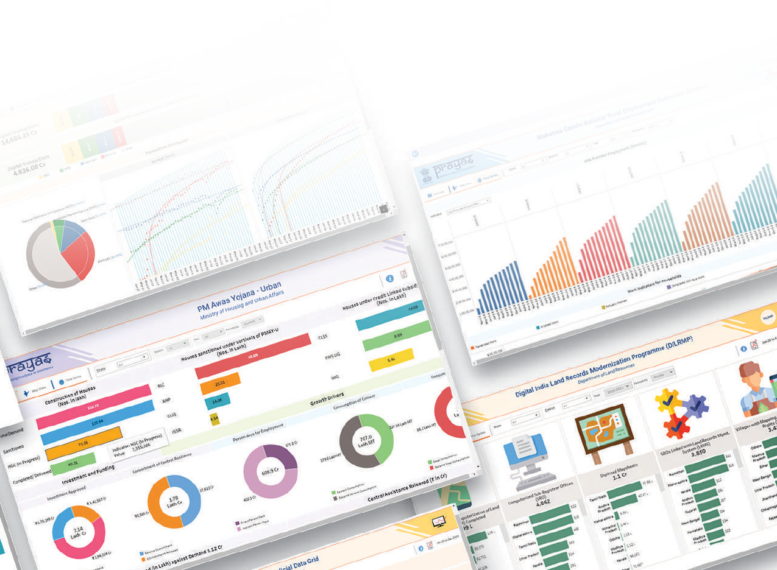

**informatics.nic.in 25**



Sector wise scheme view

Ministry wise scheme view

Thematic Dashboards

Multi-Dimensional Comparative Dashboards

**System Features**

Role-based Access

**Analytics Platform (Data Processing)**

Overview

Graphs

Time Series

Actionable Insights

Visuals, Maps

Real-time Analysis

**Ministries and Departments**

Electronic Data Transfer

**Identify Sources (Data Collection)**

**Launch**

**Status Input**

Data Security

Schemes with implementation focus at

National Level

State/ District Level

Block/ Village Level

Data Availability

KPIs

Target Oriented

Granularity Periodicity Av Data

ailability

Data Quality

Prayas Dashboard: Components View



Policy Makers

Implementing Agencies

Beneﬁciaries (Citizens)

Benefiting Stakeholders

##### Benefits to Stakeholders

* + - **Prayas** empowers policy makers to analyze per- formance of schemes for better financial planning and structuring of future schemes

•

Undertake inter-relation & comparative study of the schemes across States/ Union Territories and derive insights

•

Enables implementation agencies to monitor progress of Schemes/ Programs across the Coun- try till last mile, through comparative view identify better performing Regions/ States/ Union Territo- ries, share success stories and best practices Benefit citizens with timely implementation of schemes and access to intended benefits till last mile

•

##### Way Forward

**Prayas** has been built with a vision – to provide an integrated and consistent view of the performance of Government Programs/ Schemes. It helps to monitor the progress of scheme implementation and track that benefits reach till the remotest part of the country. Assimilated learnings and insights

facilitate in planning for future initiatives and programs. More importantly, this platform is pre- configured hence the States can readily use this platform to onboard their state specific flagship programs/ schemes and KPIs in minimal time for reviewing their progress till district/ sub-district level. The platform supports automated detection of exceptions in trends of incoming data such as sudden rise of **200%** in person days generated under MGNREGA in the State or sudden drop of people visiting Health and Wellness Centre. **Prayas** is designed to cater to the data-driven governance and outcomes would get enriched over time.

For further information, please contact:

**Anjali Dhingra**

HoD, Centre of Excellence for Data Analytics (CEDA) National Informatics Centre Services Inc. (NICSI) 6th Floor (Hall No. 2&3), NBCC Tower, 15 Bhikaji Cama Place- 110066

NEW DELHI

Email: [anjali.d@nic.in,](mailto:anjali.d@nic.in) Phone: 11-26105054

# AABHAR

### The Digital integrated pension system with mobile app eKoshLite (Pension Corner)

T

Edited by **Dr. DIBAKAR RAY**

##### AABHAR,the web enabled pension portal is a fully integrated end-to-end process- based solution facilitating all processes digitally without any physical file movement.

**The finance department has made necessary amendments in finance rules and procedures**

**accordingly and adopted process re-engineering. This website seamlessly integrates a wide array of innovative technologies**

**- the web, SMS, Mobile Apps, Digital Signature, SFTP, XML.**

he vision of the Department of Finance, Ch- hattisgarh is to ensure timely payment of well- earned pension benefits to pensioners. The goal is to ensure payment of all retirement dues and delivery of Pension Payment Order (PPO) to retiring employees on the day of retirement itself. Towards this goal, the department has launched an online ap-

plication called **AABHAR** since July 2018.

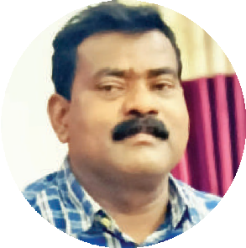

**NIC Chhattisgarh is playing a Vital Role**

**in implementation of Various e-Governance Projects in the State. The Outstanding efforts and Proactive ICT Support from the NIC Officers in AABHAR could make it to**

**Till date more than ₹402 Crore under pension, ₹1654 Crore under Gratuity and**

**₹90 Crore towards Commutation payment have been disbursed through the portal. About 370 grievances have been redressed.**

**I appreciate the efforts and commitment of NIC State Centre in providing technical support to the Directorate Treasury Account and pension for successful development and implementation of online pension management system.**

**ensure timely payment of pension benefits.**

**NEELKANTH TIKAM,** IAS

**Director**

**Treasury Accounts & Pension Government of Chhattisgarh**

**AABHAR** the web enabled pension portal is fully integrated end to end process-based solution facili- tating all processes digitally without any physical file movement. The finance department has made nec- essary amendments in finance rules and procedures accordingly and adopted the process re-engineering. This website seamlessly integrates a wide array of in- novative technologies - the web, SMS, Mobile Apps, Digital Signature, SFTP, XML.

This web solution and mobile app have been created to improve the quality, transparency and offer timely services to the pensioners. Pensioners can share their opinions, suggest any improvement and post their grievances in the “Pension Grievance Redressal System” regarding pension related issues

##### Pension Process Flow

The digital process starts with each “Pension Acceptance Officer” (PAO) who prepares data online using a common pension form for different types of pensions and uploads supporting documents. It is marked to the Divisional Joint Director (JD) who verifies the pension case online. After verification, JD performs the calculation and generates the digitally signed electronic Pension Payment Order (ePPO) and forwards the case for further processing of payment to Treasury Officer (TOs). JD can revert the case to the PAO if any discrepancies are found

###### Dr. AK Hota

Dy. Director General

& SIO

[**ak.hota@nic.in**](mailto:ak.hota@nic.in)

**Pension Process Flow**

**01**

**03**

To verify docs & process online ebill & make payments (Pension,

###### Shishir Raizada

Sr. Technical Director & HoD

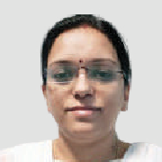[**raizada.s@nic.in**](mailto:raizada.s@nic.in)

**Shweta Choubey**

Scientist - B

[**shweta.sharma@nic.in**](mailto:shweta.sharma@nic.in)

DDO ﬁles pension from online in “AABHAR” and upload supporting documents and sends to Joint Director (JD)

**DDO ofﬁce**

**JD ofﬁce**

**02**

JD generates digitally signed EPPO, ECPO, EGPO and sends to treasury ofﬁcer

Gratuity, Commutation) to pensioner A/C & sends e-PPO along with doc and digitally sign the xml to the SFTP folder for CPCC

Treasury Ofﬁce

**CPCC ofﬁce**

**04**

CPCC opens pension account, monthly payment & sends digital scroll to State Treasury

**05**

Monthly Pension Credited

Pensioner

for necessary corrections. The Treasury Officer on receiving the case, processes the eBill (Gratuity, Pension and Commutation) for payment directly to the Pensioner’s account through the digital payment gateway. After the initial payment, treasury officer sends the digital signed electronic pension payment order along with supporting documents and digitally signed xml data through SFTP server to the Central Pension Processing Centre (CPPC) for processing and maintaining the pension account. The CPPC will provide monthly electronic scroll of all pensioners after due payment to Director Treasuries through SFTP server for further analysis. The entire system is supported with SMS services at different stages to send messages to the pensioners..

##### Key Stakeholders

**Internal -** DTAP Administrative Departments (53), Head of Office (6348), Treasury Offices (28), Head of Department (94), Joint Directorate (5)

**External - 10** Nationalized banks, Employees due

to retire within next 24 months (8000+), Pensioners/ Family of Pensioners (1 lakh+)

##### Capacity Building

Directorate of treasury office organised the training program for Treasury Officers of the state and designated them as Master trainers for the pension system. Master trainers gave the training to their respective DDO’s of the district. Joint Directors and Budget controlling officers were trained on the total process flow.

##### Benefits for Administration

* + Better cash and debt management with correct assessment of future pension liability Strengthening of service delivery mechanism through fully automated system to ensure timely delivery of services to the pensioners

•

•

Timely disposal of pension cases has considerably reduced complaints and grievances related to retiral dues

•

Early preparation and scrutiny of cases at the HOD level reduces chances of objection and delay in process

•

Enhanced accountability, transparency, accuracy and efficiency in the system

•

Online database securing all important data



**53**

Departments

**26498**

PPO Issued

**6348**

DDOs

**23845**

GPO Issued

**952**

**15228**

CPO Issued

Retiring

Employees

**Aabhar Portal**

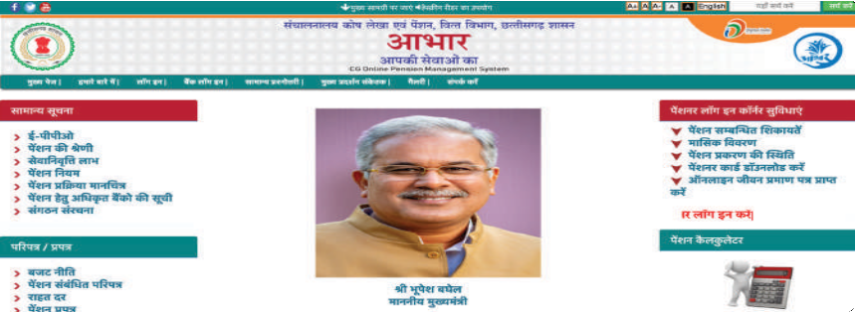

* All documents can be accessed anytime and from anywhere

•

Real time monitoring of pension cases at all concerned levels

##### Benefits to Pensioners

Under the concept of good governance, this system has empowered the pensioners with the following facilities which were not available to them earlier

•

Dedicated website for pensioners which contains all general information including:

* Pension related rules
* Circulars/ Forms
* Historic and updated Dearness Relief rate
* Pension calculator
* Link for Digital Life Certificate

•

Login facility to pensioners in website and mobile app (e-Kosh lite) which provides:

* Digitally signed Pensioner identity card
* PDF copy of e-PPO, e-GPO, e-CPO, Covering Letter
* Real time tracker
* Monthly pension slip
* Grievance can be filed to DTAP for redressal within 15 days
* SMS alert to pensioners at every level
* No more physical verification of pensioner at treasury office, hence saving time and effort

1-2 Year,

8243, 52%

6-below 1 Year,

3033, 19%

1 Month,

549, 4%

2-6 Month,

3974, 25%

##### Processes Re-engineered/ Technology intervention

* Abrogation of Physical verification of Pensioner at Treasury level

•

Program based calculation of retirement dues of a pensioner has resulted in considerable saving of manpower requirement at all levels

•

Timeframe for work/ case disposal is stipulated for every stakeholder that make them responsible for any delay

•

Grievance management System is a milestone of online pension management governance as it is a weapon in hands of stakeholders to ensure transparency and accountability of government in a time bound manner

•

Use of digital signature on pension payment order gives additional level of trust to the stakeholders PUSH SMS alert, Pension status update & notification alerts for stakeholder’s awareness and convenience

•

•

Mobile App provides access to pensioners their pension details at finger-tips – anywhere anytime. Online Pension Tracker is available to all stakeholders

•

•

Feedback option, user manual, RTI, help section, screen reader for physically challenged person, bilingual content, search functionality, sitemap, archive etc. are some of the features made available in the website to make AABHAR system user friendly, easily accessible, optimized and responsive

•

Youtube channel of AABHAR, containing tutorial videos for handling of the website for all stakeholders making the system more usable.

For further information, please contact:

**Shishir Raizada**

Senior Technical Director & HoD

NIC Chhattisgarh State Centre, AD-2-14, 15, 16 Mahanadi Bhawan, Mantralaya, Raipur- 492002

CHHATTISGARH

Email: [raizada.s@nic.in,](mailto:raizada.s@nic.in) Phone: 0771-2510642

## Online Booking System of BCD

### ICT-driven Solution for Building Construction Department, Bihar

Edited by **Dr. DIBAKAR RAY**

##### After a year of implementation of these digitization processes, the Building Construction Department, Govt. of Bihar was able to approve around 240 booking of Bhawan and after implementation, during 2018-

**2019, 2019-2020 revenue of**

**₹4.96 Crore and ₹5.48 Crore was generated respectively**

**through online booking. Revenue earning was increased two-**

**fold after implementation of online booking. Through online internship around 150 students got registered and project report was submitted after successful completion of internship programme.**

###### Pradeep Kumar Nayak

Scientist-C

[**p.n**](mailto:p.nayak@nic.in)[**ayak@nic.in**](mailto:ayak@nic.in)

**Abhishek Kumar**

Scientist-B

[**kumar**](mailto:kumar.abhishek@nic.in)[**.abhishek@nic.in**](mailto:.abhishek@nic.in)

efore computerization, Building construction department was booking Bhawan and premises manually with dedicated 4-5 member officials in providing information about availability of Bhawan on specific date and time slots. A separate booking register was maintained and confirmation letter was issued once booking gets approved. The process was done for 3-4 Bhawan and their premises in each office person deputed to handles this. Online booking system has been introduced, and it makes the process very convenient for the department and stakeholders. It has reduced workload, manpower and added features of digital payment which was

earlier done through Cheque/ DD mode only.

B

Online Internship platform is another initiative to make student aware through website so that they can apply through portal and register themselves for the process of their internship. Earlier student was approaching the department for enquiry about internship.

Another initiative was for eMeeting. Meetings were regularly held by department to execute their agenda in timely manner. But managing meeting was very cumbersome process altogether and communicating about the date, timing and Minutes of Meeting to the participants and members. Special cell was working for arranging meetings and circulating MOM. eMeetings platform has been introduced to help in scheduling and execution of eMeeting digitally providing facilities like alerts through sms, email MOM and assigning agenda of MOM to the members for compliance within stipulated timeline. Dashboard provides information about upcoming meeting, past meeting and compliance of MOM.

###### Introduction

Leveraging ICT for better e-Governance and delivering enhanced services to citizens an innovative ICT-driven solution has been implemented by for Building Construction Department, Govt. of Bihar which includes Online Booking System, Online Internship and eMeetings.

Building Construction Department, Govt. of Bihar initiated with National Informatics Centre (NIC) for design & development of online portal to enrich public and stake holders in smooth functioning of department works. The portal facilitates an effective, IT based and paperless mechanism through digitization of various processes.

###### Online Booking System

Online Booking Website is for booking of government large convention centre or auditorium or Bhawan like Samrat Ashoka Convention Centre, Gyan Bhawan, Adhiveshan Bhawan and M.M.H. Auditorium. Online Booking system was inaugurated by

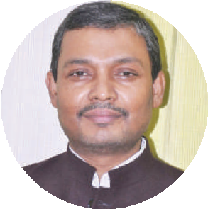

State-of-the-art ICT services provided by NIC Bihar State unit and their commitment towards finishing the assignment in a time bound and professional manner had played a significant role in the successful implementation of e-governance projects. Online booking system portal is a remarkable solution given by NIC which facilitates hassle free online booking through digital payment mode. This system puts vacancy related information in the public domain and thus reduces time and requirement of manpower in the booking process. Meeting Management System developed by State NIC has great potential for execution and follow up actions on agenda/ minutes of various departmental meetings. This system can be replicated on a larger scale in various departments.

I congratulate the NIC team for extending

continuous support to the department. I wish them very best in their future endeavours and hope that they carry on the development of e-governance structures for the ultimate benefit of the common man.

**CHANCHAL KUMAR,** IAS

**Principal Secretary**

Government of Bihar

Hon’ble Minister, Building Construction Department, Govt. of Bihar, Shri Maheshwar Hazari in the presence of Shri Chanchal Kumar, IAS, Principal Secretary and Shri Amit Kumar, IAS, Joint Secretary, Building Construction Department, Govt. of Bihar.

**Objectives of Online Booking System**

* To ensure the activities of National Green Tribunal with the philosophy of Digital India

•

To facilitate online booking using digital payment method

•

To provide accessibility of information to all the stakeholders with transparency

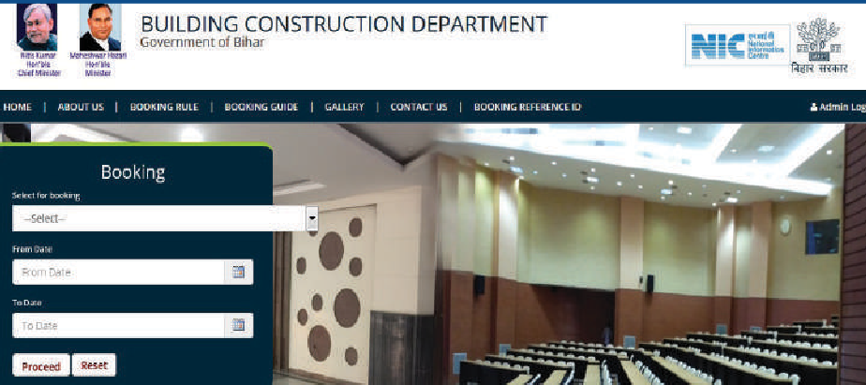

Booking Interface of Online Booking System of Building Construction Department, Bihar

meetings. It is used to view upcoming meetings at a single glance. Administrator can create meetings with date, time, and venue for respective forums and upload meeting agenda in a .pdf format file. Admin can also modify, delete meeting already created before the scheduled date & time. SMS and eMail are generated and sent to the participants regarding the schedule and agenda of the meeting information. There is facility to upload MoM of the meetings and allocation of tasks to the participants. On uploading of MoM it gets circulated through email to all the participants automatically. When compliance is done by participants he/ she can also upload compliance report. A dashboard is available keeping track of meetings, work allocation and compliance against task allocated.

* + To enable digitization and transformation of bookings

•

To ensure effective and efficient delivery of G2C and G2G services

**Features of Online Booking System**

* + Stakeholders can query online about vacancy of Bhawan for Specific date and time

•

Online approval and rejection through admin of department

•

Digital payments and online fee receipt generation SMS alerts are sent to applicants after approval, rejection and cancellation against booking of premises

•

•

Automated MIS reports of bookings

**Technology Used**

* + IIS 10.0, Asp.net 4.0, SQLServer 2012
  + Operating System Windows Server 2016

**Benefits of Project**

* + Digital India’s key guidelines implementation for effective and efficient G2C and G2G services

•

Real-time Bhawan vacancy information

•

Not required to maintain manual register of booking

•

No need to visit office to enquiry about vacancy of Bhawans, deposit cheque or DD

•

Better case management resulting into faster disposal and pendency reduction

•

Reduction in time of user department to manage bookings

•

Digital payment makes it easier and convenient to

pay from head office outside state also Can be applied from other state also

Booking increased and revenue increase two fold after this website implementation

•

•

•

Easy and credible online services to citizens

**Impact**

* Before implementation in 2017-18, **₹2.12** Crore revenue generated

•

After implementation, during 2018-2019, 2019-2020 revenue of **₹ 4.96** Crore and **₹5.48** crore has been generated respectively

•

Online payments have made it simple for citizens

###### Online Summer/ Winter Internship

Online internship portal has been designed and implemented for the candidates interested for summer/ winter internship. It provides facility to apply online and making payment through SBI e-collect. After successful filling the application and payment an enrollment number is sent to applicant through SMS. A module to print ID card for internship students is also incorporated. After completion of internship candidate have to submit project report through this portal. Reports like total number of candidates, total payment made through e- mode and number of students submitted project report is also available.

###### eMeeting

eMeeting website has been designed and implemented to conduct and keep track of

It makes easier for managerial person to achieve targets against meeting.

**Benefits**

* No bulky print-outs of notes, no more requirements for photostat copying, checking copies of notes No need for circulation/ dispatch of Agenda of Meetings

•

•

No time lag between upload of agenda and availability of the same to users

•

No compromise with security of confidential information

•

Saves time, efforts and money due to short, simplified and convenient process of creating meetings, distributing of MoM among the participants

•

Keep track of work allotted and its compliance. It also saves paper and environment

•

**Features**

* Login ID/ Password based access rights to the relevant members of department. On successful authentication, they can able visualize MoM

•

All content PDFs stored inside application

•

Notice, MOM, Notes in PDF for an ensuing meetings date will be available on system without time lag Participants get SMS alerts about scheduled meeting

•

•

MoM is communicated to every participant on his email Id

•

Able to view about past meetings and its MoM

**Technology Used**

* IIS 10.0 , Asp.net 4.0, SQL Server 2012

Launch of Online Booking System by Shri Maheshwar Hazari , Hon’ble Minister, Building Construction Department in presence of Shri Chanchal Kumar, IAS, Principal Secretary and Shri Amit Kumar, IAS, Joint Secretary, Building Construction Department, Government of Bihar

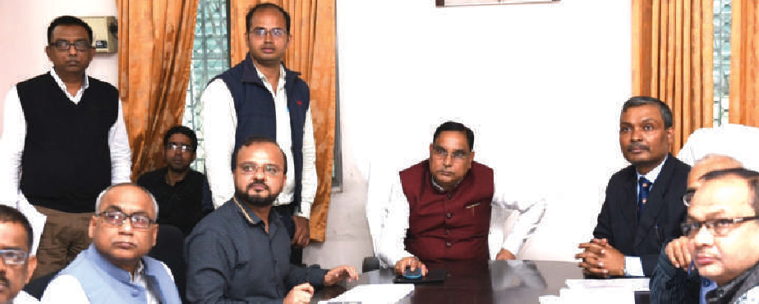

* Operating System Windows Server 2016

###### Summary

eMeetings helped in scheduling of meetings and execution of Agenda/ MOM. Through eMeetings, consumption of paper and time was saved. Online Booking and eMeetings application is highly appreciated by the officers of Building Construction Department.

For further information, please contact:

**Rajesh Kumar Singh**

Dy. Director General & SIO

NIC-Bihar State Centre, Technology Bhawan, 3rd Floor Bailey Road, Patna- 800015

BIHAR

Email: [sio-bih@nic.in,](mailto:sio-bih@nic.in) Phone: 0612-2547964

## IFMS Punjab

### The Next Gen Integrated Financial Management System

Edited by **SARBJEET SINGH**

##### With release of Revised Estimate (RE) for Financial Year 2020-

**21, Government of Punjab has shifted to next-gen Integrated Financial Management System (IFMS) developed by NIC Punjab. In addition to usual features of an IFMS like planning, budgeting, receipt, expenditure, bill and payment processing, this new IFMS has a lot of new state-of- the-art features which make it a next-gen portal.**

###### Satyender Kumar

Dy. Director General & SIO

[**satyender**](mailto:satyender.kumar@nic.in)[**.kumar@nic.in**](mailto:.kumar@nic.in)

**Anoop Kumar Jalali**

Sr. Technical Director

& HOD

[**anoop.**](mailto:anoop.jalali@nic.in)[**jalali@nic.in**](mailto:jalali@nic.in)

**Navinder Kumar Sharma**

Scientist-C

[**navinder**](mailto:navinder.sharma@nic.in)[**.sharma@nic.in**](mailto:.sharma@nic.in)

ew next gen IFMS was designed to bring efficiency in financial planning and expenditure control in the state. This has brought various stakeholders such as Department of Finance, Treasuries, Administrative Departments, Accountant General, RBI and Banks on a single platform with role based Smart Dashboards. These Smart Dashboards

have provided a better Decision Support System.

N

##### Salient Features of 5 modules of new IFMS

**eBudget [https://ifms.punjab.gov.in]**

eBudget module facilitates planning, budgeting and allocation of Budget from Department of Finance to Administrative Department and to DDOs thereafter. Salient Features are given below:

•

Online receipt of Budget/ Supplementary Proposals from DDOs onwards

•

Workflow based preparation of online Budget by Finance Department

•

Budget documents are generated through the system

•

Online SOE Based Distribution/ Allocation/ Revision/ Release/ Re-appropriation of Budget Implementation of FR Management instructions, including online issue of Budget for Deposit Works Budget is checked vis-a-vis allocations

•

•

•

Generation of Final Re-Appropriation to be submitted to AG

•

Accounts from AG posted digitally

**eTreasury [https://ifms.punjab.gov.in]**

This module facilitates DDOs for creation of bills and Treasuries for passing of bills and payments thereafter. It also facilitates management of Stamps, PLA and EMD accounts at treasuries. Salient Features are given below:

•

Preparation of 40 types of bills: Salary, TA, Contingency, Medical, DA Arrear, LTC, General refunds, Court Refunds & Allowances etc.

* + Creation of Unique Payee Code for each employee (mapped with HRMS Employee Codes) or other payees for electronic payment through Treasuries
  + Details of GPF/ PRAN and DDO NPS registration are captured (with reference to Payee Code) in Employee and DDO’s profile
  + OTP based real time authentication for submission of bills
  + Online Tracking of ECS Orders and DDO Receipt
  + Checks on bill preparation vis-a-vis FR management instructions
  + Online bill processing at Treasuries
  + Integrated with eKuber (RBI System) for making payments to the Payee

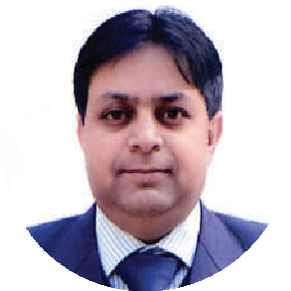

**The Government of Punjab, in**

**November 2019, decided to transition to a new IFMS w.e.f. 01/04/2020. Not only the entire activity of planning, development, testing and launch of various modules was time-bound but the expectation of achieving the service levels of existing IFMS, from day one, was itself challenging. The challenges were further compounded by the unforeseen lockdowns imposed by the Government due to COVID-19 Pandemic. The State not only successfully transitioned seamlessly but the new system has additional, new features to address the lacunas of the earlier IFMS. I must congratulate the entire NIC team who worked tirelessly to ensure an uneventful, smooth and seamless transition.**

**Dr. ABHINAV TRIKHA,** IAS

**Director, Treasuries & Accounts**

Government of Punjab

* Integration with NSDL for verification of NPS Employees
* Maintenance of Online PD/ PLA/ RD/ CCD accounts & its linkage with e-Receipt
* Preparation of Accounts related to Receipts and Expenditures
* Interface for AG Office for downloading of monthly accounts data
* Linkage of Refund bill directly with receipts deposited at e-Receipts portal



PSP & eSEWA

Portal



Rural & Panchayat Development



Labour & Employment



Revenue



& Many More



PFMS



NABARD



PWDIMS & FPMS



NSDL



GST

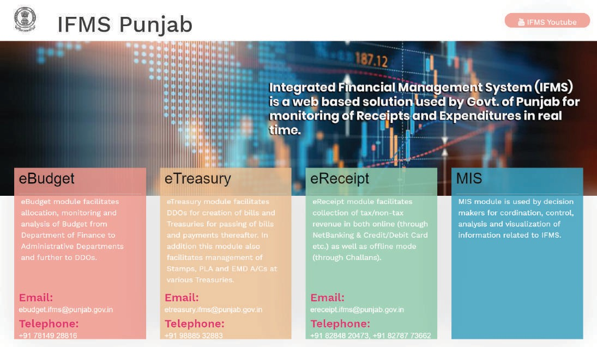

##### Software Architecture



IFMS

AG

Punjab

eBudget

eTreasury

eReceipt



HRMS



VMS



GPMS



eKuber(RBI)



Banks



Agriculture



Industries



Excise & Taxation

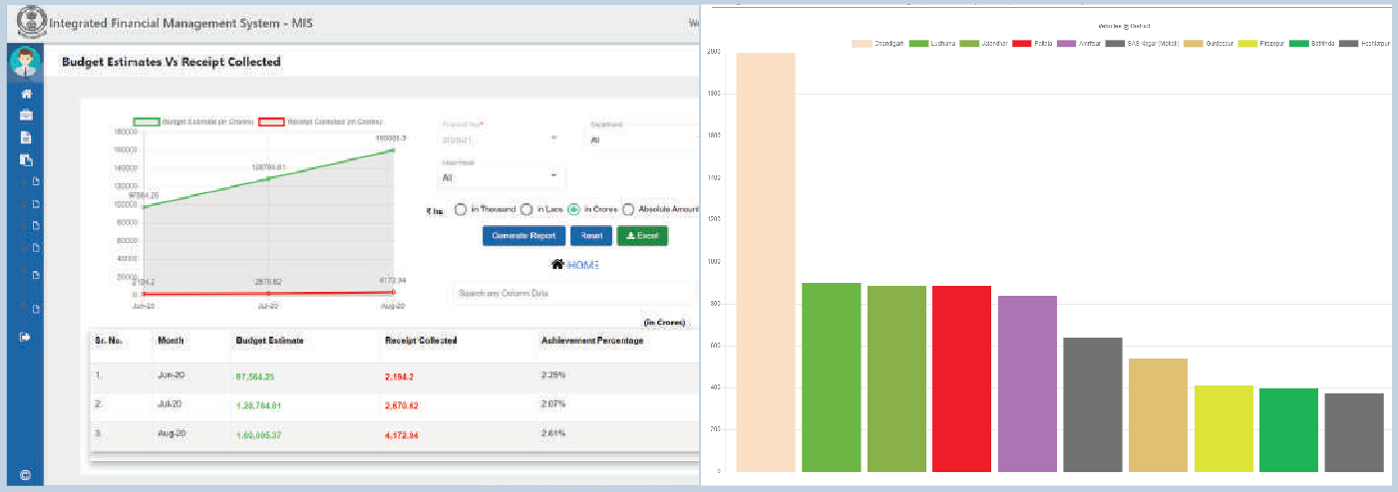

Charts and Graphs depiction at IFMS, Punjab

**eReceipt [https://ifms.punjab.gov.in]**

This module facilitates collection of Tax/ Non- Tax revenues in both Online [via NetBanking, Debit/ Credit Card, Airtel Payment Bank, UPI Payments (Google Pay, PhonePe, Bhim App, PayTM and Amazon Pay)] as well as Offline mode (via Challans). Salient Features are:

•

Online 24*7 preparation of Challan

•

Depositor can deposit Govt. receipt PAN INDIA in any branch of SBI, PNB, IDBI and PNB (For VAT only) Debit Card/ Credit Card/ NetBanking/ NEFT/ RTGS/ UPI based payments through payment aggregator of PNB (PayU) and SBI (MOPS)

•

•

Auto bifurcation of VAT deposits (11% in Dept A/C and 89% in Government Treasury)

•

Integrated with portals of Agriculture, Legal Metrology, Excise & Taxation, PSP & eSEWA, Health & Family Welfare, Director General of Police, Rural & Panchayat Development, Labour & Employment, Revenue, Chief Electrical Inspector, Transport and Industries for online submission of fee

•

Stamp Vendors can deposit Stamp Fee through Online Mode and can avail discount of 1% or 2% as per applicability

•

Online verification of fee through GRN (Government Receipt Number)

•

Cyber Treasury for reconciliation and preparation of State receipt account with the authorized banks at a central location

•

Integrated with GSTN for SGST Receipts

##### Vehicle Management System (VMS) and Govt. Property Management System (GPMS)

Vehicle Management System (VMS) facilitates a check on POL Bills of State Government vehicles. Every Govt. official (Earmarked) or Vehicle (Pooled) has a POL Limit (on Fuel & Maintenance) assigned by Department of Finance, Government of Punjab. VMS is keeping track of each limit. In first year of its launch VMS has saved more than **17 Crore Rupees** for State Government.

**Salient Features:**

* Availability of vehicles and POL Expenditure at a particular Office, Tehsil, District and State Head Quarters etc.

•

Each earmarked vehicle mapped with HRMS Code Intimation regarding No. of Vehicle with an Official Intimation of excess use of vehicle to Seniors Helping state government in crisis by providing information like vehicle available at particular region/ institute/ offices of the state

•

•

•

Govt. Property Management System (GPMS)

facilitates keeping track of immovable properties (Land/ Buildings) of Govt. of Punjab. Once a Property is verified by authority, the designated officials can search for un-utilized Properties and allocate the same to needed offices/ departments.

##### Technologies Used

All the modules were developed using Micro- Service Level Architecture where one backend can serve many frontends like WebApp and Mobile App. The portal was developed using following technologies:

•

Frontend: **Angular 11 with Material Design** Backend: **NodeJS 14 with Express 4 & NET Core 3.1** Database: **SQL Server 2019, PostgreSQL 11**

•

•

##### Benefits

* Using new eBudget module, State Govt. can assign District Wise Receipt Targets to any Department Using Vehicle Management System (VMS), State Government has saved more than **17 Crore Rupees** for State Government

•

•

Using GPMS, State Government can check availability of vacant office space at a particular location

•

Using Smart Dashboards of eReceipt, State Govt. has recovered more than Rs. **13.50 Crore** from banks

•

With introduction of Unique Payee Code, State Govt. has reduced 98% of RNs (Return Note) returned by eKuber (RBI) while making payments

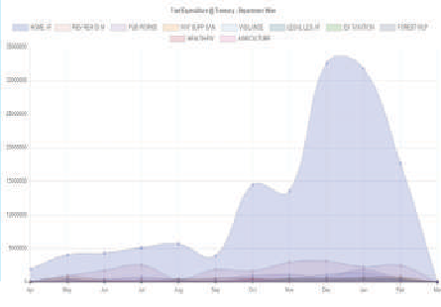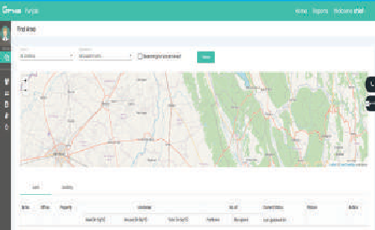

Hence facilitated seamless payments

•

Linkage between Receipt & Refund, AC & DC Bills, EMD & PD/ PLA Bills has reduced leakage of funds

##### Way Forward

The team has designed an excellent application architecture which can be extended further for heavy loads in future. Some of the In-Process activities are:

•

New Debt Management System in integration with eReceipt

•

Implementation of e-Vouchers in the Treasuries Integration with e-Kuber (RBI) for Receipts, so that Receipts can be monitored in real time without any manual intervention of banks

•

For further information, please contact:

**STATE INFORMATICS OFFICER**

NIC Punjab State Centre

Block No. 3, Ground Floor, Kendriya Sadan Building Sector 9, Punjab -160009

CHANDIGARH

Email: [sio-punjab@nic.in,](mailto:sio-punjab@nic.in) Phone: 0172-2747357

# BYOB- Build Your Own Bot

### BYOB + VANI = Single window destination for Bot lifecycle

Edited by **MOHAN DAS VISWAM**

##### As was mentioned by multiple speakers in RAISE2020, BYOB aims to ‘democratize AI’ beyond the realms of technical personnel. BYOB aims to empower change-makers in the government domain like Mr. Ranjitsinh Disale (Global Teacher Award Winner 2020), a

**simple school teacher, who used technology to revolutionize education in the village he was posted to. With this platform we’re making a paradigm**

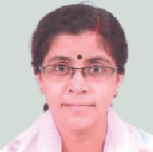**shift in NIC’s chatbot services VANI (Virtual Assistance by NIC) by automating the entire integration & business logic development through giving the control in user’s hands.**

###### Sharmistha Dasgupta

Dy. Director General

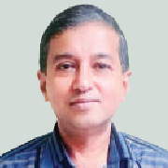& HoD [sharmi@nic.in](mailto:sharmi@nic.in)

###### John Philip

Technical Director [johnphilip@nic.in](mailto:johnphilip@nic.in)

ith the aim of pushing AI beyond labs and professional spheres, BYOB will act as a bridge between creating an AI agent and

making it functional with business logic and features (which is currently being done by **VANI** framework). It will automate the entire process of creating a bot from scratch. Right from teaching how to build a bot, to coming up with a finished product. It will eliminate the current dependency on humans to integrate their AI agent with **VANI** framework. This platform is effectively opening up **VANI** framework to the users now, instead of keeping it limited to the **VANI** Server.

W

BYOB provides an easy and a single point destination for managing multiple bot lifecycles by each user. It also has an Orchestration layer to automate the administration of all bots at all stages and generating automated alerts etc. as and when required. NIC has at present made 16 chatbots online and many are in different stages of development. This Orchestration layer is meant to smoothen this task of administering these bots.

##### Technology Brief

As shown in figure 1, BYOB service automates the user side and a lot of integration work for each user. Orchestration service will automate all the backend management for administration activities like UAT reviews, sending timely reminders to users, creating/ updating bot entries, etc. This service will be like a tracker which monitors the status of every bot of every user, sending periodical email notifications to the user regarding their bot status if need be, archiving/ disabling a bot if not updated or

not put in production for a long time.

##### Features

* A single point home dashboard to monitor the progress of all the chatbots that the user has created, as is shown in **figure 2**

•

AI agent platform agnostic – Currently made for Google’s Dialogflow, more platforms like NIC’s own upcoming NVIDIA Jarvis platform and others will be integrated eventually.

•

Connectivity with AI agent platform as shown in

**figure 3**

•

A rich array of features like ‘API reference’, ‘Display Web URL’, and others, to choose from shown in **figure 4**

* **API Reference & OTP Authentication (Initial API)**

- To display a result like application status etc. using your API

* **Display Web URL**- To display a web URL as a response to the user
* **PDF Modal Window**- To pop up a PDF modal window as a response to the user
* **Chat End** - This feature will end the conversation with a good bye message and disable the text area of the chat window. You will be required to select the intent name against which you wish to close the chat session
* **Others** - For a requirement which doesn’t fit in any of the features provided. You may send in your requirement with a proper justification to

[**byob.vani@nic.in**](mailto:byob.vani@nic.in)

* More features in pipeline

•

Dashboard service available from testing stage to monitor and tune chatbot performance pre-and post-deployment

•

Zero coding experience for user

•

Other options like edit, review, and delete bots

**Nidhi Lohat**

Scientist- B [nidhi.lohat@nic.in](mailto:nidhi.lohat@nic.in)

Fig. 1



**Daemon Service**

**Orchestration**

**2 Home Dashboard**

**2a Edit Bot**

**BYOB**

*@*

**4 Creating AI Agent (& Pre-requisites)**

*@*

**5 Connect Your Agent**

*@*

**6 Add Features to your Agent**

**VANI**

**Framework**

*@*

**7 UAT Certiﬁcate**

**3 Create New Bot**

**1 Parichay Login**

Invisible to the user. i.e., user won’t be in touch with these background processes directly.

Logical flow that the user will directly be in touch with.

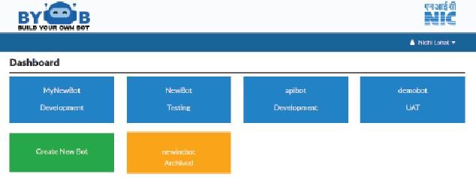

Fig. 2

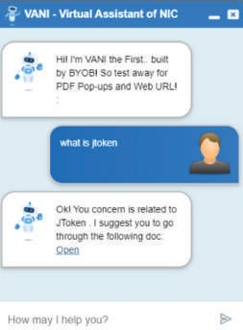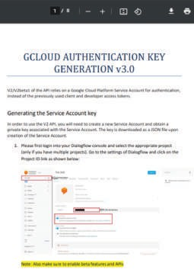

Fig. 5

Figure - 2

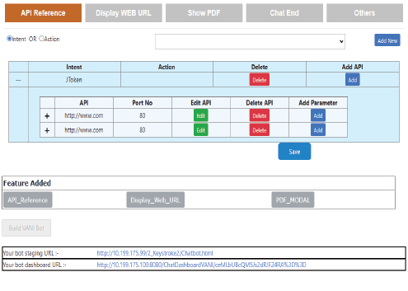

Fig. 4

**How Does the Software Work?**

The users registered for VANI in AI as a Service will be able to access the service on **https://byob.nic.in.**

**BYOB** interacts and synchronizes with existing NIC services like Parichay, NIC- Email, **VANI** Framework, and VANI Dashboard. (**VANI** Chat Transfer to be integrated soon). Once logged-in through Parichay, a user is met with their home dashboard where they can see all the chatbots they’ve created and what stage each chatbot is in. From here, a user can take three actions for each bot – **Review, Delete,** and **Edit.** There’s also a separate option to create a new chatbot.

To create a new chatbot, a user is given resources like ‘Things to Know Before Creating a Chatbot’, ‘Features’ Guide’, some tutorials w.r.t. the AI agent platform that they selected. Once a user is ready with AI agent, they are educated about creating authentication tokens on their respective platforms and uploading on

**BYOB** portal. **BYOB** establishes the agent connectivity with agent platform in the background through **VANI**. Next, a user adds features (**refer figure 4)** depending on their use case, and generates a testing URL, along with a dashboard URL for tuning and training purpose. The user now has a test bot with GUI to test, look and feel how their bot will perform in real like **figure 5**, complete with all the features that the user selected. Once a user is satisfied after a thorough testing, they’re supposed to sign a UAT (User Acceptance Testing) certificate and upload it for review. Once approved by Admin, production URL and scripts generated by **VANI** are shared with the user.

An underlying, yet an important subservice of BYOB is its Orchestration Layer from administration perspective. It is majorly divided into two modules, each module having its own submodule – Actions and Alerts Centre. Orchestration also monitors the progress of every bot. Bots which are observed to be inactive in development stage after a certain amount of time are auto-archived, thus rendering the user unable to make any further changes. Action Centre allows the admin to take actions for – UAT Review (Accept, Reject, Question), Unarchive bots, or forcefully archive bots upon observing suspicious activity.

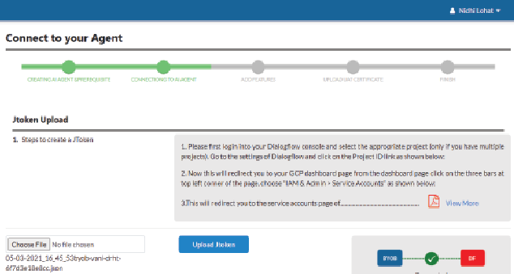

Fig. 3

Alert Centre allows the admin to send custom notification to a specific user or broadcast to all users in a special scenario outside the bounds of simple bot creation/ edit cycle like maintenance notification, etc.

##### Benefits

* Makes AI accessible to non-AI trained workforce
* Faster turnaround time for creating and editing chatbots since there’s no actual coding involved. the actual AI part is taken care of by AI agent platform and

business logic along with GUI are taken care of by **BYOB** and **VANI** Framework. Since **VANI**, and soon enough **BYOB** as well, are well audited projects with all the relevant firewall rules already in place, user gets a secure product by the end of the cycle in a very short amount time. This in general, along with coding effort would’ve taken months at the very least

##### Application Areas

There’s hardly any field left in the world which doesn’t see application of chatbots. In Indian context, we can use **BYOB** to create multilingual chatbots for farmer welfare, Jeevan Pramaan, students’ results announcement, raising tickets/ grievances, and many more.

For further information, please contact:

**John Philip**

Technical Director, Artificial Intelligence Resource Division

CoE-AI, 7th Floor, NIC HQ, A-Block, C.G.O Complex, Lodhi Road - 110003 NEW DELHI

Email: [johnphilip@nic.in,](mailto:johnphilip@nic.in) Phone: 011-24305241

# Mobile App Development

### Technologies/ Frameworks and Steps to Develop Mobile App

Edited by **MOHAN DAS VISWAM**

##### Today, the focus area in eGover- nance, to cover larger user base, is through Mobile Apps because of the availability of smart phones with majority population in India and extensive mobile connectivity. A forecast of smartphone users in

**India in 2021 is 76 crores which will make more than 50% population coverage. Therefore, quick develop- ment of mobile apps using appro- priate technologies/ frameworks is the need of the hour. The broadly categoried mobile app development frameworks are Native, Progressive web and hybrid (Cross platform). A typical mobile app project consists of three integral parts, back-end/ server technology, API(s) and the mobile app front-end.**

###### Ajay Singh Chahal

Dy. Director General & SIO

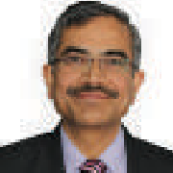[**ajay.**](mailto:ajay.chahal@nic.in)[**chahal@nic.in**](mailto:chahal@nic.in)

**Sandeep Sood**

Sr Technical Director

[**sood.sandeep@nic.in**](mailto:sood.sandeep@nic.in)

mobile application, commonly referred to as an App, is a type of application software designed to run on a mobile device, such as a smart

phone, tablet, smart TV, computer or smart watch. Mobile applications are intended to provide users with similar services on touch screen devices as are accessed on PCs using browser. This is achieved with the help of Services/ APIs. Mobile App development can be carried out using various Technologies/ Frameworks available today. The idea is to enable the use of suitable technology or framework as per different criteria and requirements. The mobile app development frameworks can be broadly categorized as:

A

* Native Mobile App Development
* Progressive Web Mobile App Development
* Hybrid (Cross Platform) Mobile App Development

##### Native Frameworks

These frameworks are available for development of mobile app meant to be used for a specific Mobile OS only. These are developed using programming languages and tools that are provided by the company that develops the platform and the OS on which they will run on. To mention a few, android app can be developed using Java or Kotlin languages using Android Studio or Eclipse IDE. Similarly, iOS/ Apple mobile app can be written in Objective C or Swift using Xcode IDE provided by Apple. There are some advantages and disadvantages in opting for Native framework:

**Advantages**

* Fastest between the three frameworks
* Single Mobile Platform to focus up on
* Distribution through Platform Dependent App Stores
* Most Interactive and Intuitive
* Advantage to use Device Essentials
* Smaller in size as compared to Hybrid Apps

**Disadvantages**

* Needs separate development effort for each Mobile Platform
* Platform Dependent Language and IDE Knowledge
* Expensive as Requires Platform Specific Skill set therefore also difficult to maintain

##### Progressive Web Mobile App

Such kind of app development is more suitable for the web application developers and is focused for mobile devices. Such apps are accessible through

web browsers and do not have easy access to device essentials. Therefore, do not enjoy the advantages available for a mobile application in terms of availability of various components of mobile device like camera, GPS etc. The pros and cons of using this type of framework would be:

**Advantages**

* First choice for web developers, being developed using HTML/ CSS/ JS
* Easy to maintain for web developer being similar to web application
* Freedom of Platform/ Language maintains continuity
* Cost Effective as compared to Native and Hybrid Apps as no additional technical manpower required if you have a web developer
* Single App for all Mobile Platforms (being accessible on browser only)

**Disadvantages**

* Browser based access
* Slower than Native & Hybrid Apps
* Cannot use the Advantages of Mobile Device Components
* Limited UI/ UX Less Intuitive
* Cannot be Installed on Device
* Cannot be hosted on App Store, No Icon based Identification

##### Hybrid Mobile App Development Framework

This is the most suitable framework if the focus is to provide mobile app for multiple platforms with single development effort. These apps provide native app like experience and 80-90% of the source code is utilized cross-platform which saves resources in terms of manpower and time. There are some positives and negatives with this kind of framework also:

**Advantages**

* Expertise of one language/ IDE required
* Cheaper than native Apps framework
* Distribution through Platform Dependent App Stores
* Most Interactive and Intuitive

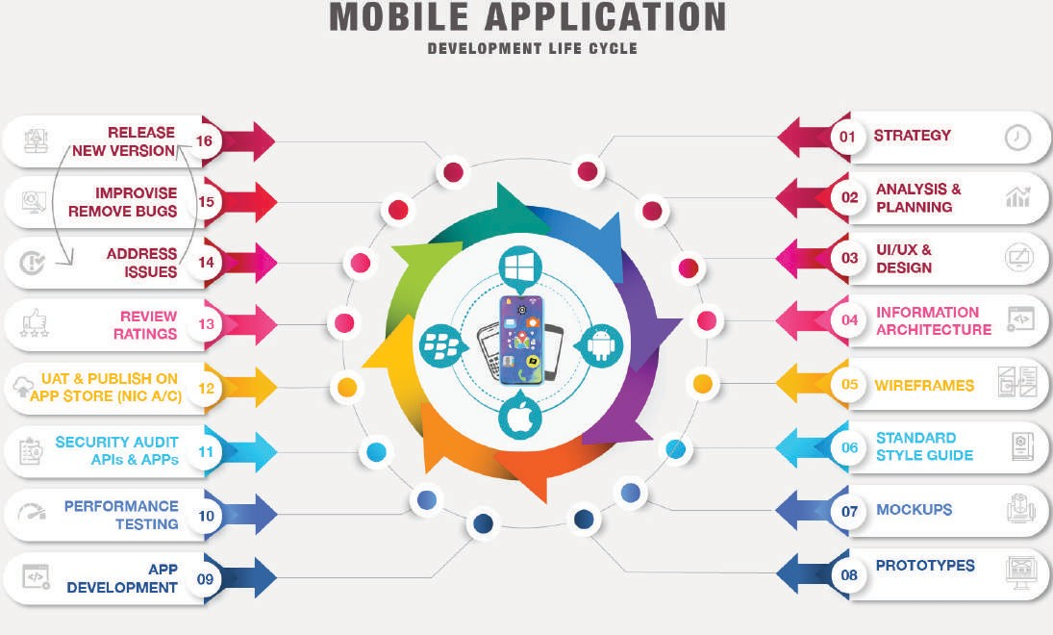

Mobile App Development Life Cycle

* + Advantage to use Device Components

**Disadvantages**

* + App Size if bigger than native apps (3-4 times)
  + Little bit slower as compared to Native Apps
  + The choice of UI controls limited to availability on all mobile platforms to be covered
  + Using device components/ essentials not easy sometimes

##### Steps to Develop Mobile App

**Strategy**

The first and foremost step is to prepare a strategy for mobile app development. This includes Identify the app users, research the competition, establish the app’s goals and objectives, identify what would be app target G2G, G2C, G2B or G2E or may be multiple service delivery types and also select a mobile platform for your app development.

**Analysis and Planning**

Identify the requirements and prepare product roadmap. Define use cases covering the complete

functionality being planned in the App. After listing the functions, decide priority for each functionality to converge into versions. Then group Functionalities into Milestones and versions. Decide the App Name

– Check for availability of same or similar names on app store to distinguish from existing ones.

**UI/ UX Design**

Create a seamless and effortless user experience. The most important part of any mobile app is the app functionalities should be easy to use and should be intuitive. A mobile app can be designed based on advanced gesture features like Tap, Swipe, Drag, Hold and more. Apps can use these gestures to offer innovative functionality that can help users to perform a task in better way. For example, an app can let users move to a next or previous step using the swipe gesture. The UI/ UX has a goal to make excellent User Experience making the app Interactive, Intuitive & User Friendly. The UI will help in user’s early adoption and intuitive UX will keep the user engaged.

**Information Architecture**

Deciding the data the App will Display, data the App will Capture. The Transactions/ Interactions

User will carry in the app the navigations within the app using the gestures or buttons. Also decide the workflows. Need to define the role-based access for the Mobile App (similar to the Roles being used in your Applications). May Plan limited Roles to start with and add functionalities of more Roles in future versions

**Wireframes**

Mobile App designers sketches the screens on paper keeping in mind the Mobile Screens. Wireframes are nothing but digital sketches of these screens. Wireframes help to understand the look and feel of the App being developed (as a prototype as sketch) .

**Standard Style Guide**

Follow the Standard set by the organization. Like logos to be used fonts to be used, color schema to be used, about the developer for feedbacks as email in addition to app store feedback reviews. Standard header/ footer, if any, to be placed.

**Mockups**

The second phase of Wireframes is to apply the Standard Styles on Wireframe to convey a final look

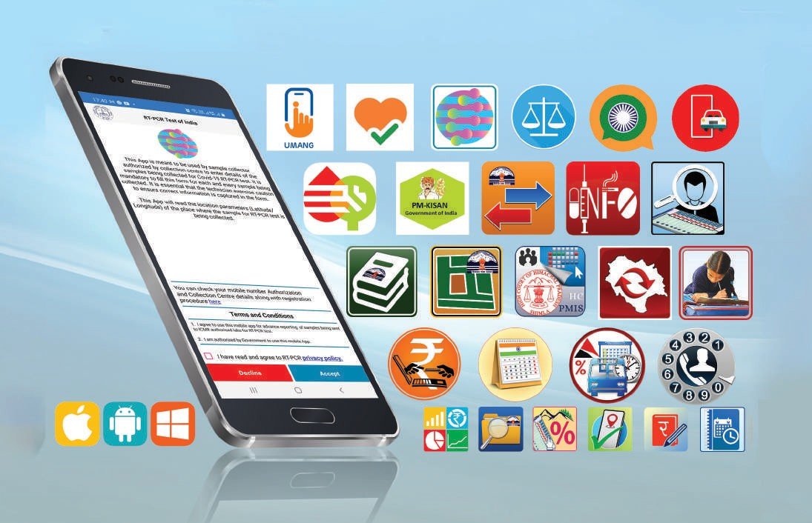

Government Mobile Apps

and feel of your app where colours, images to be used are also part of design. This gives and exact screen wise look of the app being planned.

**Prototypes**

Arranging the mockups to produce app functionalities. This helps to go through the App as a prototype (Simulation).

**App Development**

Planning remains an integral part of this phase in the mobile app development process. Before actual development/ programming efforts start, developer will have to define the technical architecture, pick a technology stack and define the development milestones. A typical mobile app project is made up of three integral parts, back-end/ server technology, API(s) and the mobile app front-end.

**UAT & Deployment**

Once the Development is complete, user acceptance testing is carried out and modifications are carried out as per testing feedback. Finally, the app is submitted in the respective platform App Store for publishing and is made available to the user for installation.

##### Advantages with Mobile App Development as Developer

**Mobile Device Features**

It enables ease of utilizing features like Camera, GPS, Contact List, SMS, Phone Calls, Gravity sensor etc. These device specific features are easy to use for the user as well as easy for the developer to incorporate. The app developer must mention the permissions required in the app. In case some sensitive data is being captured or sensitive permission is required, app store dependent declaration and privacy policy becomes must.

**Ability to work offline**

The other major advantage with Mobile App is leverage of local app-based database which can be integrated in Mobile App for online and offline features. There can be an app which provides tool for field functionaries to report progress or even Geo Tag assets or locations. The basic data as per user’s role can be provided offline in the app using Web API at a connected location and the data collection can be carried out against this offline data in the field by the app users. This offline data can be sent to central server automatically as and when the user gets connectivity.

##### Application Areas

Providing services to different set of users in Government through mobile apps is known as mGovernance. The mobile apps can be useful where services are provided to the citizens and they need to apply through a form and upload documents or photos. The form length is limited and status of submission and service delivery comes as an SMS or mobile notification in the App. The user doesn’t have to login repeatedly and remember the User credentials/ passwords.

The Mobile apps can be used for location-

based services like geo-tagging of Government assets, taking feedback, carrying out location based inspections to ensure that it has been carried out on- location only.

Mobile apps are also useful in providing all Government information, contacts, tourist, hospital, police, petrol stations, directions for emergency services, one click based SoS services, voice and face recognition-based services.

For further information, please contact:

**State Informatics Officer**

NIC Himachal Pradesh State Centre HP Secretariat, Shimla-171002 HIMACHAL PRADESH

Email: [sio-hp@nic.in,](mailto:sio-hp@nic.in) Phone: 0177-2624045

**Appscape**

###### Appscape

**Budget Rajasthan**

A

s an initiative towards the paperless budget, “BUDGET RAJASTHAN” mobile app was developed by NIC Rajasthan for Department of Finance, Government of Rajasthan. Budget Rajasthan app facilitates viewing of various Budget Documents of the State to the Members of the Rajasthan Legislative Assembly (MLAs) and citizens. Different State budget documents available at one place in digital format which includes Budget Speech, Economic Review in Hindi and English, Budget Study, Budget at a Glance, Budget Summary, Revenue Receipts, Revenue Expenditure, Social Services, Economic Services, Capital Expenditure, Public Debt, Loan, Public Account, Posts, Grants Loans and Investments, 10 Different volumes related to works under PWD, Budget Related Analytical Statements, Finance Bill in Hindi and English, FRBM Document. App was developed on both Andriod and iOS platform and is now available on Google play store

and Apple store.

This app facilitates the Hon’ble Chief Minister of Rajasthan Shri Ashok Gehlot to present the first paperless budget estimates for the financial year 2021-2022 and revised estimates for the financial year 2020-2021 in Rajasthan Legislative Assembly.

App also facilitates to provide feedback on different budget volumes and to view the Budget Documents caption in Hindi and English. Common facilities like FAQ is also available in Hindi and English.

**Nammude Kozhikode**

ammude Kozhikode’ is an initiative by Kozhikode District Administration and Local Self Governments of Kozhikode with technical

N

support of National Informatics Centre to create a platform for the citizens to ‘participate, co-design and co-create’ futuristic Kozhikode along with District Administration consisting of all departments and Local Self Governments. It is to ensure transparency and quality of service, build on the Kozhikode civic culture and also collaborate with citizens, tap the potential of citizen involvement and contribution to build a prosperous, vibrant, cleaner, greener and a happier district.

Citizens can use this platform to connect with

Govt Authorities/ Departments and to report the issues related to basic civic services and emergency issues and only are left to communicate to phone numbers of officials. This would provide opportunities for the citizens to avail services, to report on the issues and disruptions related to basic civic services and also report emergencies to facilitate swift response from authorities. Departments, LSGIs can tap the potential of social capital and willingness to contribute in creating a futuristic district.

The web portal and mobile application was

officially launched by Hon’ble CM of Kerala Shri Pinarayi Vijayan on 30th of January 2021. The launch event was held online.

#### PANI

**ortal for Assets and Navigational Information (PANI)** is a digital solution initiated by Inland Waterways Authority of India, Ministry of Ports, Shipping and Waterways for Ease-of-Doing business. This portal and mobile application solution has been hosted by National Informatics Centre and the portal was launched by Hon’ble Prime Minister of India, Shri

P

Narendra Modi on 18th February 2021.

PANI App provides detailed information on various waterways in India for facilitating transportation of Cargo and other vessels through National Waterways. This will help in better understanding of the key features of the National Waterways that are essential for decision making on use of waterways as mode for transportation. Mobile App of this portal is launched with two key features: Navigation and Voyage Planning.

**Navigation:** GIS map Based Visualization of LAD, location of Infrastructure facilities, Cross waterway structures, navigation aids on National Waterways

**Voyage Planning:** View the feasibility of the expected voyage, by giving some basic inputs to the system.

The hosting management of the PANI digital solution is by the Shipping Informatics Division of National Informatics Centre.

**For NIC apps related query, please contact**

**Android**

**Sandeep Sood**

**Email:** [**sood.sandeep@nic.in**](mailto:sood.sandeep@nic.in) **| Phone: 0177-2880890**

**iOS**

**Andrews Varghese**

**Email:** [**kerkan@nic.in**](mailto:kerkan@nic.in) **| Phone: 0497-2700761**

**Visit the Mobile App Store at**

**https://egovmobileapps.nic.in**

April 2021

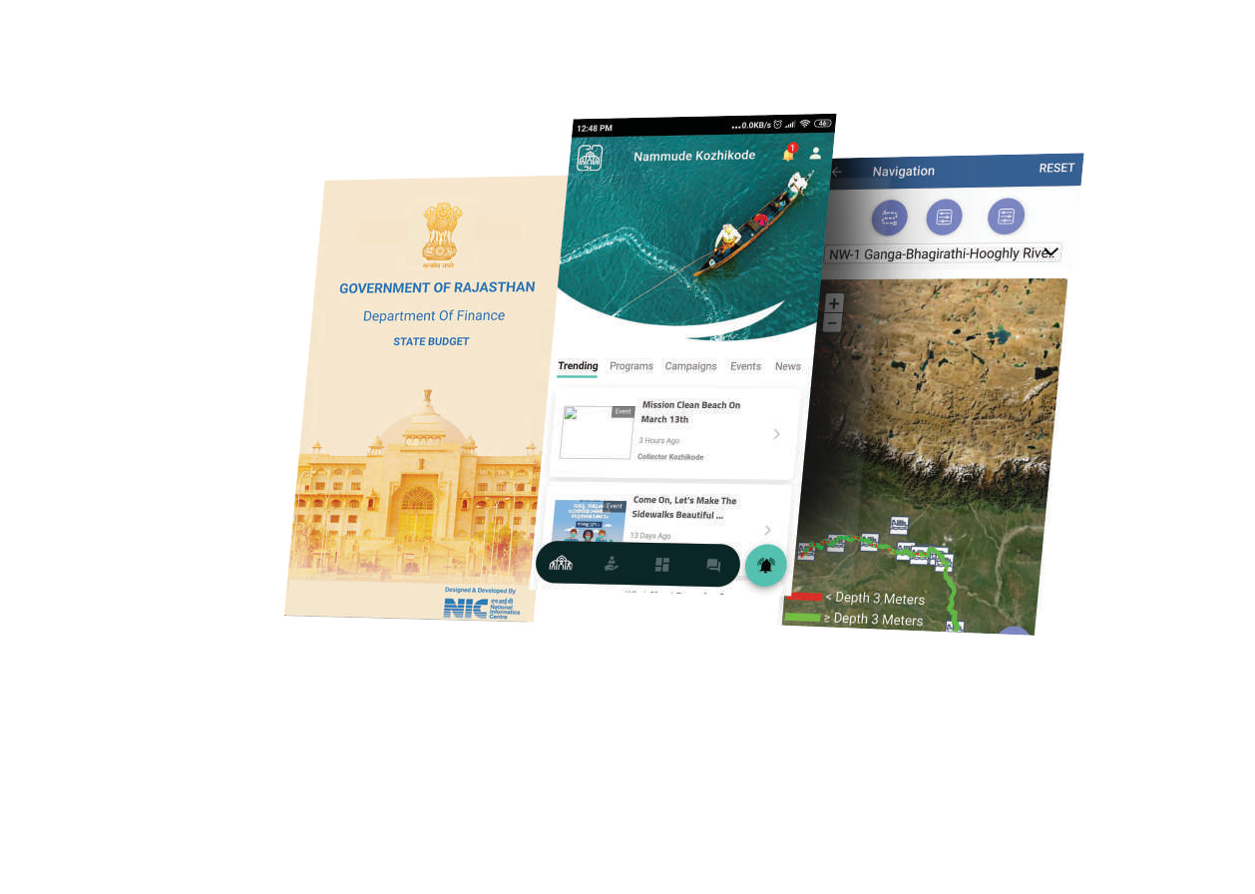

**informatics.nic.in 39**

**Hon’ble Prime Minister,**

**Shri Narendra Modi unveils postage stamp on Gujarat High Court's Diamond jubilee**

on’ble Prime Minister, Shri Narendra Modi addressed an event marking the Diamond Jubilee of the High Court of Gujarat via video conferencing. He also released a Commemorative Postage

H

Stamp marking the completion of sixty years of the establishment of the High Court. Hon'ble Union Minister of Law & Justice, Communications, Electronics & IT, Hon’ble Chief Minister of Gujarat, Hon’ble Judges of Supreme Court & Gujarat High Court, and members of the law fraternity were present on the occasion.

***- Informatics News Desk , NIC-HQ***

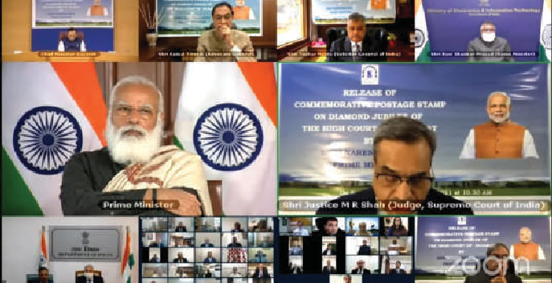

**Hon’ble Prime Minister, Shri Narendra Modi delivering address via video conferencing**

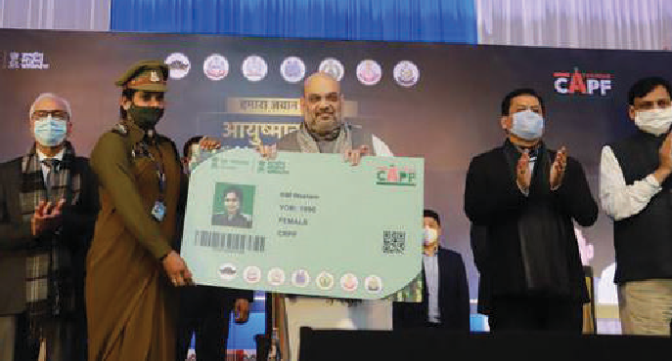**Hon'ble Union Home Minister launched 'Ayushman CAPF' scheme**

nion Home Minister Shri Amit Shah launched the ‘Ayushman CAPF’ scheme at CRPF Group Centre Guwahati that has gifted the access of healthcare providers under ‘Ayushman Bharat: Pradhan Mantri ogya Yojana (PM-JAY)’ to about 28 Lakh CAPFs, Assam Rifles & NSG

U

Jan Ar

personnel and their families in all the states where PMJAY is operational. To this end an MoU between the National Health Authority and

Ministry of Home Affairs was signed on the occasion which was also attended by Shri Sarbananda Sonowal, Chief Minister of Assam and Ministerof State for Home Affairs Shri Nityanand Rai, and other dignitaries. Smt Bhudhaswari Devi, mother of CRPF Mahila Constable Namita Devi became the family member to receive the e-card under the scheme. The Home Minister then e-inaugurated Sashastra Seema Bal’s 168 Type-II Quarters, 10 Bedded hospitals, and an Administrative building situated at different locations across Assam.

**Hon'ble Union Home Minister, Shri Amit Shah presenting Ayushman CAPF beneficiary e-health card**

***- Informatics News Desk, NIC-HQ***

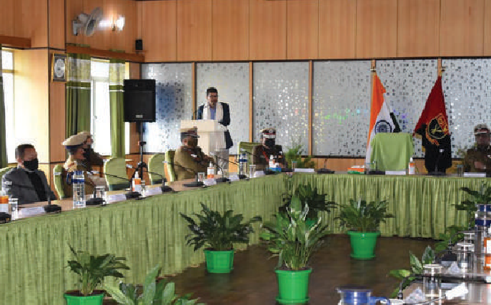**Launch of e-Challan Digital Traffic Enforcement Solution in Meghalaya**

e

Shri R.

-Challan Application - a Digital Traffic Enforcement Solution was officially launched on the 2nd March 2021 by Shri Lahkmen Rymbui, Hon’ble Home Minister of Meghalaya in the presence of Chandranathan, IPS Director General of Police, Meghalaya, Shri Timothy Dkhar, Deputy Director General and SIO National Information Center (NIC) Meghalaya, officers from NIC Meghalaya, State Bank of India

and other officers from Home Police Department.

In his keynote address, the Hon'ble Home Minister expressed hope that the new system will bring in transparency, fairness and efficiency in the enforcement of Central Motor Vehicle rules and traffic rules. The Hon'ble Home Minister congratulated and thanked the eChallan Software Development Team, NIC Kolkata and National Information Center (NIC) Meghalaya for their efforts and support extended in making this happen. Director General of Police, Meghalaya and other speakers also appreciated and thanked National Information Center (NIC) Meghalaya for the efforts and support in successfully implementing the eChallan application in the state of Meghalaya.

**Hon'ble Home Minister, Meghalaya, Shri Lahkmen Rymbui delivering keynote during the Conference**

***- Candida B. M. Booth Shadap , Meghalaya***

**Hon'ble Chief Minister, Himachal Pradesh launched eParivahan Services in all RTO/ RLAs of State**

S

at Shim

hri Jai Ram Thakur, Hon’ble Chief Minister, Himachal Pradesh launched the eParivahan services in the Transport sector in all RLAs/ RTOs of State on 25-February-2021 in an impressive function la. Shri Bikram Singh Thakur, Hon’ble Minister for Transport,

Industries, Labour and Employment, Shri Suresh Bhardwaj, Hon’ble Minister of Urban Development, TCP, Housing, Shri Suresh Kashyap, MP, Shri Anil Khachi, Chief Secretary, Shri K.K. Pant, Principal Secretary (Transport), Dr. R.N. Batta, Advisor to HCM, Shri Sandeep Kumar, Managing Director, HRTC was present on the occasion. Hon’ble Transport Minister informed that Himachal Pradesh is among the pioneer States in introducing ICT in Transport sector for the benefit of citizens and transporters.

**The Jal Shakti Ministry launched a unified portal on the 'Gobardhan' scheme**

The sc

T

he Jal Shakti Ministry launched a unified portal on the 'Gobardhan' scheme on 3rd Feb, 2021 developed by National Informatics Centre (NIC) & the Department of Drinking Water and Sanitation (DDWS). heme aims to support villages in effectively managing their

cattle and biodegradable waste. The Gobardhan scheme is expected to help enhance farmers' income by converting biodegradable waste into compressed biogas (CBG). This portal acts as a data repository for different activities of Gobardhan and enables monitoring progress of the Programme with real time tracking, ensuring transparency & social accountability of the scheme.

The scheme is being pursued as a priority programme under the Swachh Bharat Mission Gramin-Phase 2 by the Department of Drinking

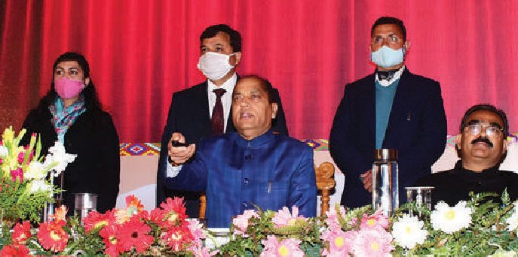

**Hon'ble Chief Minister, HP launching the eParivahan Services for all RLA/ RTOs**

***- Ajay Singh Chahal, Himachal Pradesh***

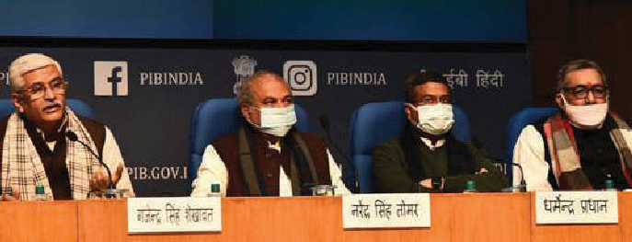

**Dignitaries at the vibrant dais set for the event**

Water and Sanitation under the Jal Shakti Ministry. It was launched in 2018.

Agriculture Minister Shri Narendra Singh Tomar, Animal Husbandry Minister Shri Giriraj Singh, Petroleum and Natural Gas Minister Shri Dharmendra Pradhan and Shri Rattan Lal Kataria, Minister of State in the Jal Shakti Ministry were also present at the event.

***- Sailendra Saxena, New Delhi***

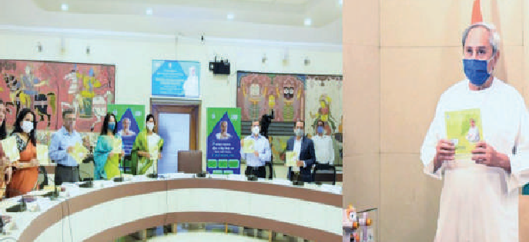**Launching of Mobile App & Portal of Women and Child Development and Mission Shakti Department by Hon'ble Chief Minister, Odisha**

I

n another step towards realization of the 5T charter of Government, Hon'ble Chief Minister Shri Naveen Patnaik launched “e-Manadeya” honorarium portal system & “eMamata” Mobile App online Services

of Women and Child Development and Mission Shakti Department on 25th Feb 21 through Video Conference in presence of Hon'ble Minister, Women & Child Development & Mission Shakti Department, Smt. Tukuni Sahu and senior dignitaries.

The “e-Manadeya Honorarium Portal System” will process payment of honorarium to 1.5 Lakh Anganwadi Workers and Anganwadi Helpers across the state through IFMS bulk payment disbursement process from February 2021 onwards. Leave management of Anganwadi Workers and Anganwadi Helpers, District wise, ICDS project wise monthly honorarium report, Head wise (HoA) honorarium data analytics for department officials can be carried out smoothly The “e-Mamata” Mobile App will ensure cash transfer benefit to all pregnant and lactating women of age

**Shri Naveen Patnaik, Hon'ble Chief Minister, Odisha launching the “e-Manadeya” & “eMamata” Mobile App**

19 year & above excluding government & public sector undertaking employees. The beneficiary will receive a total incentive of Rs.5000 in two installments, subject to the fulfilment of specific conditions & Aadhar based authentication. Payment will be made by e-transfer from the CDPO to the beneficiary account.

***- Hara Prasad Das, Odisha***

**April 2021**

**informatics.nic.in 41**

**Hon'ble Union Minister for Infor- mation & Broadcasting launched the DigitalCalendar & Diary of GoI**

on’ble Union Minister for Information and Broadcasting Shri Prakash Javadekar launched the Digital Calendar and Diary of Government of India. In a ceremony held at National Media

H

Center

, Shri Javadekar, with the click of a button unveiled the Android and iOS mobile applications of the calendar and diary. It was developed in collaboration with NIC by Bureau of Outreach & Communication, Ministry of Information & Broadcasting, Government of India.

This App has the provision for scheduling meetings, taking notes securely in digital form, lists official holidays and important dates and provides information on schemes, events & publications of the Govt.

***- Informatics News Desk , NIC-HQ***

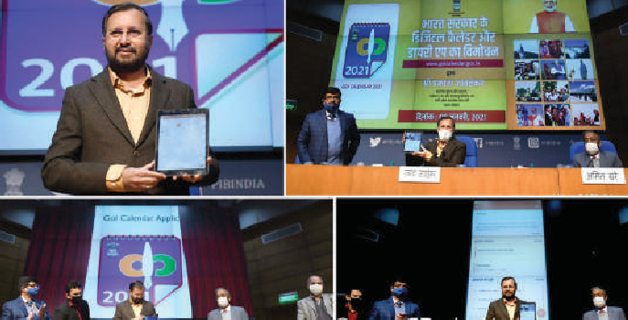

**Shri Prakash Javadekar, Hon'ble Union Minister for Information & Broadcasting launching the DigitalCalendar & Diary Application**

**NIC Kerala State Centre Inaugurated the ‘Bhunaksha Portal’**

hri E Chandrasekharan, Hon'ble Minister for Revenue and Housing, Government of Kerala inaugurated BhuNaksha portal of Kerala https://emaps.kerala.gov.in on 18/02/2021. The portal hosts village resurveyed digital maps enabling citizens to view and take print

S

level

of FMB sketches. Online payment is enabled and integrated with the common Revenue ePayment portal for digitally signed sketches.

The portal is integrated with ReLIS [Revenue Land Information System] for concurrent land records maintenance including FMB/ Sketch/ Map updation and PEARL [Package for Effective Administration of Registration Laws] for property registration for automating data transfer for mutation. On completion of Land Mutation [Pokkuvaravu],

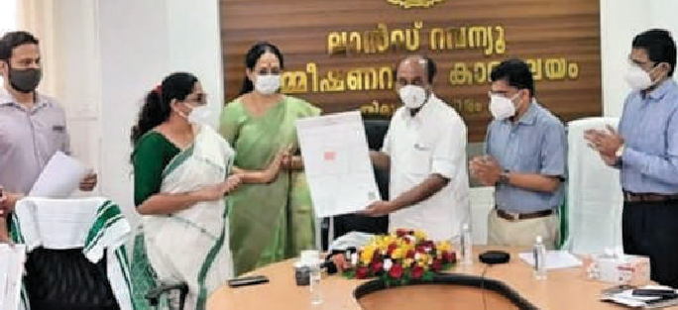

**Shri E Chandrasekharan, Hon'ble Minister for Revenue and Housing releasing Land Parcel Map (eMap) during the inauguration of Bhunaksha Portal**

the updated land map [FMB Sketch] is made available online for the landowner through e-Maps. Online facility is provided for getting any corrections done on the map as well.

***- Ahamed Shaheer J, Kerala***

**NIC jointly with the CBSE & AIM provides the CollabCAD Software for CBSE affiliated schools**

ational Informatics Centre (NIC), MeitY and Central Board of Secondary Education (CBSE), Ministry of Education along with Atal Innovation Mission (AIM), NITI Aayog, provided the CollabCAD Software for students and released a comprehensive e-book on CollabCAD

N

3D modelling on 14th January 2021.

The virtual event was graced by the distinguished presence of Shri Ajay Sawhney, Secretary, Ministry of Electronics & Information Technology (MeitY), Dr. Neeta Verma, Director General, National Informatics Centre (NIC), Shri Ramanan Ramanathan, Mission Director, Atal Innovation Mission (AIM), Shri Manoj Ahuja, IAS, Chairperson, CBSE, Dr. Antriksh Johri, Director (IT & Projects), CBSE, Dr. Joseph Emmanuel, Director (Academics), CBSE, Dr. Savita Dawar, Deputy Director General, NIC and HoG, CollabCAD and other senior officers from NIC and CBSE.

The event started with the welcome address by Dr. Savita Dawar. She briefly summarized the journey of CollabCAD which started around 2000. She conveyed her thanks to all the contributors of CollabCAD and welcomed the esteemed guests.

NIC and CBSE also inked a Memorandum of Understanding (MOU)

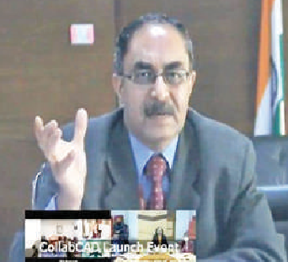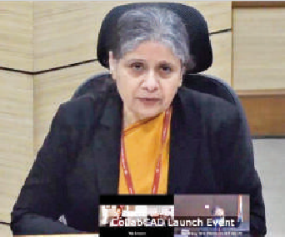

**Shri Ajay Prakash Sawhney, IAS, Secretary, MeitY and Dr. Neeta Verma, DG, NIC delivering the keynote address**

for ‘CollabCAD Software Support and Training for Students and Faculty in Engineering Graphics Curriculum for Class X and XII across CBSE affiliated Schools’ for a period of 10 years.

Dr. Neeta Verma, Director General, National Informatics Centre, said, “We are glad to share this software with the CBSE students. It is very simple software with industry features. This software is an innovative way for students to learn 3D Model designing and this knowledge will give them a competitive edge in their higher education. In our Prime Minister’s vision of Atmanirbhar Bharat when we are going to particularly promote industry and manufacturing in the country, this kind of initiative will contribute in a significant way.”

***- Guntuku Prasad, New Delhi***

**Hon’ble Chief of Minister Haryana, Shri Manohar Lal launched Skilling Portal of the Haryana Skill Develop- ment Mission**

on’ble Chief Minister Haryana, Shri Manohar Lal launched Skilling Portal (https://skill.haryana.gov.in) of the Haryana Skill Development Mission on 22nd February 2021. The Skilling portal veloped in compliance to the directives and visionary outlook of the Honourable Chief Minister, Haryana to have a single portal for all short- term skilling in the state to make it easy for candidates to identify the right skill training and the training center for them at the click of a button. Such

H

has de

**Auto-Mutation of Land Records in Tamil Nadu**

H

on’ble Chief Minister of Tamil Nadu Shri Edapadi K Palaniswami launched ‘Auto Mutation of Land Records’ on 23th February 2021. The ultimate objective of Land records Computerization

is Automatic Mutation and Conclusive Titling. Currently, on receipt of registration details through online mode from the Registration Department (Star 2.0 Software), the records are updated to TamilNilam (TamilNadu Information System on Land Administration and Management) land Records application and processed by the respective Revenue officials to affect the Patta Transfer. This results in delay of the process of Record of Rights generation.

Tamil Nadu Government has decided to initiate Automatic Mutation of Land records and has suggested starting with Title Transfers that do not involve sub-division of land Parcels. NIC, Tamil Nadu has integrated the Registration Application with Land Records application in a secured way such that the Record of Rights gets generated automatically and the digitally signed ROR is sent to the applicant via Email/ SMS without

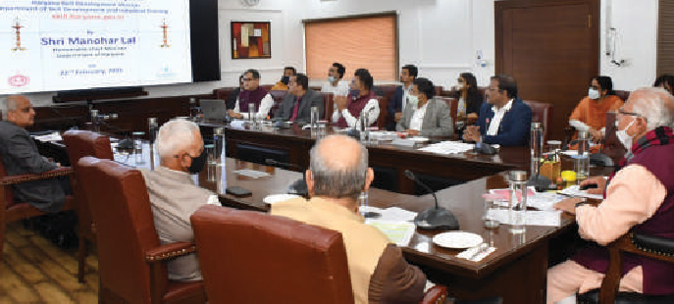

**Shri Manohar Lal, Hon'ble Chief Minister, Haryana launching the Skilling Portal**

a portal was also envisaged to provide an integrated database of all skilled youth who can then be linked to employment opportunities.

***- Deepak sawant , Haryana***

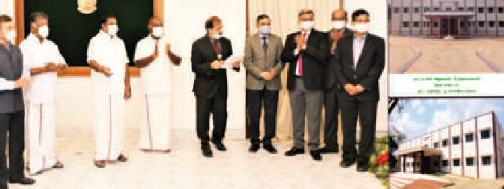

**Shri Edapadi K Palaniswami, Hon’ble Chief Minister, Tamil Nadu launching the ‘Auto Mutation of Land Records’**

critical data from the registration department is being signed using the Document Signer and the data along with signed hash in PKCS7 form is sent to TamilNilam Application as web services. Once the signing is verified at TamilNilam application, Patta number is generated automatically which facilitates instant generation of Record of Rights without any manual intervention. The records which are populated in TamilNilam Application are also signed using the Document Signer available in TamilNilam Server to maintain the data integrity. Required Checks and Balances are incorporated to ensure seamless transfer of data.

manual intervention. To maintain the integrity and authenticity, the ***- Gayatri R, TamilNadu***

Read

Previous Issues at

**https://informatics.nic.in/**

**Ad**

April 2021

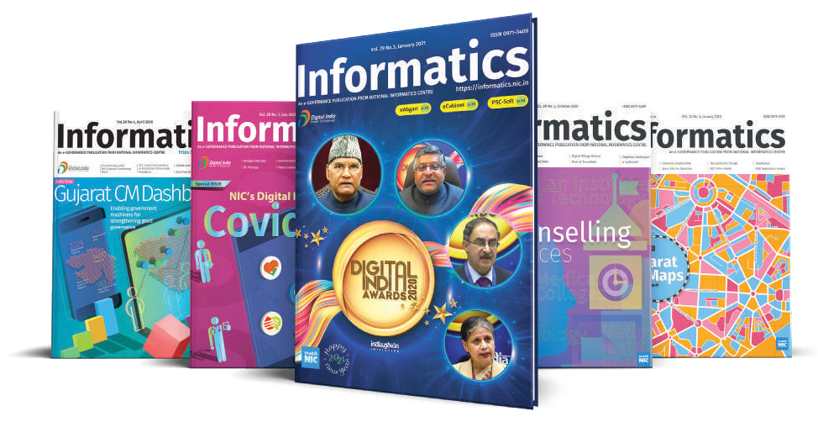

**informatics.nic.in 43**

**Inauguration/ launch of Mobile Application ‘CLEAN KASGANJ’ NIC- Kasganj (UP)**

LEAN KASGANJ - An Android App was developed by NIC District Centre, Kasganj (UP), under District Governance Mobile Challenge (DGMC). To become a part of Swachh Bharat Mission launched Hon'ble Prime Minister of India, the participation of people from

by the

C

cities, towns and villages is a must. This App is being developed specifically for Kasganj District. Any Citizen can upload the location & picture of the garbage / filthy area which is not being removed from concerned authorities. Citizens can login into the Mobile App by using their gmail Ids. App admin will receive all complaints and can share with the concerned

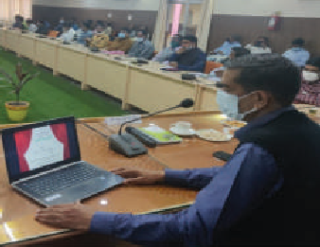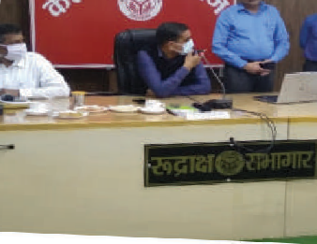

**DM, Kasganj, Shri C.P. Singh (IAS) Launching the Mobile App 'Clean Kasganj'**

authorities of local bodies (viz. Nagar palika parishad, Nagar panchayat & ADO panchayats etc.) for further necessary action.

***- Vandhana singh, Uttar Pradesh***

**eKalyan Mobile App Launched under District Governance Mobile Challenge (DGMC): NIC, Solan, Himachal Pradesh**

hri K.C. Chaman, IAS, Deputy Commissioner, Solan launched the eKalyan Mobile App for Social Justice and Empowerment Department. This is the District Administration initiative with an ive to facilitate Social Security Pensioners to know the status of their

S

object

Pension. Further, this App will also provide real time data pertaining to Social Security Pensions of all Districts in State for better decision making through respective authorized login.

Speaking on the occasion, the Deputy Commissioner informed that with the help of this App Social Security pensioners can get the status of the pension credit in their account on quarterly basis thus, eliminating visit to respective Welfare Offices for queries. He appreciated the efforts of the Department of Social Justice and Empowerment and NIC Solan in developing this App, which will be useful to more than 6 lakh beneficiaries under various schemes.

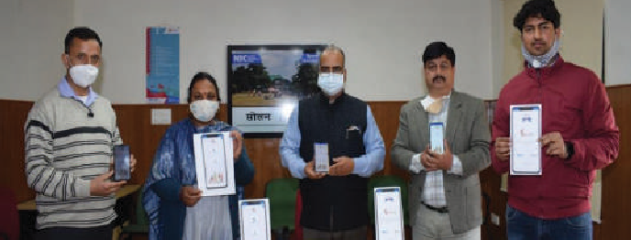

**Shri K.C Chaman, Deputy Commissioner, Solan (H.P.) launching the eKalyan Mobile App**

This App is developed by the NIC District Unit, Solan in Android platform initially and is available on Google Play store under NIC Account. The App has been developed under the guidance of Shri Lalit Kapoor, ASIO and Shri Ashish Sharma, Scientist-C who are handling the back-end eKalyan web application. Shri Sanjeev Kumar, DIO and Shri Swetansh Shatak, DIA Solan have developed this Mobile App as part of District Governance Mobile Challenge. The application provides data for the State and, hence, developed for the State of Himachal Pradesh covering all Districts.

***- Ajay Singh Chahal, Himachal Pradesh***

**Inauguration of “My Ration” mobile application**

O

n 16th March, 2021, Collector & District Magistrate, Banaskantha (Gujarat) Shri Anand Patel, I.A.S. has inaugurated this mobile app. On the launch of this mobile app he described the features

of my ration mobile app and how the citizen will get its benefit. Collector & District Magistrate, Banaskantha (Gujarat) appreciated the efforts of NIC-Banaskantha (Gujarat) and wished for the huge success & use of this mobile app for citizen’s benefit. On this occasion RDC (Resident District Collector) Shri A.T. Patel, GAS and other officers were present.

Under District Governance Through Mobile Challenge (DGMC) and guidelines received from state HQ - Gujarat, NIC-Banaskantha has developed “My Ration” mobile app. The Android version of “My Ration” mobile app is developed by Nand Kishore Tak, DIO and Shiwanshu, DIA. It is a G2C application, where citizens can view his/ her ration card details like member information, address, card type, attached FPS detail, entitlement etc.

With the help of this mobile app, citizens can check their ration card details, family member’s details, Card entitlement (Food grain) with quantity and price. Citizens can also view the last six month transaction

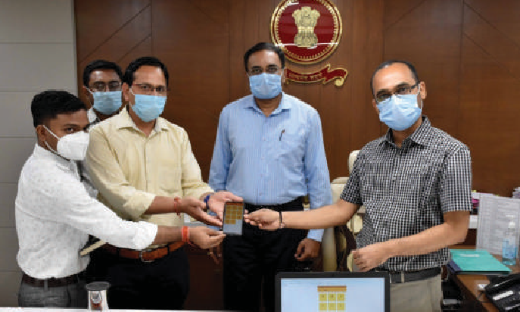

**Shri Anand Patel, I.A.S. launching the “My Ration” mobile app along with other officers**

of Ration card on FPS. Citizens can also find the attached Fair Price Shop (FPS) detail in this app. Citizens can find the officer details of his district; he can give his feedback about the app.

***- Amit, Dinkerbhai Shah, Gujarat***

**Dr. Neeta Verma, DG, NIC felicitated with ‘Top 10 Women Tech. Leaders India Awards 2021’**

**Accolades**

**The Great Indian Women Award (GIWA) 2021 to Dr. Neeta Verma, DG, NIC**

REVA Academy for Corporate Excellence, REVA University has selected Dr. Neeta Verma, Director General, NIC, for ‘Top 10 Women Tech Leaders India Awards 2021’. Dr. Verma is selected for this esteemed award due to her relentless efforts and initiatives for a digital India that benefitted millions of people during the pandemic times. Dr. Verma was felicitated with ‘Top 10 Women Tech Leaders India Awards 2021’ for leading technology initiatives, at a virtual award ceremony organised by REVA Academy for Corporate Excellence, REVA University, Bengaluru. Dr. Verma has been instrumental in implementing large-scale challenging digital initiatives of the government throughout the country. With a career spanning over three and a half decades, she brings extensive experience and has led the launch of Open Data Platform to release government data open for the public good.

Dr. Neeta Verma has been selected for the The Great Indian Women Awards 2021 in the Category of Impact Making Indian Woman Leader. Celebrating the UN International Women’s Day 2021, GIWA Awards are presented to exceptional women selected by the eminent jury of GIWA for making substantial contributions in their respective fields. The selection for the award was done after a detailed assessment and selection process involving leading women from different parts of the world. GIWA Awardees this year come from various countries like US, UK, South Africa, Kenya, Mauritius, Trinidad, Guyana, Fiji, UAE, Thailand etc. These women are those who made remarkable contributions in the field of science, IT, law, business, journalism, social work, arts and culture. The official Award Ceremony shall be physically held in April 2021

**NIC UP & Gujarat wins Digital Technology Sabha Excellence Awards 2021**

Digital Technology Sabha Excellence Award 2021 were held on 23rd Feb 2021 through Virtual Conference organized by Express Com- puters of Indian Express Group. The Awards hon- our Government Depart- ments/ Agencies/ Insti- tutions that demonstrate innovative use of a partic- ular technology or a com- bination of technologies for distinct benefits to the stakeholders.

The Digital Technology Sabha Excellence Awards 2021 ceremony was held as a virtual event on 23rd February 2021. Organized by Express Computers of Indian Express Group, the Awards honour Government Departments, Agencies and Institutions for demonstrating innovative use of technologies benefitting the stakeholders distinctively.

Smt. Ministhy S. IAS & IG Stamps and Registration, UP, Shri Krishna Kumar, IAS & Additional IG, Stamp & Registration and Shri Vinay Kumar Singh, Senior Technical Director, NIC received the AWARD through virtual ceremony. The Award under the Enterprise Application Category

was conferred to Stamps & Registration Department & NIC Uttar Pradesh for the project **PRERNA (PRoperty Evaluation & RegistratioN Application)**.

The Award under the **Data Center Category** was won by the **Department of Science and Technology, Govt. of Gujarat.** Various applications of the Department are hosted at the Gujarat State Data Centre. Shri Dharmendra Devaka, Tech. Director (NIC), the Project Manager and CISO of Gujarat State Data Centre and Shri C. Semmalai, Scientist- C, the composite team member of GSDC received the Award.

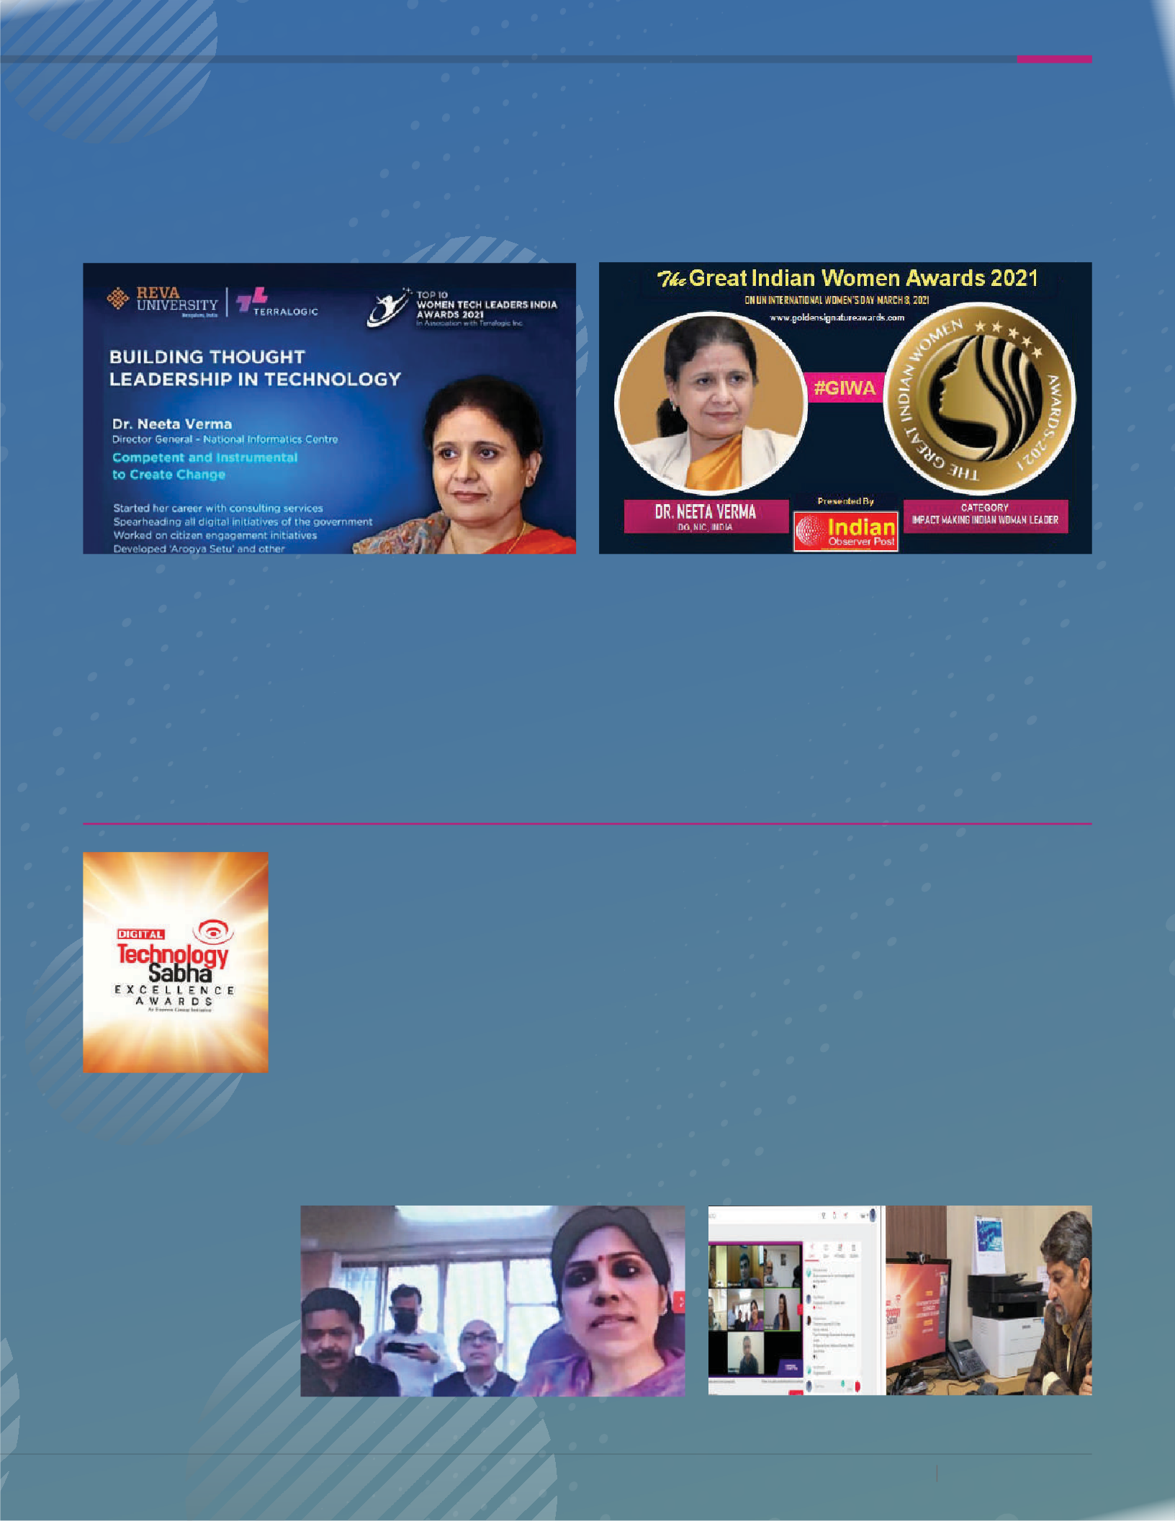April 2021

**informatics.nic.in 45**

**Accolades**

**CSI SIG eGov** AWARDS 2020

The 18th Computer Society of India (CSI) Special Interest Group (SIG) eGovernance Awards 2020 was held in Lucknow, Uttar Pradesh on 12th February 2021. The Hon’ble Chief Minister of Uttar Pradesh, Shri Yogi Adityanath presided over the award function.

NIC (Head quarters and States) won several Awards in different categories. The Aarogyaseva, Central Public Procurement Portal (CPPP) of NIC hqrs., and eMantrimandal of NIC, Uttarakhand were conferred the Award for Excellence. PM Mementos Auction Online (On- line auction of mementos presented to Hon’ble Prime Minister) and Ease of Doing Business in Assam were conferred Award of Appreciation. Award of recognition was bestowed on Digidhan Dashboard for Monitoring Digital Transactions, eOffice, Panchayat NishchaySoft Portal of Bihar, FRUITS (Farmer Registration & Unified Beneficiary Information System) of Karnataka, eOffice MMP Implementation for GoMP, Madhya Pradesh, Padhai Tumhar Duar, Chattisgarh, Price Statistics in Rajasthan (PSR), eAudit (Online Audit Management System) of Uttarakhand, iORA (Integrated Online Revenue Application) of Gujarat, and RT- PCR/ RATI mobile Apps + Covid Portal of Himachal Pradesh. Award of Special Recognition was given away to Covid-19 Jagratha, NIC Kozhikode, Kerala, Aarogya Darshak Maps (GIS Mapping of Containment Zones and Hospitals), NIC Nandurbar, Maharashtra and Covid-19 Jagratha Mobile App, NIC Kannur, Kerala. The Award for sustenance were conferred on ReALCraft (Registration & Licensing of Fishing Crafts) and eDistrict by NIC Kerala, Aadhaar enabled PDS through ePOS Collectorate Krishna District by NIC Andhra Pradesh and Mobile based State Asset Register by NIC State Centre, Bihar.

District)

Award of Special Recognition for the project EnteJilla (My

Award for the project National Power Portal

Award for the project Central Public Procurement Portal (CPPP)

Award of Special Recognition for the project Arogya Darshak Maps – GIS Mapping of Containment Zones and Hospitals

Mobile App

Award of Special Recognition for the project Covid19 Jagratha

Award of of Appreciation for the project Ease of Doing

Business

Management System (eAudit)

Award of Appreciation for the project Uttarakhand Audit

tratioN Application)

Award for the project PRERNA (PRoperty Evaluation & Regis-

Award for the project Price Statistics in Rajasthan (PSR) portal

Applications)

Award for the project iORA (Integrated Online Revenue

From Tap in Puri City

Award for the project Smart Water Management Under Drink

Award for the project e-Cabinet (Mantrimandal)

Award for the project Padhai Tunhar Duar

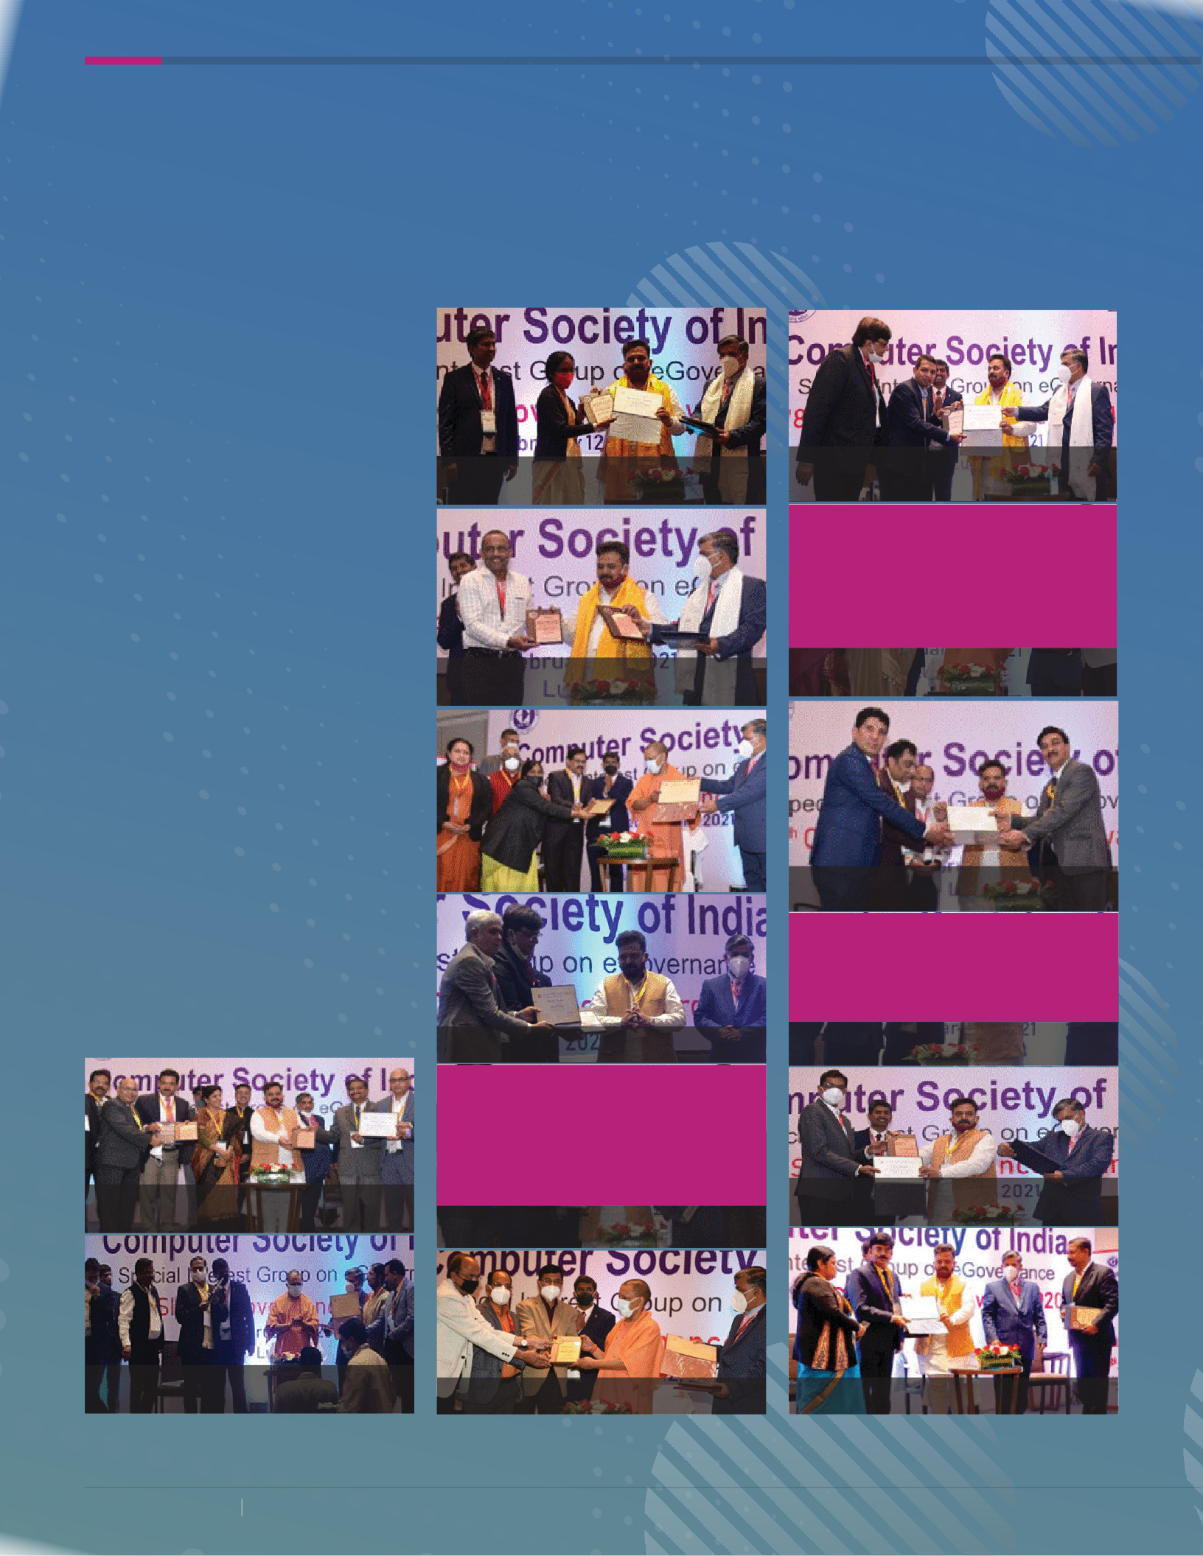46 informatics.nic.in

Dashboard

Award of Special Recognition for the project Digidhan

**April 2021**

**Excellence in PM-Kisan Scheme implementation Awards to NIC**

U

nion Union Minister for Agriculture and Farmers Welfare, Shri Narendra Singh Tomar has awarded the top-performing States and Districts for their exemplary work with respect to the implementation of the Prad-

han Mantri Kisan Samman Nidhi Scheme on 24th February 2021. Karnataka, Maharashtra and UP were awarded for being the most efficient PM-Kisan implementation States. **A** NIC(HQ) Development team received the award for PM-Kisan website and mobile App development in a record time and providing technical support to NIC’s state and district centres for successful implementation of the scheme. **B** Maharashtra received the award for Best State in effectively attending the beneficiary complaints and grievances. **C** Ahmed Nagar District has received the Best District Award for the comple- tion of physical verification. **D** Pune District has received the Best District to address the beneficiary complaints and grievances. **E** The Districts, Ananta-

**Accolades**

**NIC wins SKOCH 2021 Awards**

eremony of the much popular SKOCH 2021 Awards for excellence in eGovernance in the country was held in a virtual ceremony on 20th March 2021.

C

pur and Nellore received the Best District awards for empowering farmers. **A** The Ministry of Tribal Affairs was conferred with SKOCH Challenger Award

for their various initiatives for better e-Governance in India. The award was received by the Hon’ble Minister for Tribal Affairs, Shri Arjun Munda. The

1. awarded initiatives include portals for various schemes of the Ministry de-

veloped by Tribal Affairs Informatics Division of NIC

**B** The SKOCH Gold Award in Technology category was conferred to the

‘Performance Dashboard’ developed and implemented by the Centre of Ex- cellence for Data Analytics (CEDA) and Tribal Affairs Informatics Division. The Dashboard portrays Analytics of sixteen schemes of the Ministry on a single platform.

1. **C** The SKOCH Gold Award for the Swasth Bharat category was given away

for the’Tribal Health and Nutrition Portal’ developed and implemented by Piramal Swasthaya, and hosted by Tribal Affairs Informatics division of NIC.

**D** The SKOCH Award for the Environment and Sustainability category went

to the “Water Management of Tribal Villages using Ice-Stupa“ implemented by the Ministry in Ladakh Region

C **NIC Haryana conferred with the eLets 10th Healthcare Leader- ship Award**

N

ational Informatics Centre, Haryana was conferred with the 10th Healthcare

Leadership Award under the category “Integrated Web based Applications for District COVID Management”. The award was for the innovative and path-breaking ICT enabled applications (web portals and apps) developed by District Informatics Office, Hisar.

D

E

The 10th Healthcare Leadership Award by Elets Techno Media and e-health magazine was held as a virtual event on 29th & 30th January 2021. The criteria for the 10th edition of awards was built

upon the on-going pandemic and how each healthcare domain has exceptionally worked hard to combat COVID-19.

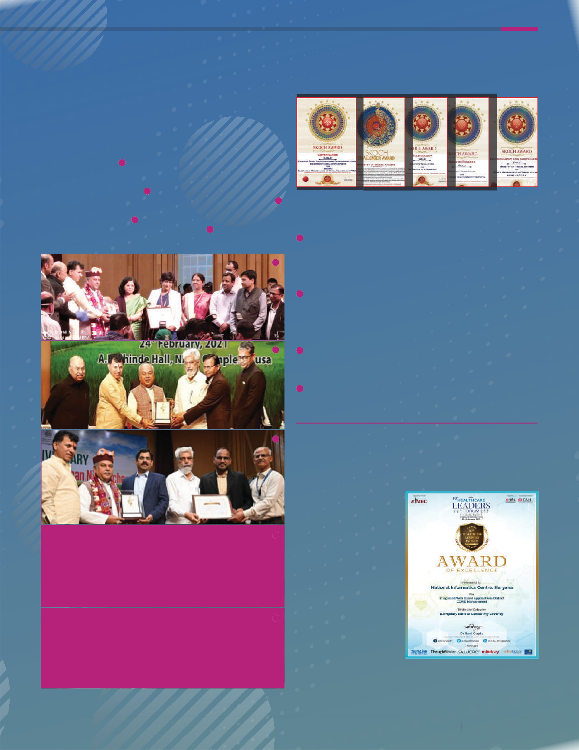**April 2021**

**informatics.nic.in 47**

**Spotlight**

**International Women’s Day** celebrated at NIC

nternational Women’s day (IWD) is celebrated every year on March 8th globally. IWD is a mark of respect and appreciation of women

I

all over the world. Sanghamitra, the women welfare association of NIC celebrated this special day at NIC Head Quarters.

The programme commenced with a warm welcome to Dr. Neeta Verma, Director General, NIC by/ and presenting her with a succulent plant. The other invited guests at the venue were senior most women officers of the NIC head quarters.

During the event, DG also released a video

movie teaser prepared by Sanghamitra.

Dr. Neeta Verma, in her address emphasised the need for everyone to update themselves with the emerging technologies and master a suitable one. She also mentioned that with hard work women can achieve any big goals in their career. She also appreciated the contributions of NIC women officers despite managing their multiple role.

The cultural programme was performed by artists of NIC from different centres of NIC. The distribution of mementos to the performers by Dr.(Ms) Ranjna Nagpal, DDG (Admin).

The next office bearers of Sanghamitra were announced during the event. A Talk on “#Choose to Challenge” was also held.

The event concluded with the vote of thanks.

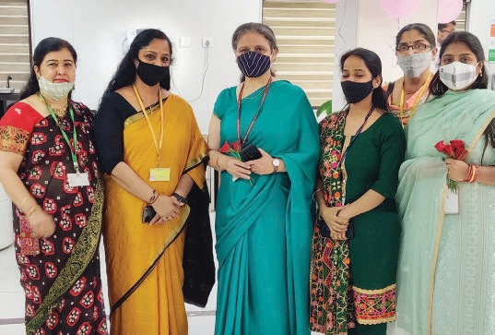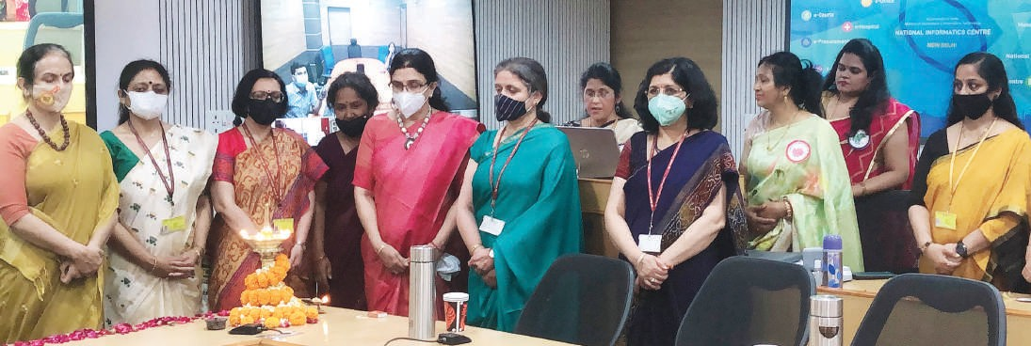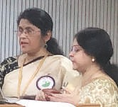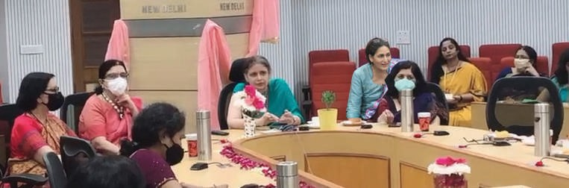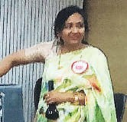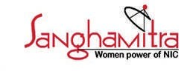

**48 informatics.nic.in**

**April 2021**